BACKGROUND
Little is known about the long-term outcomes in elderly survivors of in-hospital cardiac arrest. We determined rates of long-term survival and readmission among survivors of in-hospital cardiac arrest and examined whether these outcomes differed according to demographic characteristics and neurologic status at discharge.
METHODS
We linked data from a national registry of inpatient cardiac arrests with Medicare files and identified 6972 adults, 65 years of age or older, who were discharged from the hospital after surviving an in-hospital cardiac arrest between 2000 and 2008. Predictors of 1-year survival and of readmission to the hospital were examined.
RESULTS
One year after hospital discharge, 58.5% of the patients were alive, and 34.4% had not been readmitted to the hospital. The risk-adjusted rate of 1-year survival was lower among older patients than among younger patients (63.7%, 58.6%, and 49.7% among patients 65 to 74, 75 to 84, and ≥85 years of age, respectively; P<0.001), among men than among women (58.6% vs. 60.9%, P = 0.03), and among black patients than among white patients (52.5% vs. 60.4%, P = 0.001). The risk-adjusted rate of 1-year survival was 72.8% among patients with mild or no neurologic disability at discharge, as compared with 61.1% among patients with moderate neurologic disability, 42.2% among those with severe neurologic disability, and 10.2% among those in a coma or vegetative state (P<0.001 for all comparisons). Moreover, 1-year readmission rates were higher among patients who were black, those who were women, and those who had substantial neurologic disability (P<0.05 for all comparisons). These differences in survival and readmission rates persisted at 2 years. At 3 years, the rate of survival among survivors of in-hospital cardiac arrest was similar to that of patients who had been hospitalized with heart failure and were discharged alive (43.5% and 44.9%, respectively; risk ratio, 0.98; 95% confidence interval, 0.95 to 1.02; P = 0.35).
CONCLUSIONS
Among elderly survivors of in-hospital cardiac arrest, nearly 60% were alive at 1 year, and the rate of 3-year survival was similar to that among patients with heart failure. Survival and readmission rates differed according to the demographic characteristics of the patients and neurologic status at discharge.

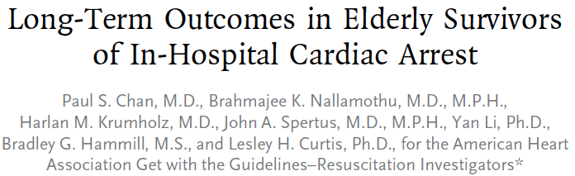
KEY POINTS
- Older patients (>75 years) were significantly less likely to live at 1 year post discharge
- White patients and women were significantly more likely to live at 1 year post-discharge than black patients and men
- As neurologic status deteriorates, they were significantly less likely to be alive at 1 year post-discharge
- Diagnosis of ventricular fibrillation as the arrest rhythm was more likely to survive than any other diagnosis

QUESTIONS
- Patients are traditionally considered to have a good neurologic outcome if
  - They signs are considered moderate or mild at discharge
  - They have the ability to walk at 180 days post discharge
  - They have the ability to spontaneously ventilate at the time of discharge
  - They have the ability to respond to noxious but not visual stimulus at the time of discharge
- Of elderly patients surviving an in hospital arrest, what percent is expected to be alive at 2 years post-arrest?
  - 20%
  - 30%
  - 40%
  - 50%

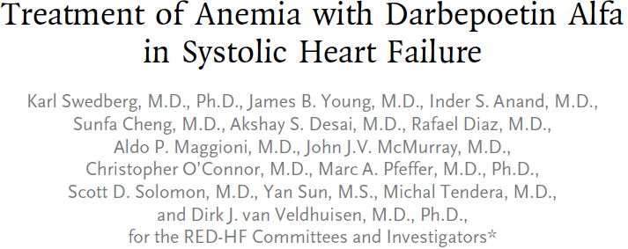

Background
Patients with systolic heart failure and anemia have worse symptoms, functional capacity, and outcomes than those without anemia. We evaluated the effects of darbepoetin alfa on clinical outcomes in patients with systolic heart failure and anemia.
Methods
In this randomized, double-blind trial, we assigned 2278 patients with systolic heart failure and mild-to-moderate anemia (hemoglobin level, 9.0 to 12.0 g per deciliter) to receive either darbepoetin alfa (to achieve a hemoglobin target of 13 g per deciliter) or placebo. The primary outcome was a composite of death from any cause or hospitalization for worsening heart failure.
Results
The primary outcome occurred in 576 of 1136 patients (50.7%) in the darbepoetin alfa group and 565 of 1142 patients (49.5%) in the placebo group (hazard ratio in the darbepoetin alfa group, 1.01; 95% confidence interval, 0.90 to 1.13; P = 0.87). There was no significant between-group difference in any of the secondary outcomes. The neutral effect of darbepoetin alfa was consistent across all prespecified subgroups. Fatal or nonfatal stroke occurred in 42 patients (3.7%) in the darbepoetin alfa group and 31 patients (2.7%) in the placebo group (P = 0.23). Thromboembolic adverse events were reported in 153 patients (13.5%) in the darbepoetin alfa group and 114 patients (10.0%) in the placebo group (P = 0.01). Cancer-related adverse events were similar in the two study groups.
Conclusions
Treatment with darbepoetin alfa did not improve clinical outcomes in patients with systolic heart failure and mild-to-moderate anemia. Our findings do not support the use of darbepoetin alfa in these patients.

KEY POINTS
- Significantly more patients in the control group received a nonstudy dose of erythropoietin stimulation agent and a blood transfusion
- No difference was noted in all cause mortality between the groups
- A significantly higher Kansas City Cardiomyopathy Questionnaire score was noted in the darbe group (that’s a good thing)
- Significantly more embolic/thrombic adverse events and septic shock were noted with the use of darbepoietin

QUESTIONS
- The use of which of the following is associated with anemia in patients with systolic failure?
  - Furosemide
  - Benazepril
  - Levosimendan
  - Carvedilol
- Which of the following events were noted significantly more frequently with the use of darbepoietin alfa?
  - Death, any cause
  - Septic shock
  - Unstable angina
  - Fatal stroke

Background
In patients with ischemic stroke, endovascular treatment results in a higher rate of recanalization of the affected cerebral artery than systemic intravenous thrombolytic therapy. However, comparison of the clinical efficacy of the two approaches is needed.
Methods
We randomly assigned 362 patients with acute ischemic stroke, within 4.5 hours after onset, to endovascular therapy (intraarterial thrombolysis with recombinant tissue plasminogen activator [t-PA], mechanical clot disruption or retrieval, or a combination of these approaches) or intravenous t-PA. Treatments were to be given as soon as possible after randomization. The primary outcome was survival free of disability (defined as a modified Rankin score of 0 or 1 on a scale of 0 to 6, with 0 indicating no symptoms, 1 no clinically significant disability despite symptoms, and 6 death) at 3 months.
Results
A total of 181 patients were assigned to receive endovascular therapy, and 181 intravenous t-PA. The median time from stroke onset to the start of treatment was 3.75 hours for endovascular therapy and 2.75 hours for intravenous t-PA (P<0.001). At 3 months, 55 patients in the endovascular-therapy group (30.4%) and 63 in the intravenous t-PA group (34.8%) were alive without disability (odds ratio adjusted for age, sex, stroke severity, and atrial fibrillation status at baseline, 0.71; 95% confidence interval, 0.44 to 1.14; P = 0.16). Fatal or nonfatal symptomatic intracranial hemorrhage within 7 days occurred in 6% of the patients in each group, and there were no significant differences between groups in the rates of other serious adverse events or the case fatality rate.
Conclusions
The results of this trial in patients with acute ischemic stroke indicate that endovascular therapy is not superior to standard treatment with intravenous t-PA.

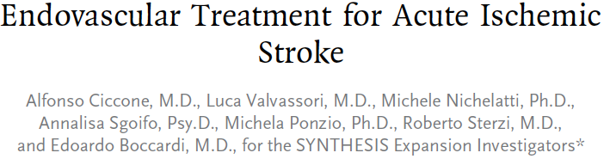
KEY POINTS
- No difference was noted in the survival at 90 days with minimal to no neurologic deficits between patients treated with endovascular therapy vs patients treated with systemic tPA
- No difference between the groups with regards to secondary outcome measures
- Authors speculate that a treatment delay in the endovascular treatment group may account for the lack of superiority of this treatment

QUESTIONS
- Please describe the difference between mechanical and pharmacologic thrombolysis
  - In mechanical they use a wire to facilitate disintegration, systems to capture and extract the thrombus, or crushing and aspirating the thrombus. Pharmacologic is just administration of tPa in the vicinity of the thrombus
- Which percent of stroke patients are expected to make a full recovery?
  - 25%
  - 35
  - 50
  - 75

