JVIM 2013;27:250-258
Effect of N-acetylcystine supplementation on intracellular glutathione, urine isoprostanes, clinical score, and survival in hospitalized ill dogs.
Viviano KR, VanderWielen B
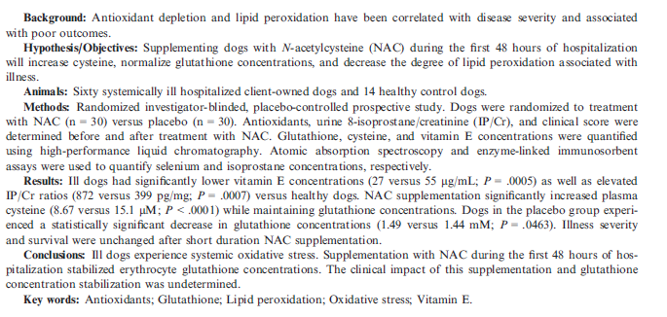
- Dogs recruited from animals admitted to hospital – does not say on what basis they were recruited
- Within 24 hours of admit were given 140 mg/kg NAC and then 70 mg/kg q6h for a total of 8 doses
- Survival prediction index clinical score was performed for each patient before and after antioxidant treatment
- 30 dogs in each group analyzed, although 12 dogs were enrolled/randomized but data was excluded b/c they were discharged before completion
- Dogs in NAC group were significantly older, dogs in the placebo group had significantly lower selenium at the start
- Compared to healthy dogs, ill dogs had significantly lower vitamin E levels and increased IP/Cr ratio
- Placebo group had decrease in RBC GSH level after treatment period
- NAC group had increase in plasma cysteine concentration and RBC GSH level remained the same
- No changed in vitamin E, selenium, urine IP/Cr ratio, and SPI2 scores in NAC group
- No difference in survival to discharge between groups

- Based on this study, which of the following is true in regards to hospitalized ill dogs:
  - The administration of NAC to ill dogs improved survival
  - The RBC GSH level decreases over time in ill hospitalized dogs.
  - The administration of NAC decreases urine IP/Cr ratio in ill hospitalized dogs
  - Survival prediction index clinical score improved with NAC administration.

JVIM 2013;27:259-267
Microbiologic and cytologic assessment of bronchoalveolar lavage fluid from dogs with lower respiratory tract infection: 105 cases (2001-2011)
Johnson LR, Queen EV, Vernau W, et al
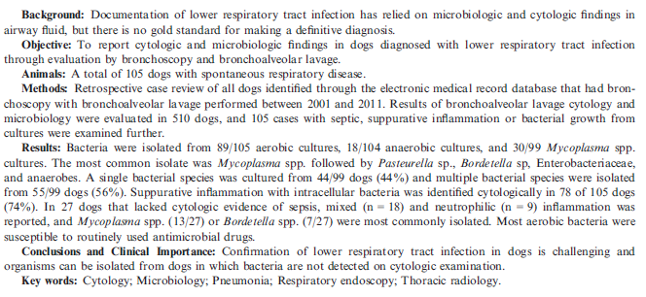
- Dogs at UCDavis, with positive bacterial cultures or suppurative inflammation with intracellular bacteria
  - Excluded dogs with bacteria isolated only from enrichment or with only rare bacterial colonies and no evidence of infection on cytology, presence of oropharyngeal contamination
- 105 dogs included for analysis
- 89/105 aerobic cultures grew, 18/104 anaerobic, and 30/99 Mycoplasma cultures
  - 44% of dogs had single isolate grown
  - 56% had multiple isolates grown
- Most common: Mycoplasma (30%), Bordetella bronchiseptica (22%), Pasteurella (21%), Enterobacteriaceae (20%), and anerobes (17%)
- 78/105 dogs has suppurative septic inflammation identified cytologyically
- In 27 dogs w/o cytologic evidence intracellular bacteria mixed inflammation was seen in most cases, suppurative inflammation in the rest.
- 3 of 105 had intracellular bacteria on cytology but did not grow anything
- Dogs with Mycoplasma were younger than dogs with enteric species, dogs with Bordetella isolated were younger then dogs with most other types of infection
- Most dogs had a cough that was chronic, median duration 120 days
- Bordetella was resistant to cephalosporins, Pseudomonas was MDR but susceptible to amikacin, most enteric isolates were very susceptible

