Serum D-lactate concentrations in cats with gastrointestinal disease. Packer RA, et al. JVIM 2012; 26: 905-910.
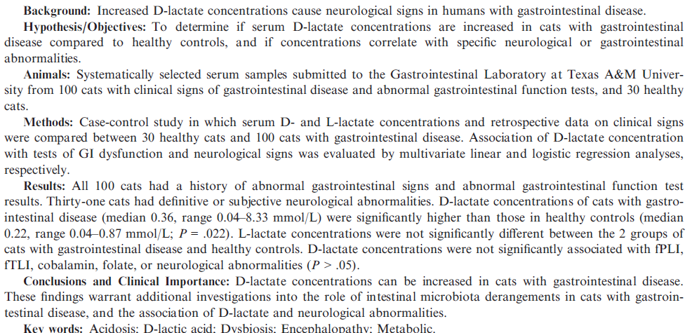
- D-enantomer of lactic acidosis is not normally present in the serum of mammals
  - Comes from exogenous source (fermentation of CHO in the GIT), intoxication (propylene glycol ingestion in cats, metabolic derangements (methylglyoxal pathway in DM)
  - In humans levels >3 mmol/L cause neurologic signs – altered mentation, ataxia, ect
  - Unknown level in cats causes clinical signs, rarely reported in cats
- Clinical monitors only detect L lactate
- D-lactic acidosis causes high anion gap metabolic acidosis
- Cats have poor ability to digest CHO, cats feed high CHO diet have increased d-lactate levels

- In this study, an elevated d-lactate level was associated with neurologic signs. T or F
- The level of D-lactate that causes neurologic signs in cats is:
  - Greater than 3 mmol/L
  - Unknown
  - Greater than 1 mmoL/L

Diagnostic yield and adverse effects of MRI-guided free-hand brain biopsies through a mini-burr hole in dogs with encephalitis. Flegel T, et al. JVIM 2012; 26: 969-976.
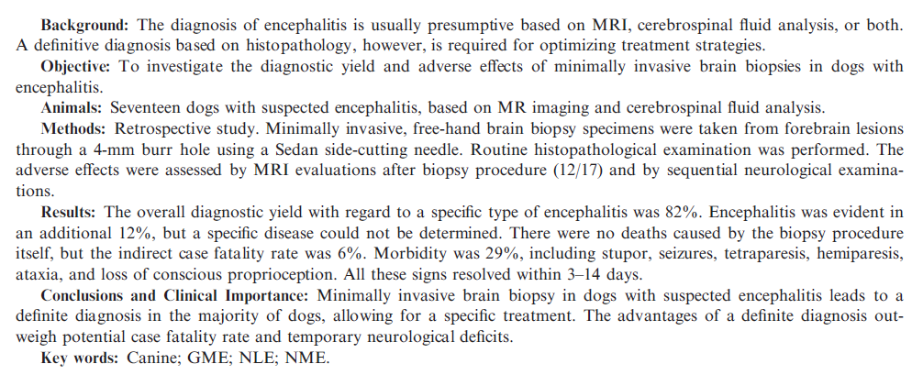
- Error rate of 33% on the first bx attempt – recommend taking two bx at different trajectories
- Allows IHC staining for infectious agents, identification of cell types/location (T vs B cell)
  - Detected distemper in one case

Acute azotemia as a predictor of mortality in dogs in cats. Harison E, et al. JVIM 2012; 26:1093-1098.
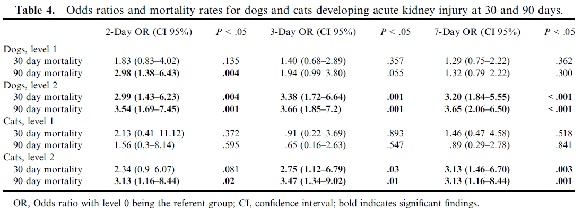
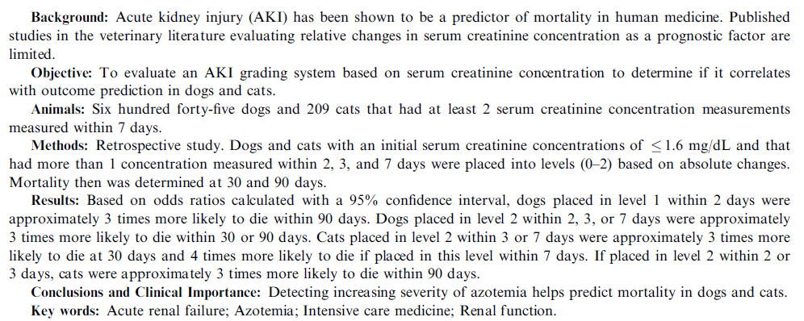

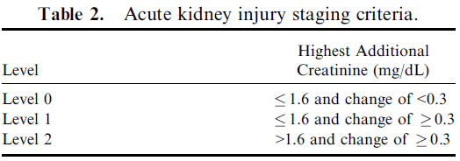

- Both RIFLE and AKIN criteria have shown increased mortality and hosp
length with worsening AKI
- Patients did not have to be hospitalized, 645 dogs, 209 cats
- Underpowered to determine if level 1 AKI impacted mortality
- Increasing SCr is correlated with mortality, but does not imply that patients are dying from kidney disease
- Did not find a difference when the length of observation was increased ( 2 vs 3 vs 7 days)

- Which of the following is true based on the above study:
  - Dogs/cats who had an increase in creatinine of at least 0.3 mg/dL were at increased risk of mortality
  - Dogs/cats who had a Cre >1.6 and an increase from baseline of at least 0.3 were at increased risk for mortality
  - There was no relationship between Cre levels and mortality
- T or F: If a patient’s Cre increased during care, they were more likely to die from kidney disease

