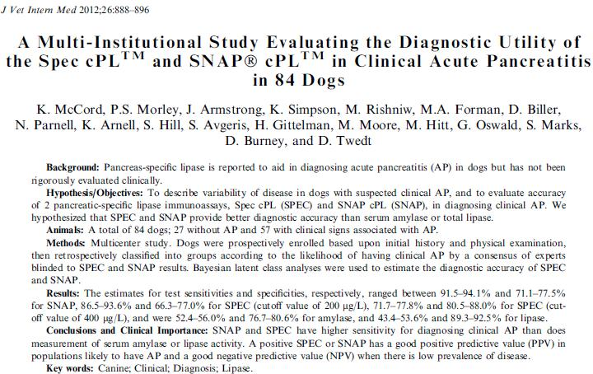

- Babyesian latent class analysis is used to evaluate a diagnostic test when there is not a perfect/near-perfect test to compare to
- Babyesian latent class analysis requires large sample size to obtain precise estimates - the 95% CIs in this study are very large
- SPEC & Snap cPLI tests had significantly higher sensitivity (~90%) than amylase and lipase (~50%)
- High NPV in the general population where there is a low incidence of pancreatitis
- All tests have modest specificity (amylase /SNAP/Spec >200 ~75%, SPEC >400 ~85%, lipase ~90%) which limits their value to definitively confirm pancreatitis as a sole test
- Interpreting these tests together dramatically improves specificity and PPV
- Combining high clinical suspicion w/ positive test produces a high PPV

- The babyesian latent class analysis should be used to evaluate a new diagnostic tests when there is a "gold standard" test available. T or F
- The SPEC and Snap cPLI tests are valuable better for ruling (in/out) pancreatitis in dogs.

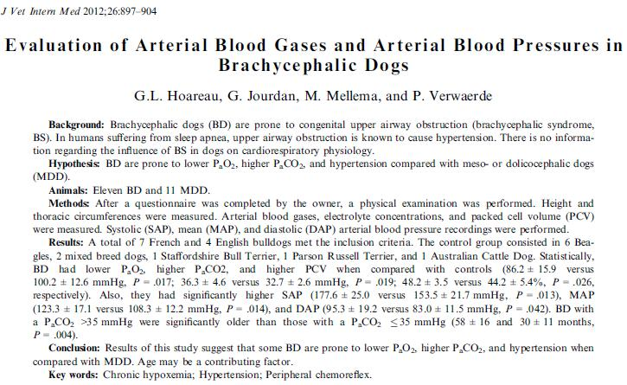
- BD questionaire - 27% had a syncopal episode, 18% breathed w/ mouth open, snoring even when awake
- BD had significantly higher PaCO2 & HCO3 & PCV & all BP parameters
- BD had significantly lower PaO2, anion gap
- A-a not statistically different between groups
- BD dogs with higher CO2 were significantly older & had higher BCS than other BD dogs and control dogs - may represent progression of dysfunction
- Peripheral chemoreflex - stimulated by hypoxemia and lesser hypercapnia, receptors in carotid body and aortic arch send signals via CN X & XI to the higher respiratory centers in medulla oblongata. Stimulates increase in MV, sympathoexcitatory vascular tone, & vagal tone to heart --> increased BP, decreased HR. Increased MV stimulates baropulmonary stretch receptors resulting in an increased HR.

- BD dogs of all ages had a significantly increased PaCO2 level. T or F
- The components of brachycephalic airway syndrome are:

- Hypertension in BD dogs may be due to this reflex____________________

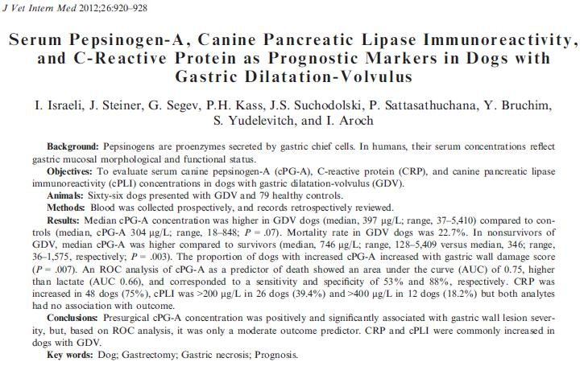
- Gastric wall necrosis at surgery has been the most consistent predictor of postoperative complications and death in dogs with GDV - associated with 11-fold increase in mortality
- Pepsinogens are inactive proenzymes secreted by gastric chief cells. 1% of pepsinogens diffuse into systemic circulation. In humans serum pepsinogen level reflects morphological and functional status of the gastric mucosa; used as marker of H pylori infection, early detection of gastritis and gastric cancer.
- Dogs in control group were significantly smaller & younger than GDV group
- mortality: overall 22.7, dogs w/ partial gastrotomy or invagination 46.7%, dogs w/o 12.2%
- 53.3% of nonsurvivors had gastric wall score of 2, 20% had a score of 1, 26.7% had a score of 0.
- Presence of arrhythmia during hospitalization not associated w/ mortality
- Presence of hemotatic abnormalities was associated with mortality - more common in dogs w/ cPG-A outside of reference interval
- control vs GDV - serum cPG-A not different, survivors vs nonsurvivors serum cPG-A was significnatly higher in nonsurvivors, but there was a lot of overlap in the ranges
- Not different between survivors and nonsurvivors: cPLI, c-reactive protein, lactate
- Despite elevated cPLI in 58% of GDV dogs, no associated with clinical pancreatitis except 1 dog.

- cPG-A concentration is a good outcome predictor in dogs with GDV. T or F

