BACKGROUND
Results of previous single-center, observational studies suggest that daily bathing of patients with chlorhexidine may prevent hospital-acquired bloodstream infections and the acquisition of multidrug-resistant organisms (MDROs).
METHODS
We conducted a multicenter, cluster-randomized, nonblinded crossover trial to evaluate the effect of daily bathing with chlorhexidine-impregnated washcloths on the acquisition of MDROs and the incidence of hospital-acquired bloodstream infections. Nine intensive care and bone marrow transplantation units in six hospitals were randomly assigned to bathe patients either with no-rinse 2% chlorhexidine–impregnated washcloths or with nonantimicrobial washcloths for a 6-month period, exchanged for the alternate product during the subsequent 6 months. The incidence rates of acquisition of MDROs and the rates of hospital-acquired bloodstream infections were compared between the two periods by means of Poisson regression analysis.
RESULTS
A total of 7727 patients were enrolled during the study. The overall rate of MDRO acquisition was 5.10 cases per 1000 patient-days with chlorhexidine bathing versus 6.60 cases per 1000 patient-days with nonantimicrobial washcloths (P = 0.03), the equivalent of a 23% lower rate with chlorhexidine bathing. The overall rate of hospital- acquired bloodstream infections was 4.78 cases per 1000 patient-days with chlorhexidine bathing versus 6.60 cases per 1000 patient-days with nonantimicrobial washcloths (P = 0.007), a 28% lower rate with chlorhexidine-impregnated washcloths. No serious skin reactions were noted during either study period.
CONCLUSIONS
Daily bathing with chlorhexidine-impregnated washcloths significantly reduced the risks of acquisition of MDROs and development of hospital-acquired bloodstream infections.

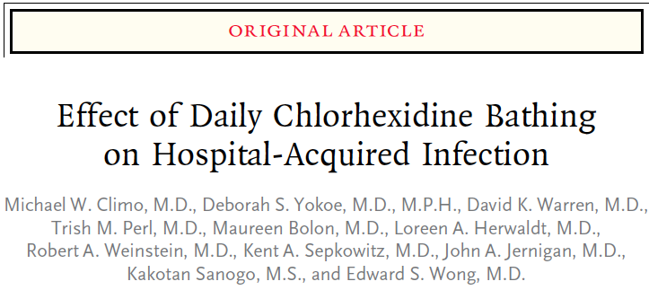
Key points
- Significantly lower overall rates of MRSA or VRE with the use of chlorhexadine, but when MRSA was evaluated alone it did not reach significance
- Significantly lower bloodstream infection with chlorhexadine use as well as central-catheter associated bloodstream infections

Questions
- T/F: use of chlorhexadine reduced the rate of MRSA infections in this study population

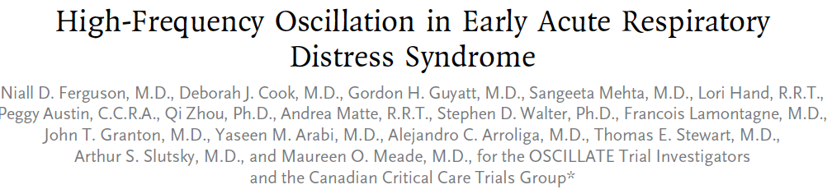
Background
Previous trials suggesting that high-frequency oscillatory ventilation (HFOV) reduced mortality among adults with the acute respiratory distress syndrome (ARDS) were limited by the use of outdated comparator ventilation strategies and small sample sizes.
Methods
In a multicenter, randomized, controlled trial conducted at 39 intensive care units in five countries, we randomly assigned adults with new-onset, moderate-to-severe ARDS to HFOV targeting lung recruitment or to a control ventilation strategy targeting lung recruitment with the use of low tidal volumes and high positive end-expiratory pressure. The primary outcome was the rate of in-hospital death from any cause.
Results
On the recommendation of the data monitoring committee, we stopped the trial after 548 of a planned 1200 patients had undergone randomization. The two study groups were well matched at baseline. The HFOV group underwent HFOV for a median of 3 days (interquartile range, 2 to 8); in addition, 34 of 273 patients (12%) in the control group received HFOV for refractory hypoxemia. In-hospital mortality was 47% in the HFOV group, as compared with 35% in the control group (relative risk of death with HFOV, 1.33; 95% confidence interval, 1.09 to 1.64; P = 0.005). This finding was independent of baseline abnormalities in oxygenation or respiratory compliance. Patients in the HFOV group received higher doses of midazolam than did patients in the control group (199 mg per day [interquartile range, 100 to 382] vs. 141 mg per day [interquartile range, 68 to 240], P<0.001), and more patients in the HFOV group than in the control group received neuromuscular blockers (83% vs. 68%, P<0.001). In addition, more patients in the HFOV group received vasoactive drugs (91% vs. 84%, P = 0.01) and received them for a longer period than did patients in the control group (5 days vs. 3 days, P = 0.01).
Conclusions
In adults with moderate-to-severe ARDS, early application of HFOV, as compared with a ventilation strategy of low tidal volume and high positive end-expiratory pressure, does not reduce, and may increase, in-hospital mortality.
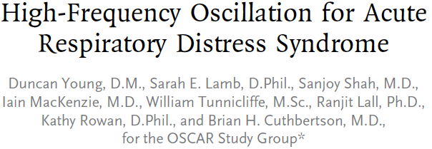
Background
Patients with the acute respiratory distress syndrome (ARDS) require mechanical ventilation to maintain arterial oxygenation, but this treatment may produce secondary lung injury. High-frequency oscillatory ventilation (HFOV) may reduce this secondary damage.
Methods
In a multicenter study, we randomly assigned adults requiring mechanical ventilation for ARDS to undergo either HFOV with a Novalung R100 ventilator (Metran) or usual ventilatory care. All the patients had a ratio of the partial pressure of arterial oxygen (Pao2) to the fraction of inspired oxygen (Fio2) of 200 mm Hg (26.7 kPa) or less and an expected duration of ventilation of at least 2 days. The primary outcome was all-cause mortality 30 days after randomization.
Results
There was no significant between-group difference in the primary outcome, which occurred in 166 of 398 patients (41.7%) in the HFOV group and 163 of 397 patients (41.1%) in the conventional-ventilation group (P = 0.85 by the chi-square test). After adjustment for study center, sex, score on the Acute Physiology and Chronic Health Evaluation (APACHE) II, and the initial Pao2:Fio2 ratio, the odds ratio for survival in the conventional-ventilation group was 1.03 (95% confidence interval, 0.75 to 1.40; P = 0.87 by logistic regression).
Conclusions
The use of HFOV had no significant effect on 30-day mortality in patients undergoing mechanical ventilation for ARDS.
Key points
- In study one there was a significantly higher mortality rate and use of vasopressors and neuromuscular blockers with high frequency oscillation ventilation
- While the second study did show increased neuromuscular blockade with HFOV as well, there was no difference in mortality or duration of vasopressor administration in this population

Questions
- Please describe what high frequency oscillation ventilation is
  - It is when the lungs are maintained inflated at all times with small volumes of gas moved into and out of the respiratory system at 3-15 hz (or 1-2 mL/kg at 3-15 breaths per second). It is thought to avoid the repeated opening and closing of the alveolus
- T/F: it is clear from these studies that the use of HFOV is superior to the use of conventional ventilator settings
- Please draw the CVP waveform as would be expected from a patient on HFOV

