Literature Review 12.6.2012 AB
The effects of cyclosporine on platelet function and cyclooxygenase in normal dogs.
Thomason et al. JVIM 2012; 26: 1389-1401.
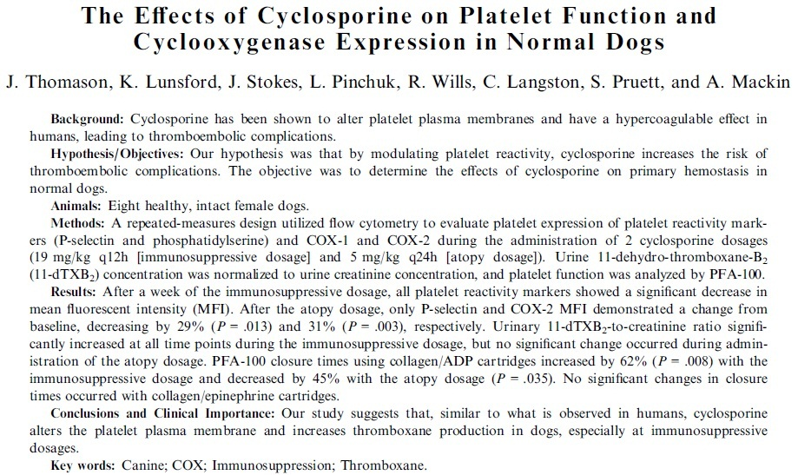
- On humans cyclosporine may increase plt reactivity and possibility of thrombus formation
- 8 FI Walker hounds, one dropped out before atopy dosing b/c of pyometra
  - Immunosupressive dose 10 mg/kg BID x 7d, checked levels on day 4 – none at immunosuppressive levels so increased dose but did not recheck levels
  - Two week washout, then atopy dose of 5 mg/kg SID x 7d
  - Dogs sampled days 1 and 7 of each treatment at both peak and trough times
- @ immunosuppressive dose: decreased P-selectin, plt phosphatidylserine, decreased plt COX-1 expression, decreased plt COX-2 expression, increased urinary 11-dTXB₂ thromboxane levels, prolonged PFA-100 closure time with collagen/ADP cartridge
- @ atopy dose: decreased P-selectin at trough times, decreased plt COX-1 expression at peak times, decreased plt COX-2 expression, shortened PFA-100 closure time with coll/ADP cartridge
- Concerns:
  - The duration of treatment was not long enough to achieve immunosuppression, are these changes reflective of what truly happens
  - Weird signalment to choose (Walker hounds?)
  - Did they ever achieve an immunosuppressive dose
  - Some values did not return to baseline levels between groups (adequate wash out?)
  - IF both COX down regulated, where did the thromboxane come from? Other sources?

Pulmonary abnormalities in dogs with renal azotemia
Le Boedec, etal. JVIM 2012; 26: 1099-1106.
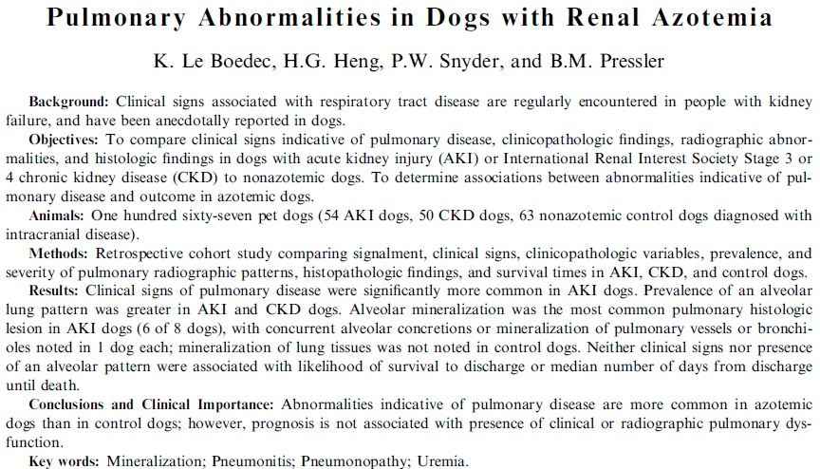
- Humans w/ uremic pneumonitis develop high-protein edema with, connective tissue proliferation, pulmonary hyaline membranes, and alveolar hemorrhage
  - Typically has butterfly or bat-wing appearance, primarily affecting right lung
  - Severity of resp dysfunction not associated with time until death
- Compared AKI, stage 3 or 4 CKD, and nonazotemia dogs with intracranial disease
- Radiographs reviewed blindly by a radiologist and patterns and severity assessed
- Dogs w/ AKI were more likely to have signs of pulmonary dysfunction than CKD or controls (54% of AKI dogs, 26% of CKD dogs, and 14% of control dogs)
- Alveolar pattern was more common in dogs with AKI or CKD vs control
  - Not related to disease severity
  - Most often affected left caudal lung lobes in AKI, and cranial lung lobes in CKD
- Presence of pulmonary disease was not associated with survival to discharge
- Most common histopath was alveolar mineralization in AKI dogs
- Concerns:
  - Intracranial disease can cause neurogenic pulm edema
  - Didn’t adequately rule out other causes of lung disease in all cases– fluid overload, CHF, pneumonia

Efficacy of pimobendan in the prevention of congestive heart failure or sudden death in Doberman pinschers with preclinical dilated cardiomyopathy (The PROTECT Study)
Summerfield et al. JVIM 2012; 26: 1337-1349.
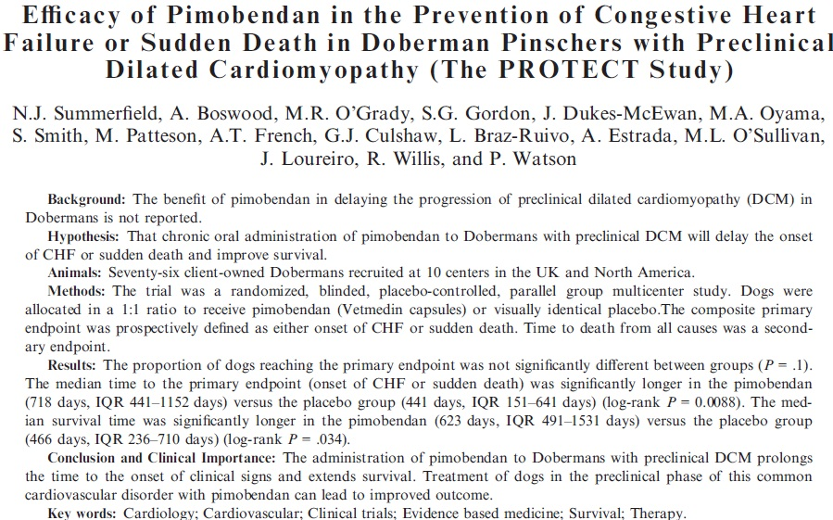
- Dobermans with echo changes consistent with DCM but no clinical signs (significant arrhythmia, syncope, CHF)
  - Screened 1000 dogs to enter 76 into the study
- Prospective, randomized, placebo-controlled study – received pimobendan vs control
- Primary endpoint was CHF or sudden death due to cardiac causes
- Dogs on pimo had a significantly longer time to primary endpoint – 718 vs 449 days
  - Hazard ratio 0.299 (CI 0.153-0.585)
- Dogs with greater LVIDSN, LVIDDN, higher HR on exam, presence of any arrhythmia on a resting ECG, greater than 4 VPCs on a resting ECG, and greater numbers of VPCs on Holter monitor had increased hazard ratio of reaching primary endpoint
- Dogs on pimo had significant decrease in LVIDS and LIVDD on recheck echo @30d vs control
- Pimo not associated with increased risk of arrhythmias or adverse drug reactions
- LVIDSN – left ventricular internal diameter in systole normalized for body weight
- LVIDDN – left ventricular internal diameter in diastole normalized for body weight

