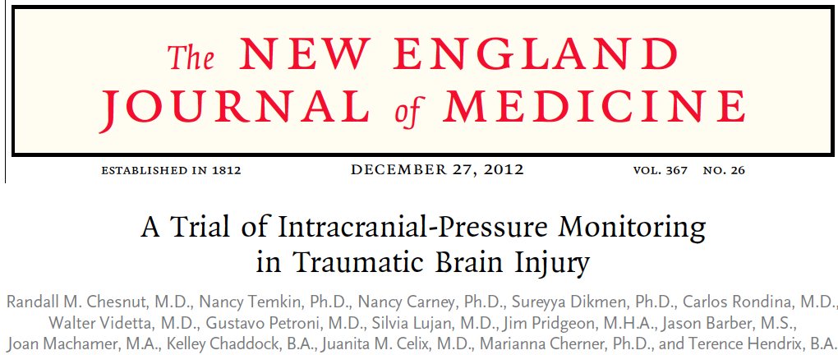
Abstract
Background
Intracranial-pressure monitoring is considered the standard of care for severe traumatic brain injury and is used frequently, but the efficacy of treatment based on monitoring in improving the outcome has not been rigorously assessed.
Methods
We conducted a multicenter, controlled trial in which 324 patients 13 years of age or older who had severe traumatic brain injury and were being treated in intensive care units (ICUs) in Bolivia or Ecuador were randomly assigned to one of two specific protocols: guidelines-based management in which a protocol for monitoring intraparenchymal intracranial pressure was used (pressure-monitoring group) or a protocol in which treatment was based on imaging and clinical examination (imaging–clinical examination group). The primary outcome was a composite of survival time, impaired consciousness, and functional status at 3 months and 6 months and neuropsychological status at 6 months; neuropsychological status was assessed by an examiner who was unaware of protocol assignment. This composite measure was based on performance across 21 measures of functional and cognitive status and calculated as a percentile (with 0 indicating the worst performance, and 100 the best performance).
Results
There was no significant between-group difference in the primary outcome, a composite measure based on percentile performance across 21 measures of functional and cognitive status (score, 56 in the pressure-monitoring group vs. 53 in the imaging–clinical examination group; P = 0.49). Six-month mortality was 39% in the pressure-monitoring group and 41% in the imaging–clinical examination group (P = 0.60). The median length of stay in the ICU was similar in the two groups (12 days in the pressure-monitoring group and 9 days in the imaging–clinical examination group; P = 0.25), although the number of days of brain-specific treatments (e.g., administration of hyperosmolar fluids and the use of hyperventilation) in the ICU was higher in the imaging–clinical examination group than in the pressure-monitoring group (4.8 vs. 3.4, P = 0.002). The distribution of serious adverse events was similar in the two groups.
Conclusions
For patients with severe traumatic brain injury, care focused on maintaining monitored intracranial pressure at 20 mm Hg or less was not shown to be superior to care based on imaging and clinical examination.
Key points
- No difference in primary outcome between patients managed by pressure target vs physical exam and imaging (which was a composite of 21 variable consisting of survival as well as neurologic function variables)
- Significantly higher use of osmolar agents in the PE-imaging group, significantly more barbituates in the pressure monitoring group
- Significantly shorter hospital stay in the physical exam-imaging group
Questions
- The use of ventriculostomy catheter carries benefit of which over the use of parenchymal catheters
  - Ease of insertion
  - Easy catheter maintenance
  - Accuracy
  - Allows for ventriculocentesis
- T/F: the use of pressure monitoring significantly reduced the length of stay

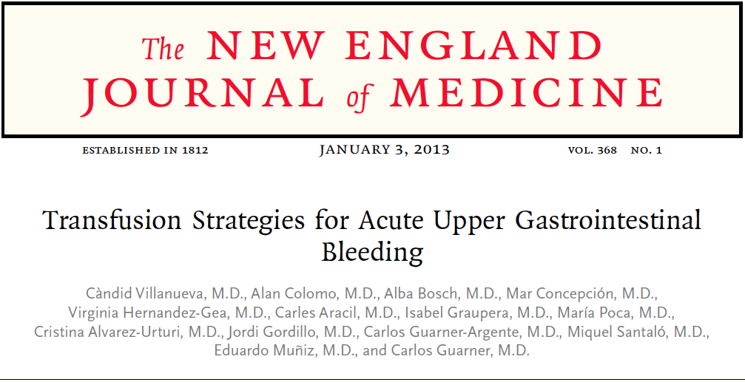
Abstract
Background
The hemoglobin threshold for transfusion of red cells in patients with acute gastrointestinal bleeding is controversial. We compared the efficacy and safety of a restrictive transfusion strategy with those of a liberal transfusion strategy.
Methods
We enrolled 921 patients with severe acute upper gastrointestinal bleeding and randomly assigned 461 of them to a restrictive strategy (transfusion when the hemoglobin level fell below 7 g per deciliter) and 460 to a liberal strategy (transfusion when the hemoglobin fell below 9 g per deciliter). Randomization was stratified according to the presence or absence of liver cirrhosis.
Results
A total of 225 patients assigned to the restrictive strategy (51%), as compared with 65 assigned to the liberal strategy (15%), did not receive transfusions (P<0.001). The probability of survival at 6 weeks was higher in the restrictive-strategy group than in the liberal-strategy group (95% vs. 91%; hazard ratio for death with restrictive strategy, 0.55; 95% confidence interval [CI], 0.33 to 0.92; P = 0.02). Further bleeding occurred in 10% of the patients in the restrictive-strategy group as compared with 16% of the patients in the liberal-strategy group (P = 0.01), and adverse events occurred in 40% as compared with 48% (P = 0.02). The probability of survival was slightly higher with the restrictive strategy than with the liberal strategy in the subgroup of patients who had bleeding associated with a peptic ulcer (hazard ratio, 0.70; 95% CI, 0.26 to 1.25) and was significantly higher in the subgroup of patients with cirrhosis and Child–Pugh class A or B disease (hazard ratio, 0.30; 95% CI, 0.11 to 0.85), but not in those with cirrhosis and Child–Pugh class C disease (hazard ratio, 1.04; 95% CI, 0.45 to 2.37). Within the first 5 days, the portal-pressure gradient increased significantly in patients assigned to the liberal strategy (P = 0.03) but not in those assigned to the restrictive strategy.
Conclusions
As compared with a liberal transfusion strategy, a restrictive strategy significantly improved outcomes in patients with acute upper gastrointestinal bleeding.
Key points
- Restrictive transfusion strategies result in decreased mortality compared to liberal strategies in all patients as well as after adjustment for baseline characteristics
- Restrictive transfusion strategies resulted in lower risk of further bleeding compared to liberal strategies
- Restrictive transfusion strategies resulted in shorter hospital stays than liberal transfusion strategies
- Liberal transfusion results in significantly higher mean hepatic venous pressure gradients compared to restrictive strategies
Questions
- The rockall score refers stratifies patients with
  - Liver cirrhosis
  - Risk of bleeding
  - Gastrointestinal bleeding
  - AKI
- Increased bleeding in patients with GI hemorrhage with transfusion is thought to be due to
  - Improved coagulation
  - Increased splanchnic blood flow
  - Decreased portal vein pressures
  - Dissecting of varicies in the GI structures

