Guyton Ch 9: Heart Muscle; The Heart as a Pump and Function of the Heart Valves

The heart is a wonderful organ and a well-oiled machine. The heart, aside from its emotional aspects, works as a system of pumps. The right heart receives blood from the periphery and peripheral organs and then pumps this blood through the lungs. The left heart then receives this freshly oxygenated blood and delivers it to the peripheral organs once again. Each atrium is a weak primer pump for the ventricle, helping to move blood into the ventricle. The ventricles then supply the main pumping force that propels the blood either through the body.

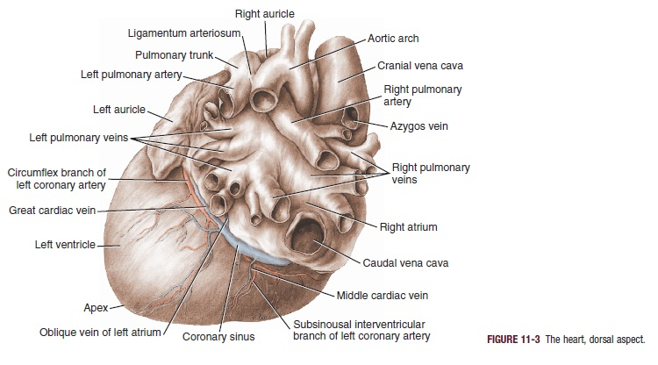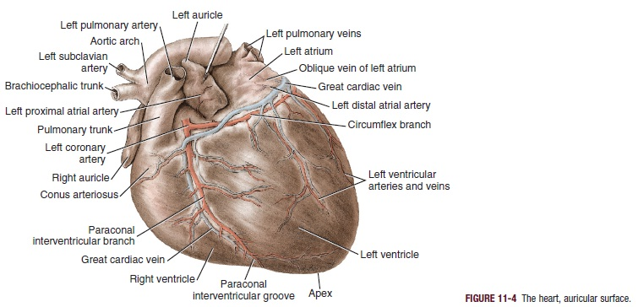
- Cardiac muscle is striated in the same manner as in typical skeletal muscle. It also has typical myofibrils that contain actin and myosin filaments almost identical to those found in skeletal muscle; these filaments lie side by side and slide along one another during contraction in the same manner as occurs in skeletal muscle

- Cardiac muscle is a syncytium; interconnected by the branching nature of the striated cardiac muscle cells, allowing easy travel of action potentials between cells. Atrial and ventricular syncytium exists, which are separate. Allows for atrial contraction to occur prior to ventricular contraction

Muscle types:
- Atrial muscle: functions much as skeletal muscle except for longer duration of contraction
- Ventricular muscle: functions much as skeletal muscle except for longer duration of contraction
- Specialized (excitatory and conductive muscle fibers): contract feebly (some may say pathetic), exhibit automatic rhythmical electrical discharge in the form of action potentials or conduction of action potentials through the heart which provides an excitatory system that controls rhythmical beating of the heart.

- AV bundle : specialized conductive system that connects the electrical signaling of the atria and ventricles

Action potential
- Resting membrane potential is -85(90)mV
- Maximum +20mV during beat
- After initial spike the membrane remains depolarized for about 0.2sec (plateau) followed by abrupt repolarization
- This allows ventricular contraction to last as much as 15x longer than skeletal muscle
- The individual fibers are separated by membranes, but depolarization spreads radially through them as if they were a syncytium because of the presence of gap junctions

- The transmembrane action potential of single cardiac muscle cells is characterized by rapid depolarization (phase 0), an initial rapid repolarization (phase 1), a plateau (phase 2), and a slow repolarization process (phase 3) that allows return to the resting membrane potential (phase 4)

- Two channels: fast sodium (as in skeletal muscle) and slow calcium-sodium
- The initial depolarization is due to Na+ influx through rapidly opening Na+ channels (the Na+ current, INa)
- The “slow” channels are responsible for the plateau (slower to open, open longer)
- The inactivation of Na+ channels contributes to the rapid repolarization phase

- Calcium ions that enter during the plateau phase activate the muscle contractile process
- Ca2+ influx through more slowly opening Ca2+ channels (the Ca2+ current, ICa) produces the plateau phase

- After onset of action potential, permeability of cardiac muscle to K+ ions decreases result is to greatly decrease the eflux of positively charged K ions, delaying the repolarization
- When the slow channels close, K+ permeability increases, causing rapid depolarization

- Refractory period of cardiac muscle - Ventricle: 0.25 to 0.30 seconds
- Relative refractory period of 0.05sec during which the muscle is more difficult to excite but can be excited
- Atrial refractory period is shorter than ventricle

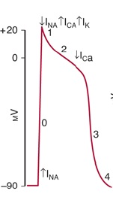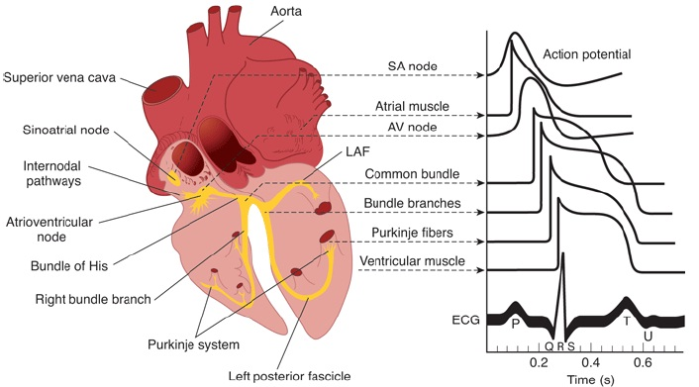

Excitation/contraction coupling is the mechanism by which the action potential causes the myofibrils of muscle to contract
- When an action potential passes over the cardiac membrane it spreads out to the interior of the cardiac muscle fibers along the T tubules
- It triggers the release of Ca2+ from the lateral sacs of the sarcoplasmic reticulum next to the T tubules
- Depolarization of the T tubule membrane activates the sarcoplasmic reticulum via dihydropyridine receptors
(DHPR)
- DHPR are voltage-gated Ca2+ channels in the T tubule membrane
- In cardiac muscle, influx of Ca2+ via these channels triggers the release of Ca2+ stored in the sarcoplasmic reticulum (calcium-induced calcium release) by activating the ryanodine receptor (RyR)
- The RyR is a ligand-gated Ca2+ channel with Ca2+ as its natural ligand
- The DHPR that serves as the voltage sensor unlocks release of Ca2+ from the nearby sarcoplasmic reticulum via physical interaction with the RyR
- The released Ca2+ is quickly amplified through calcium-induced calcium release
- The calcium ions diffuse into the myofibrils and catalyze the chemical reactions that promote the sliding of actin and myosin filaments causing contraction.
- Second effect particular to cardiac cells: Extra calcium ions diffuses in the sarcoplasm from the T tubules themselves
- Ca2+ is reduced in the muscle cell by the sarcoplasmic or endoplasmic reticulum Ca2+ATPase (SERCA) pump
- The SERCA pump uses energy from ATP hydrolysis to remove Ca2+ from the cytosol back into the SR, where it is stored until released by the next action potential
- Once the Ca2+ concentration outside the reticulum has been lowered sufficiently, chemical interaction between myosin and actin ceases and the muscle relaxes

- T tubules are much wider than in skeletal muscle, and contain mucopolysaccharides that bind Ca++ ions.

