- Which of the following is a justification for beta blockade in arrhythmias?
  - Increased parasympathetic activity with sustained VT
    - Sympathetic activity contributes to disease
  - The role of cGMP with the causation of ischemia relate VF
    - This is cAMP
  - Tachycardia alone may contribute to triggered activity in some arrhythmias
  - Antifibrotic effects of beta blockade
- Which of the following arrhythmias is most likely to respond to beta blockade
  - Torsade de pointes
  - Ventricular tachycardia
  - Supraventricular tachycardia
  - Atrial standstill
- Which of the following is a contraindication for beta-blockade?
  - Pregnancy
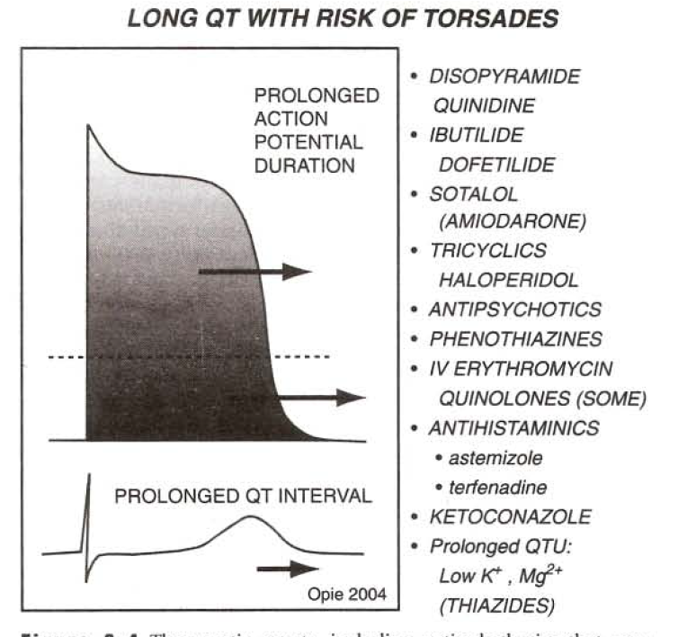
  - Bilateral renal arterial stenosis
  - Heart failure
  - AV block
- Which of the following drugs should co-administration of sotalol be avoided?
  - Acepromazine
  - Lidocaine
  - Benazepril
  - Lasix
- Amiodarone is predominantly
  - Class I
  - Class II
  - Class III
  - Class IV
- Intravenous amiodarone risks
  - Profound hypotension
  - Hypoglycemia
  - Lupus
  - Seizure
- List three cellular effects of adenosine
  - Opening of adenosine-sensative inward rectifier potassium channel
  - Inhibition of sinus node
  - Inhibition of AV node
- Please explain the diagnostic utility of adenosine
  - In the differentiation of etiology of wide-complex tachycardia, the administration of adenosine will stop tachycardias of supraventricular origin with minimal chance of a major adverse hemodynamic consequence in patients with VT. Additionally in patients with retrograde conduction VT, it will block the P wave. Also in differentiation of antegrade vs retrograde pre-excitation the administration of andenosine will cause a transient high-grade AV block in retrograde conduction and will cause a PR interval shortening/QRS widening with no AV block in anterograde conduction.

