Chapter Six: The peripheral vascular system
Cardiovascular transport
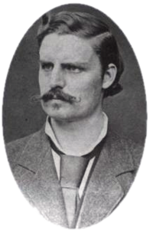
The Fick Principle
- Convective transport: mechanism by which substances are carried between organs within the CV system. Process of being swept along with the flow of the blood in which they are contained
- Transport rate (mass/time)=flow rate (volume/time) x concentration (mass/volume)
- Two methods available for altering rate a substance is carried to an organ
  - Change in blood flow rate through organ
  - Change in arterial blood concentration of substance
- Fick principle: extends convective principle to determine tissue’s rate of utilization/production of substance
  - Transcapillary efflux rate (mass/time)=blood flow rate (volume/time) x [arterial concentration –venous concentration]
  - X_{tc}=Q([X]_{a}-[X]_{v})
  - If tissue is producing substance that diffuses into the vascular space, equation will yield a negative utilization rate
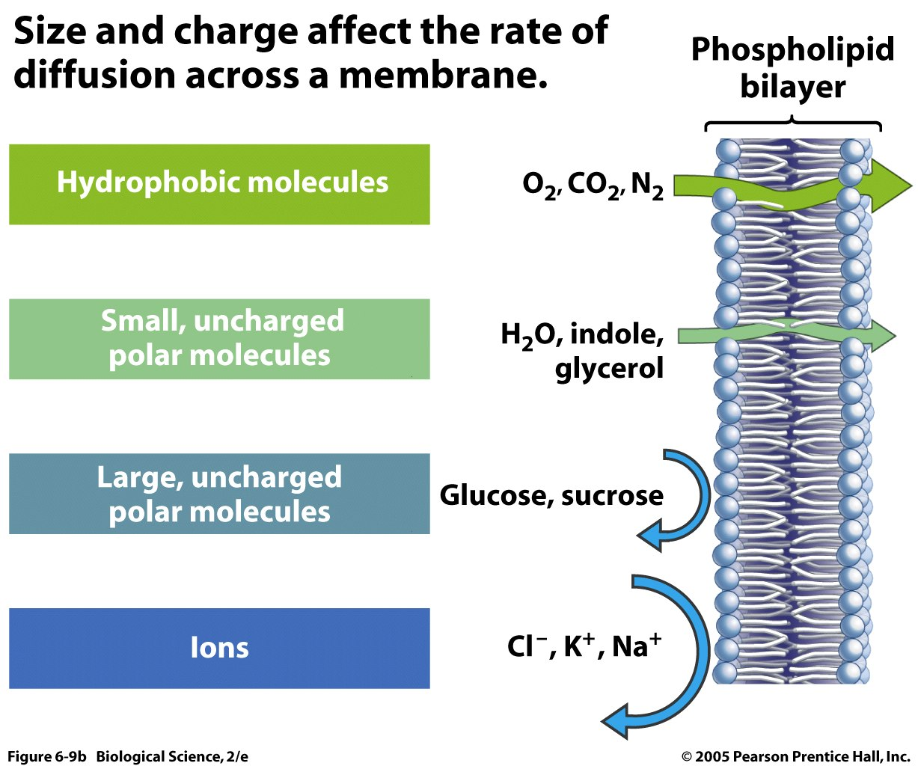
Transcapillary Solute Diffusion
- Diffusion is typically passive from high concentration to low concentration
- Determined by four factors:
  - Concentration difference
  - Surface area for exchange
  - Diffusion distance
  - Permeability of capillary wall
- Capillary beds maximize area and minimize diffusion difference
  - Consists of single thickness endothelial cells
  - Permeability is used to describe the ease w/ which solute crosses capillary wall
- Lipid soluble substances cross capillary wall easily
  - Can occur through the entire capillary surface area
- Small polar particles diffuse much less easily, postulated capillaries are somehow perforated at intervals with channels or pores
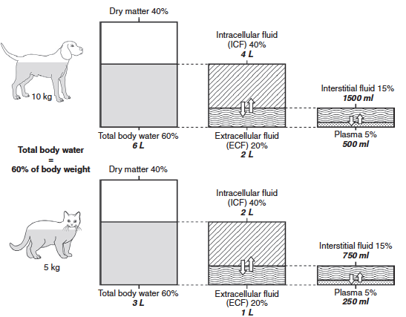
- Capillary permeability varies by tissue type-brain is tight and kidney is leaky
Endothelial cells
- Layer of endothelial cells lines entire cardiovascular system-including heart chambers and valves
- Contain enzymes that convert some circulating hormones from inactive to active forms
- Involved in producing substances leading to clot formation
- Produce vasoactive substances influencing arteriolar diameter
Transcapillary Fluid Movement
- Fluid shifts responsible for
  - Maintenance of blood circulating volume
  - Interstitial fluid formation
  - Tissue edema formation
  - Saliva, sweat and urine production
- Filtration: movement of fluid out of capillaries
- Reabsorption: movement of fluid into capillaries
- Hydrostatic and osmotic pressure influences transcapillary fluid movement
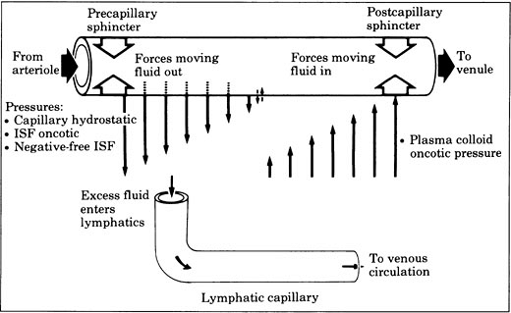
  - Osmotic pressure: the hydrostatic pressure necessary to prevent osmotic water movement into the test solution when it is exposed to pure water across a membrane permeable only to water
    - Proportional to the total number of solute particles in the solution
  - Oncotic pressure: portion of a solution’s total osmotic pressure due to particles that do not move freely across capillaries
  - Normal hydrostatic pressure: intracapillary 25 mmHg, interstitial 0 mmHg
  - Normal osmotic pressure: plasma 5000 mmHg
  - Normal oncotic pressure: plasma 25 mmHg, interstitial fluid 0 mmHg
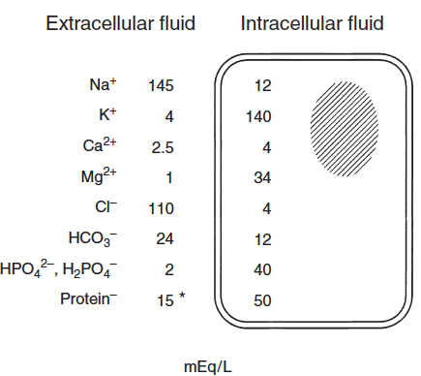
- Starling hypothesis: relationship among the factors that influence transcapillary fluid movement
  - Net filtration rate = K [(P_{c}-P_{i})-(π_{p}-π_{i})]
    - P=hydrostatic pressure of the intracapillary and interstitial fluid
    - π=oncotic pressure of the intracapillary and interstitial fluid
    - K=constant expressing how readily fluid can move across the capillary
Lymphatic system
- Represents a pathway by which large molecules reenter the circulating blood
- Begins in tissues w/ blind end lymphatic capillaries, similar in size to regular capillaries
  - Very porous and collect large particles and interstitial fluid with ease
- Lymph flow promoted by
  - Increased tissue interstitial pressure
  - Contractions of lymphatic vessels themselves
  - Valves prevent backward flow
Basic Vascular Function
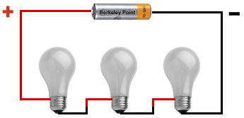
Resistance to flow in Networks of Vessels
- Can be interpreted by evaluated individual elements in a network and how they are connected
- Series orientation of resistance
  - R_{s}=R₁+R₂+…+R_{n}
  - R_{s} represents resistance in a series
  - Flow through this network would be Q=ΔP/R_{s}
  - Pressure drop across any element in the series can be calculated by applying basic flow equation to that element
    - Ie ΔP₁=QR₁
- Parallel orientation of resistance
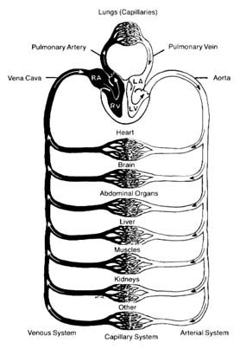
  - 1/R_{p}=1/R₁+1/R₂+….+1/R_{n}
  - Total flow would be Q= ΔP/R_{p}
  - Overall resistance will always be less than that of any element in the network
  - Generally the more parallel elements in a network, the lower the overall resistance of the network
Peripheral Blood Flow Velocities
- Blood flows most rapidly in the region w/ the smallest total cross-sectional area (the aorta) and most slowly in the region with the largest total cross-sectional area (capillary beds)
- Laminar flow
  - Most flow in CV system is laminar
  - Flow velocity is highest along central axis
  - Concentric layers of fluid with different velocities slip over one another
  - Little mixing occurs
  - Due to viscosity, blood exerts shear stress on walls of vessels
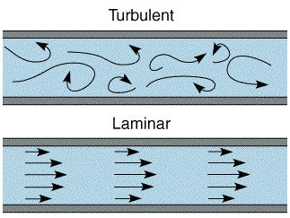
    - Proportional to the rate of flow through a vessel
    - Endothelial cells are able to sense shear stress and thus rate of blood flow
- Turbulent flow
  - When blood is forced to move with too high velocity through a narrow opening
  - Significantly increases resistance to flow
Peripheral Blood Volumes
- Peripheral venous pool: circulating blood pool within the veins of systemic organs-very large
- Central venous pool: circulating blood pool within the great veins of the thorax and right atrium-a bit smaller
- Constriction of peripheral veins results in displacement of peripheral pool to central pool
  - Increases central venous volume and pressure
  - Enhances cardiac filling
  - Augments stroke volume according to the Frank-Starling law of the heart
Peripheral Blood Pressures
- Blood pressure decreases in consecutive segments
  - Only a small drop of pressure is seen in the arterial system
  - Large pressure drop occurs in arterioles, and pulsatile nature of blood is nearly lost
  - Average capillary pressure is 25 mmHg
  - Central venous pressure is normally close to 0 mmHg
Peripheral Vascular Resistances
- Minimal decrease in the arteries
- Modest decrease in mean pressure in the capillaries
- Large chances in an organ’s blood flow are achieved by changes in its overall vascular resistance to blood flow
- Overall vascular resistance of organ must equal the sum of the resistances of consecutive vascular segments:
  - R_{organ}= R_{arteries}+R_{arterioles}+R_{capillaries}+R_{venules}+R_{veins}
  - Overall organ vascular resistance determined to large extent by the resistance of arterioles
    - Arteriolar resistance determined predominantly by its radius
  - Arteriolar constriction drops capillary and vein pressure while increasing arterial pressure
  - Arteriolar dilation increases organ blood flow and drops arterial pressure and increases capillary pressure
Total Peripheral Resistance
- Total peripheral resistance-overal resistance to flow through the entire systemic circulation
- Since organs are in parallel, 1/TPR=1/R_{organ1}+R_{organ2}+…+R_{organn}
Elastic Properties of Arteries and Veins
- Important to overall cardiovascular function b/c they act as reservoirs for substantial amounts of blood
- Compliance (C)= ΔV/ ΔP
- Arterial compartment at normal pressure (100mHg) compliance is about 2 mL/mmHg
  - Elastance allows them to act as a reservoir on a beat-to-beat basis
  - Increased volume during systole and decreased volume at end of diastole
- Venous compartment at normal pressure (5-10 mmHg) compliance is over 100 mL/mmHg
- Small changes in peripheral venous pressure can cause significant a amount of blood movement to or out of the peripheral venous pool
Determinants of Arterial Pressure
Mean Arterial Pressure
- Related to cardiac output and peripheral resistance
- MAP=CO X TPR, assuming that central venous pressure is approximately zero
- Calculating true mean requires averaging arterial pressure waveform over 1 or more complete heart beats
- Rule of thumb: MAP is approximately = to diastolic pressure plus 1/3 of difference between systolic and diastolic pressures
Arterial Pulse Pressure
- Defined as systolic pressure minus diastolic pressure
- Tends to increase with age
- Is also equal to approximately stroke volume divided by arterial compliance
- Minimally effected by changes in total peripheral resistance, as this causes parallel changes in both systolic and diastolic pressures

Questions
- Determine the net direction of fluid movement given the following data:
  - Plasma oncotic pressure: 8 mmHg
  - Interstitial oncotic pressure: 10 mmHg
  - Plasma hydrostatic pressure: 18 mmHg
  - Interstital hydrostatic pressure: 20 mmHg

- Which of the following would result with normal MAP but high pulse pressure?
  - Low stroke volume
  - High heart rate
  - Decreased peripheral resistance
  - Increased arterial stiffness
- Calculate an estimated mean arterial pressure from the following: systolic 140, diastolic 67

- What four factors will determine rate of diffusion?

- Calculate the transcapillary carbon dioxide flux w/ the following information:
  - Blood flow rate: 60 mL/min
  - P_{a}CO2: 35 mmHg
  - P_{MV}CO2: 47 mmHg

- Which of the following is the correct formula to determine compliance?
  - ΔP/ΔV
  - ΔQ/ΔR
  - ΔV/ ΔP
  - ΔR/ΔQ

