Chapter 85 Acquired Coagulopathies

- Thrombocytopenia and acquired coagulopathies are the most common hemostatic defects encountered in clinical practice
- Acquired coagulopathies include disease processes that delay or prevent fibrin clot formation or increase the rate of fibrinolysis
Synthetic Failure
- The liver is the sole or primary source of all the serine protease coagulation factors and anticoagulants (factors II, VII, IX, X, XI, XII, proteins C and S) and other critical hemostatic proteins including factors V, XIII, antithrombin, and plasminogen
- Liver failure typically manifests as a hemorrhagic diathesis
- Liver failure results in quantitative factor deficiency
- Factor VII goes first with a half-life of 6 hours
- Plasma fibrinogen is often normal or elevated in patients with inflammatory and cholestatic disease
- Diseased hepatocytes may produce a dysfunctional fibrinogen that impairs fibrin formation
and polymerization
- The development of hypofibrinogenemia in patients with liver disease is an indicator of severity and associated with poor prognosis
Activation Defects
- Vitamin K dependent factors require the addition of gamma - carboxyglutamic acid residues in order to interact with calcium, bind to membrane surfaces, and form active enzyme complexes
- Vitamin Kparticipates in the carboxylation reaction through oxidationof vitamin K hydroquinone to vitamin K epoxide
- This epoxide form of vitamin K is continuallyrecycled to replenish KH 2 by the enzyme vitamin K epoxide reductase
Factor Consumption/ Dilution
- Hemorrhage does not result in factor deficiency in animals with normal liver function
- Many snake venoms contain proteases that activate clotting factors and directly cleave fibrinogen, resulting in systemic factor depletion and defibrination in a consumptive process
- Dilutional hemostatic defects are common after aggressive fluid resuscitation or massive transfusion
- Activation of coagulation secondary to trauma – induced tissue factor expression also leads to factor consumption

Coagulation Inhibitors
- Antibodies directed at particular coagulation factors
- The term “ lupus anticoagulant ” was formerly usedto describe antibodies that prolong in vitro clottingtimes by blocking the interaction of coagulation factors with phospholipid reagents
Fibrinolysis Defects
- Accelerated fibrinolysis causes hemorrhage by degradingfibrin clots before vascular repair is complete
- Hyperfibrinolysis, mediated by high tissue plasminogen activator develops in people infected withRocky Mountain spotted fever
- Neoplasia is associatedwith hyperfibrinolysis due to specific elaboration ofplasminogen activators by tumor cells or DIC
- The prostate and uterus are rich int - PA and urokinase plasminogen activators
- Surgery onthese organs risks hemorrhagic complications due to local hyperfibrinolysis and impaired intra - and post -operative hemostasis
Point of care testing
- Activated clotting time is useful in detecting abnormalities of the intrinsic and common pathways
- Thromboelastography is helpful in diagnosis of hypocoaguable and hyperfibrinolytic states
- Activated partial thromboplastin time (aPTT),prothrombin time (PT), thrombin clotting time (TCT)and fibrinogen concentration are basic screening tests for coagulopathies
- Theassays are functional tests, configured with specificreagents that sequentially activate distinct series ofcoagulation factors (i.e. aPTT and PT) or with athrombin - containing reagent that directly transformsplasma fibrinogen to fibrin (i.e. TCT and fibrinogen)
- Factor deficiencies are detected by prolongation of clotting times
- 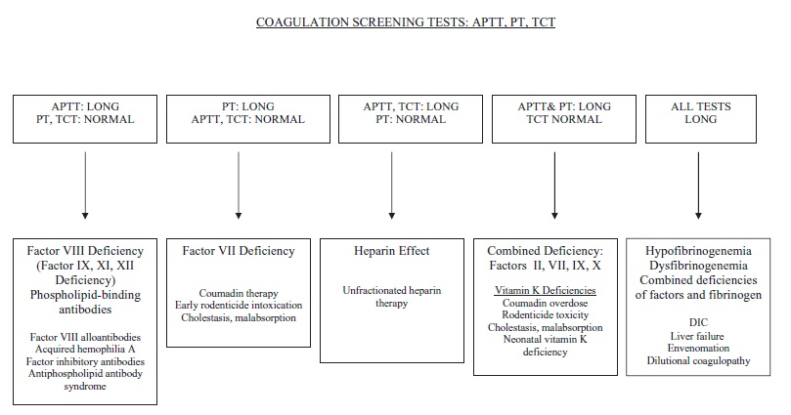
Liver disease
- Liver disease causes major alterations inmany hemostatic mechanisms, including platelet and endothelial cell reactivity, procoagulant and anticoagulant protein production and function, dysregulation of fibrinolysis, and complications arising from portalhypertension and splenomegaly
- Clinically severehemorrhage is generally seen in animals with fulminantor end - stage hepatic failure
- Measurement of protein C activity may be useful as abiomarker of liver function and hepatoportal blood flow in dogs
- Low protein C activityhelps differentiate porto - systemic vascular anomalies from microvascular dysplasia
- It is also a useful predictorof clinical outcome
- Pre - operative vitamin K 1 administrationis indicated for animals with cholestatic disorders (0.5-1.0mg/kg SC) and/or prolonged aPTT and PT
Vitamin K deficiency
- Vitamin K deficiency results from inadequate intestinal absorption or impaired intrahepatic recycling
- Biliary obstruction,intrahepatic cholestasis, chronic oral antibioticadministration, and infiltrative bowel disease may allreduce vitamin K absorption
- Coumadin and second - generation anticoagulant rodenticides act by irreversibly blocking the activity of epoxide reductase
- Factor deficiencyand resultant signs of a bleeding diathesis develop overa period of several days post - ingestion of anticoagulantpoisons as vitamin K stores become depleted
- Management of vitamin K deficiency requires replacementtherapy with vitamin K 1
- Synthesis of sufficient activefactors to correct the coagulopathy requires at least 12hours from the start time of initiating vitamin K supplementation
Dilutional Coagulopathy
- Hemostatic defect that developsafter high volume fluid resuscitation
- Traumatic coagulopathyoccurs in up to 1 of 4 human trauma patientsand is considered a negative prognostic indicator
- Correction of hemostatic abnormalities is associatedwith improved survival in people
Coagulation Inhibitors
- Underlying conditions associated withacquired factor VIII inhibitor development include systemic lupus erythematosus, rheumatoid arthritis, drug hypersensitivity, inflammatory bowel disease, malignancy,and the post - partum state
- Unfractionated Heparin overdose as few clinical studies have beenperformed to define effective dosage regimens
- Clinical signs of hemorrhageor marked prolongation of aPTT (i.e. > 2.5 timesbaseline) are indications for discontinuing UFH therapy
- Due to its short (2 – 3 hour) plasma half - life, hemorrhageis usually transient
- People with major hemorrhage due to UFH over dosage are infused with protamine sulfate,a basic polypeptide that binds tightly to UFH andimmediately neutralizes its anticoagulant activity
- Protamine administration causes systemic hypotensionin dogs; therefore transfusion therapy is used to controllife - threatening hemorrhage caused by excessive UFHanticoagulant effect

