Chapter 8: Central Venous Pressure: an Indicator of Circulatory Hemodynamics
Interaction of system components
Components of the systemic cardiovascular circuit
- Circulatory system is closed circuit divided into functionally distinct components: heart, arteries, arterioles, capillaries, veins
  - Veins conceptually separated into two compartments: large, diverse peripheral section; smaller intrathoracic central section
Mean circulatory filling pressure
Compartment | Volume at zero pressure (mL) | Compliance (mL/mmHg) | Resistance (mmHg/L/min)
Ventricle, diastole | 30 | 24 | 0
Arteries | 600 | 2 | 1
Arterioles | 100 | 0 | 13
Capillaries | 250 | 0 | 5
Peripheral veins | 2500 | 110 | 1
Central veins | 80 | 4 | 0
Entire circuit | 3650 | 140 | 20
Table 1: Typical properties of major components of the human systemic CV circuit
- The pressure that would exist in a cardiovascular system in the absence of flow
- Determined by
  - Circulating blood volume
  - State of peripheral venous vessel tone
  - **since arterioles contain small relative volumes, arteriolar tone does not play major roles on filling pressures and arteries and capillaries don’t alter their volumes largely so they don’t either
- Flow-induced distribution of blood volume and pressure
  - Flow does not change total blood volumes or mean pressures
  - Can distribute some of the volume from venous to arterial side, thus increasing arterial pressure over mean and decreasing venous pressure below the mean circulatory filling pressure
Central Venous Pressure: an Indicator of Circulatory status
Defining central venous pressure
- Corresponds roughly to the volume enclosed by the right atrium and great veins in the thorax
- Venous return is the rate at which blood returns to the thorax from the peripheral vascular beds
  - Aka The rate at which blood enters the central venous compartment
  - In stable situations, venous return must equal cardiac output
Influence of central venous pressure on venous return
- As a group, the peripheral vasculature pressures are described as the peripheral venous pressure
- Peripheral venous pressure can be viewed essentially equivalent to the mean circulatory filling pressure
- A decrease in central venous pressure will lead to an increase in venous return up to a point
  - When central venous pressure falls below intrathoracic pressure, venous return will decrease due to pressure mediated collapse of the central veins
  - The venous function curve demonstrates an inverse, linear relationship between venous return and central venous pressure
Influence of peripheral venous pressure on venous return
- The difference in pressure between the peripheral and central venous compartments will determine venous return
  - An increase in peripheral pressure will be just as effective in increasing central venous pressure as a drop in central pressure
- Mechanisms of altering peripheral pressure
  - Change in volume
  - Change in tone
    - Increases seen with increased sympathetic vasoconstrictor tone
    - Increase in any force compressing veins from the outside
- Increases in blood volume or venous tone will shift the venous function curve to the right, vice versa with decreases
Determination of cardiac output and venous return by central venous pressure
Association of cardiac output and central venous pressure
- Central venous pressure is the filling pressure of the right heart, so strictly speaking this will affect only the stroke volume of the right heart pump
  - Cardiac output refers to the output of the left heart pump
  - In steady state, however, right and left sides of the heart have equal outputs
  - Changes in central venous pressure cause parallel changes to the filling pressure of the left side of the heart
- In normal patients, cardiac output proportionately below central venous pressure will eventually result in elevations of central venous pressure beyond peripheral venous pressure and transfer the added pressures back to the peripheral system
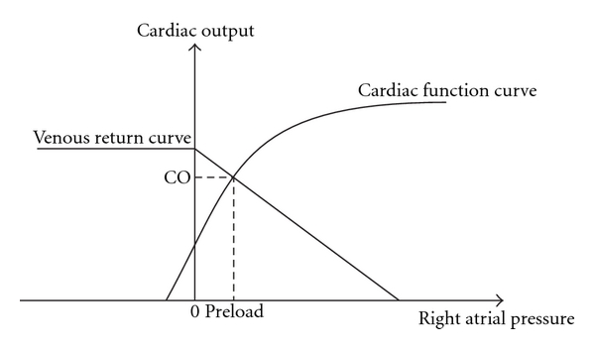
  - Therefore a state of equilibrium will eventually be reached
Figure 1
- Cardiac output can, therefore, be plotted alongside the venous function curve as depicted in figure 1
  - Cardiac output can be altered by mechanisms outside of increased preload
  - Alterations in cardiac output will therefore always be a result of altered cardiac function curve or altered venous function curve

Questions
- Discuss the importance of a relatively high compliance of the ventricle in diastole
  - Demonstrates how sensitive the ventricular end-diastolic volume (and thus stroke volume/cardiac output) is to small changes in cardiac filling pressure (and central venous pressure)
  - Cardiac filling pressure is crucial in determining the adequacy of cardiovascular system operations
- a. Using a graph, diagram the relationship between venous return and central venous pressure

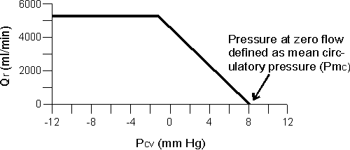
b. What effect should norepinephrine have on this curve (assuming all other physiologic mechanisms remain unchanged)?
Shift to the right

c. What effect should massive blood loss have on this curve (assuming all other physiologic mechanisms remain unchanged)?
Shift to the left

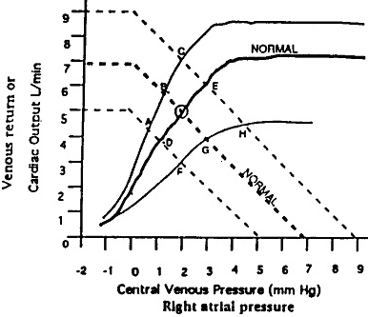
- Assuming all other values are equal, an increase in cardiac output not associated with an increase in preload, following a period of equilibration, will result in which of the following
  - No change to central venous pressure
  - Increased peripheral venous pressure
  - Decreased venous return
  - Increased mean circulatory filling pressure
- Now assuming normal physiologic response mechanisms are intact, diagrammatically depict the changes to the venous function curve/cardiac output curve immediately following and in response to hemorrhage (i.e. first draw the normal venous function curve and the normal cardiac output curve, then draw new curves depicting decreased cardiac output to be expected with hemorrhage, then draw curves which result in maintenance of a near normal cardiac output.) Also describe the physiologic mechanisms at work to shift these curves.

Immediately following hemorrhage there will be a significant left shift in the central venous pressure curve, which prior to any bodily response, the cardiac output curve should not change, so the intersection of the venous function curve with the cardiac output curve will depict the reduced cardiac output. Following response, the venous function curve should be right shift (though not to its original value) and the cardiac output curve should be left shifted to the point at which cardiac output will be near normal. The physiologic mechanisms are mainly through sympathetic stimulation to result in an increased venous tone and increased venous return. Sympathetic tone increase will also result in an increase in the contractility of the heart

- In regards to the venous function and cardiac function curves, how would be get an increased central venous pressure
  - Depressed cardiac function curve-ie dysfunctional heart muscle
  - Right shifted venous function curve-ie excessive fluid volume
- How about a decreased central venous pressure?
  - Elevated cardiac function curve-overexcessive cardiac function?
  - Left shift of the venous function curve-low blood volume or lack of venous tone

