Chapter 3 : Calcium Channel Blockers
Overview
- Act mainly through vasodilation and reduction of the peripheral vascular resistance
- Chemically classified into the dihydropyridines (DHPs) and the non-DHPs
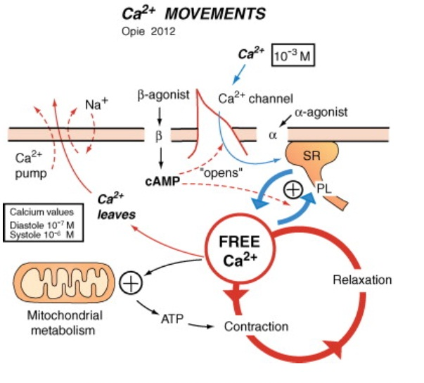
- Distinctions between the DHPs and non-DHPs are reflected in different binding sites on the calcium channel pores
- Non-DHPs, by virtue of nodal inhibition, reduce the heart rate
- The heart rate limiting CCBs have a prominent negative inotropic effect, and inhibit the sinus and the AV nodes
- These inhibitory cardiac effects are absent or muted in the DHPs( amlodipine)
- Amlodipine is very widely used in hypertension with proven outcome benefit in people
- Only the non-DHPs, verapamil and diltiazem, have antiarrhythmic properties by inhibiting the AV node
Mechanism of action
- All CCBs selectively inhibit the inward flow of charge-bearing calcium ions when the calcium channel becomes
- There are at least two types of calcium channels, the L and T
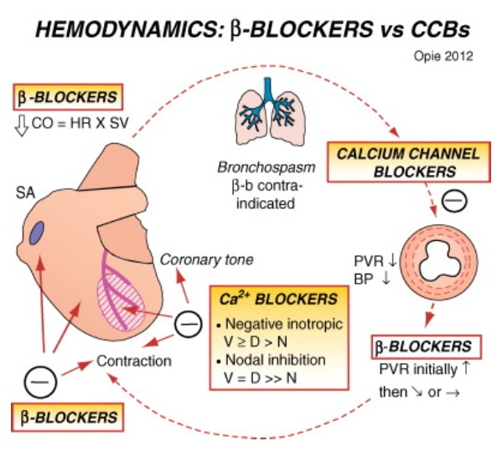
- The long-lasting opening calcium channel is termed the L-type channel, which is blocked by CCBs and increased in activity by catecholamines
- The function of the L-type is to admit the substantial amount of calcium ions required for initiation of contraction via calcium-induced calcium release from the sarcoplasmic
- The T-type (T for transient) channel opens at more negative potentials than the L-type and is important in the initial depolarization of the SA and AV nodal tissue
- In smooth muscle calcium ions regulate the contractile mechanism independently of troponin C
- Interaction of calcium with calmodulin forms calcium-calmodulin, which then stimulates myosin light chain kinase (MLCK) to phosphorylate the myosin light chains to allow actin-myosin interaction and, hence, contraction
- Cyclic adenosine monophosphate (AMP) inhibits the MLCK

Classification
Dihydropyridines
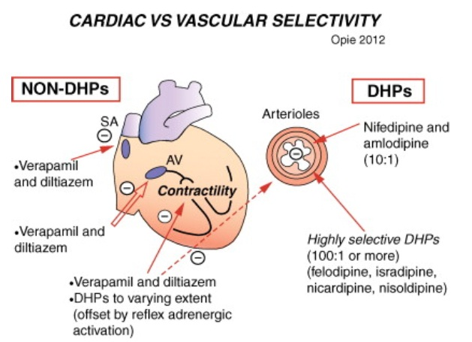
- The DHPs all bind to the same sites on the α1-subunit (the N sites), thereby establishing their common property of calcium channel antagonism
- They exert a greater inhibitory effect on vascular smooth muscle than on the myocardium, “vascular selectivity”
- The effects of DHPs on the sinoatrial (SA) and AV nodes are negligible
Nondihydropyridines: Heart rate lowering agents
- Bind to site on the α1-subunit of the calcium channel
- Acts on nodal tissue, being therapeutically effective in supraventricular tachycardias
- Decrease the sinus rate and inhibit myocardial contraction more than the DHPs/ are less vascular selective
- Along with the peripheral vasodilation, the inhibition of contraction leads to substantial reduction in the myocardial oxygen demand
Major indications for Calcium Channel Blockers
- Stable effort angina (or unstable as well) – not relevant
- Coronary spasm – not relevant
- Hypertension
  - CCBs are excellent antihypertensive agents, among the best for older adult and black patients(?). As effective as other antihypertensive classes. In hypertension with nephropathy, both DHPs and non-DHPs reduce the BP, which is the primary aim, but non-DHPs reduce proteinuria better
- Supraventricular tachycardia
  - Verapamil and diltiazem inhibit the AV node, which explains their effect in supraventricular tachycardias. Nifedipine and other DHPs are clinically ineffective
Specific Drugs
Verapamil
Pharmacokinetics :
- In dogs, verapamil is absorbed well (more than 90%) but undergoes extensive first pass hepatic metabolism, so bioavailability is only 10% to 23%
- Verapamil is metabolized to several active and inactive metabolites; most of the metabolites are excreted in the bile
- Half-life of verapamil is 1.8 to 3.8 hours in anesthetized experimental dogs, and the volume of distribution is 2.6 ± 1.0 L/kg
Indications:
- Verapamil is indicated for the acute termination of supraventricular tachycardia in the dog
- Literature suggests that verapamil may be effective for terminating accelerated idioventricular rhythm in patients in intensive care units and for treating digitalis-induced ventricular tachyarrhythmias
Administration and dosage:
- For the acute termination of supraventricular tachycardia, the intravenous dose ranges from 0.05 to 0.15 mg/kg
- Initial dose of 0.05 mg/kg should be administered over 1 to 2 minutes while the ECG is monitored, if this initial dose is not effective, the same dose should be repeated 5 to 10 minutes later
- If the arrhythmia still is not terminated, a last dose of 0.05 mg/kg (total dose = 0.15 mg/kg) should be administered 5 to 10 minutes after the second dose
- This dosage schedule is effective at terminating supraventricular tachycardia in approximately 85% of dogs
- For longer control, the initial bolus injections can be followed by a constant infusion of verapamil at 2 to 10 µg/kg/min
Toxicity:
- Verapamil can depress cardiac contractility and cause peripheral vasodilation and should not be used in patients with severe myocardial failure or patients in heart failure, unless hemodynamic monitoring can be done and immediate administration of calcium or catecholamines can be performed
Drug interactions:
- Verapamil and β-blockers should not be used together for several reasons: verapamil and β-blockers results in additive negative inotropic, chronotropic, and dromotropic (conduction properties) effects on the heart
- Profound myocardial depression, prolonged AV nodal conduction, and depressed heart rate, resulting in severe cardiovascular depression
- Verapamil can increase the bioavailability of some β-blockers by decreasing first pass hepatic metabolism
- Coadministration of verapamil and lidocaine to experimental dogs anesthetized with isoflurane produces profound cardiovascular depression and severe systemic hypotension
- Cimetidine decreases total body clearance of verapamil

