Chapter 102 : Hematopoietic Stem Cell Transplantation

- Hematopoietic stem cells vary in phenotype according to cell cycle stage
- Cell cycle dependent traits include in vivo engraftment, progenitor numbers, expression of adhesion proteins and cytokine receptors, and differentiation into megakaryocytes and granulocytes
Donor types
Allogeneic Transplantation
- Immunosuppressive therapy is required for allogeneic HSCT in order to suppress both host and donor responses
- Host immunosuppression is necessary for engraftment, whereas donor immunosuppression prevents graft versus host disease
- Graft versus host disease (GVHD)is one of the most significant hurdles to allogeneic HSCT
- It results from immune targeting of host cells by the donor T cells
- GVHD can be beneficial in some patients as they have greater affinity for leukemia cells “graft versus leukemia”
- Used for Lymphoma, leukemias, genetic diseases, autoimmune diseases, myelodysplasia
Syngeneic/Autologous Transplantation
- Autologous or syngeneic transplantation has no genetic incompatibility, which obviates the need for post - transplantation immune suppression, GVHD, and engraftment failure
- Has some efficacy in immune disorders and is thought to “reset” the immune system
Xenogeneic Transplantation
- The major obstacle to overcome is graft rejection
- Largely research based, except for some efficacy in AIDS patients
- May induce some tolerance of xenogenic organ transplantation
Bone Marrow
- Whole bone marrow is rarely used now
- Whole bone marrow affects engraftment and GVHD, now can be purified
- With purified HSC we can see poor engraftment from the depletion of T cells
- The poor engraftment following depletion of donor T cells to prevent GVHD can be reversed by increasing the dosage of CD34+ cells
- In veterinary medicine purified HSC are uncommon\
- Mesenchymal stromal cells are 100x less common in marrow than HSC
- They may have some immunomodulatory effects which enhance engraftment and are non-immunogenic
Sources
Bone Marrow
- Studies have shown that marrow derived HSCs have superior proliferative and reconstitutive ability compared with peripheral blood CD34+ cells, although these differences do not appear to have clinical significance
- Technically less demanding, no leukopharesis required
Peripheral blood
- Extravascular HSCs can be mobilized into the blood with the use of hematopoietic growth factors such as granulocyte colony stimulating factor and granulocyte macrophage colony stimulating factor
- Advantage over bone marrow is easy accessibility of large volumes of blood
Umbilical Cord blood
- A possibility for veterinary medicine in the future
- Little research at this time in animals
Transplantation
- In allogeneic HSCT, a related leukocyte antigen matched donor is ideal
- Recipient conditioning aims to augment or facilitate engraftment and prevention of GVHD
- Recipients may receive full body radiation +/- chemotherapy
- The incidence of GVHD has been decreased by augmenting a purine inhibitor (e.g. mycophenolate mofetil) with a T cell activation inhibitor (e.g. cyclosporine)
- HSC are given intravenously as they naturally go to the marrow

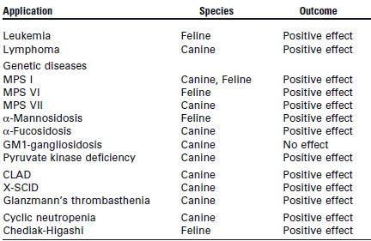

Questions
- What is the mechanism of action of cyclosporine
  - Inhibits T_{h} cells early in their immune response to antigenic stimuli
  - Inhibits dihydroorotate dehydrogenase, an enzyme responsible for the synthesis of pyrimidine
  - Decreases the expression of or blocks Fc receptors on macrophages
- Name the major breeds affected by pyruvate kinase deficiency
Basenjis, Beagles, WHWT, Cairn Terriers,
Lab, Pug

