Ch. 3 - The Heart Pump
Heart can be divided into LEFT and RIGHT pumps for the purpose of physiology.
The cardiac cycle is defined as one complete sequence of contraction and relaxation.
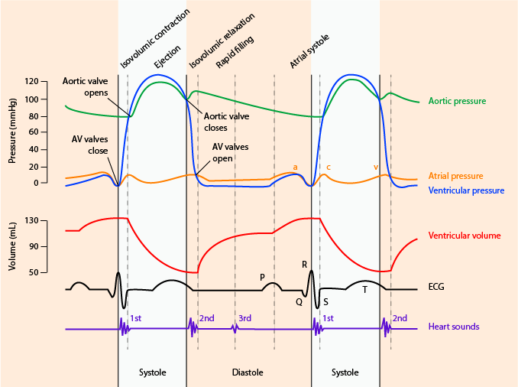
LEFT Pump
Ventricular diastole – begins with the opening of the AV valves
Mitral valve opens when LV pressure falls below LA pressure. This begins the period of ventricular filling. Blood from the atrium rapidly enters the ventricle (first passively due to the higher atrial pressures), causing rapid drop in the atrial pressure.
Atrial contraction – initiated near the end of ventricular diastole (correlates with the P wave of the ECG). Atrial filling not required at normal heart rates but plays significant role at higher rates.
Throughout diastole, atrial and ventricular pressures are nearly identical.
Ventricular systole – begins when the action potential represented by the QRS occurs.
AV valve closes – due to contraction of the LV leading to increased intraventricular pressure that rises above that of the atrium
Pressures in the LV continue to rise as contraction intensifies (isovolumetric contraction – fixed volume). Aortic valve opens when the LV pressure exceeds that of the aorta (end diastolic volume reached just before aortic valve opening).
Ventricular ejection begins with the opening of the aortic valve. Rapid ejection phase – early ejection from LV to aorta, driven by the higher LV pressure.
Peak systolic pressure – point of maximal muscle contraction. Aortic pressure begins to fall as blood travels further away from the heart.
Aortic valve closes when the intraventricular pressure falls below aortic pressure (ventricle has reached end-systolic volume). This causes abrupt closure of the aortic valve. Pressure tracings record this as a dicrotic notch (small volume of blood in aorta flows backward to fill the aortic valve leaflets as they close.
Isovolumetric relaxation – both AV and aortic valve close.
Atrial pressure progressively rises during ventricular systole.
Ultimately, intraventricular pressure falls below atrial pressure and the AV valve opens.
Systolic pressure – maximum pressure in the aorta/ventricle
Diastolic pressure – lowest aortic pressure, reached at end of diastole when the aortic pressure is at its lowest due to blow flow leaving aorta.
Pulse pressure – difference between systolic and diastolic pressures.
Heart spends approx. 2/3 in diastole, 1/3 in systole at a HR of ~70bpm.

RIGHT Pump
Mechanistically similar to the left pump, valve closure is synchronized.
Because the two sides of the heart are arranged in series they must have identical stroke volumes
Major difference – magnitude of peak systolic pressure is considerably lower in the right heart. Typical pulmonary artery systolic and diastolic pressures are 24 and 8 mmHg, respectively.
Pressure pulsations from RA are transmitted retrograde to the great vessels, and can be seen as a waveform on CVP tracings:
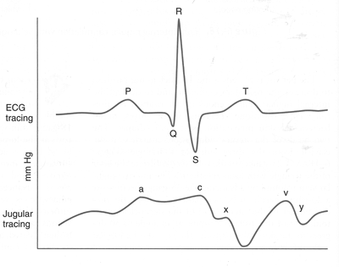

a wave: atrial contraction
c wave: tricuspic valve closure / onset of ventricular contraction
v wave: atrial filling / bulging of tricuspid valve

x descent: RA relaxation
y descent: RV relaxation, RA emptying

Heart sounds
S1 – first heart sound. Occurs at beginning of systole due to closure of the AV valves. Heard best at apex of the heart.
S2 – second heart sound. Closure of the aortic and pulmonic valves at the beginning of isovolumetric relaxation.
S3 and S4 are not normally present, if so produce gallop rhythms.
S3 gallop – ventricular gallop rhythm – may be present in LV failure
S4 gallop – atrial gallop rhythm – associated with atrial contraction and rapid active filling of the ventricle. Often indicates increased ventricular diastolic stiffness.

Cardiac cycle pressure-volume and length-tension relationships
Intraventricular pressure and volume are linked to the tension and length of the cardiac muscle cells in the ventricular wall. Cardiac muscle length-tension behavior is the underlying basis for ventricular function.
Each major phase of the ventricular cardiac cycle has a corresponding phase of cardiac muscle length and tension change.
During diastole – progressive increase in pressure increase in muscle tension.
End diastolic ventricular pressure = ventricular preload (it sets the end-diastolic ventricular volume and therefore the resting length of the cardiac muscle fibers at the end of diastole)
Systemic arterial pressure = Ventricular afterload (it determines the tension that must develop by cardiac muscle fibers before they can shorten)

Determinants of cardiac output
Cardiac output – L/min
CO = HR x SV
Variations in heart rate (sympathetic induced increased, parasympathetic induced decrease mediated thru the SA node)

Influences on stroke volume
Preload – the Frank Starling law of the heart
Stroke volume increases as cardiac filling increases (all other things being equal)

Cardiac function curves are used to show the influence of alteration of sympathetic activity. Basically increases of sympathetic input shifts curve up (increased cardiac output), decreases shift curve down (decreased cardiac output).

Summary of sympathetic neural influences on cardiac function:
- Increase in heart rate (positive chronotrophic effect)
- Decrease in cardiac action potential duration – minimizes the detrimental effect of high heart rate on diastolic filling time
- Increase in rate of action of potential conduction (positive dromotrophic effect)
- Increase in cardiac contractility (positive ionotrophic effect) – increases the contractile ability of cardiac muscle at any given preload
- Increase in rate of cardiac relaxation (positive lusitrophic effect) – helps minimize the detrimental effect of high hear rates on diastolic filling time

Energy sources
ATP – pool turns over every 10 seconds. Relies on constant supply. Adult heart – fatty acid oxidation, carbohydrates (glucose and pyruvate), fatty acids, triglycerides, ketones. Fetal: glucose and lactate. In heart failure, adult heart switches back to fetal metabolism.

Determinants of myocardial oxygen consumption
Basal metabolism – 25% of myocardial ATP (non contraction)
Muscle contraction – 75% of energy use (50% alone in isovolumetric contraction)
Effected by:
Myocardial contractility
Heart rate

Questions:

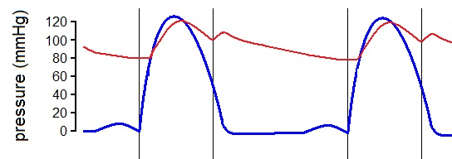
- Label the following on the drawing:
  - Diastole
  - Systole
  - Isovolumetric contraction
  - Isovolumetric relaxation
  - Systolic pressure
  - Diastolic pressure
  - Pulse pressure
  - Dicrotic notch
  - Closure of the aortic valve
  - Closure of the mitral valve

- Label the following on the CVP tracing:
  - Y descent
  - A wave
  - X descent
  - V wave
  - C wave

