Cardiovascular Disease in Small Animal Medicine
Chapter 4: Overview of Electrocardiography
Introduction
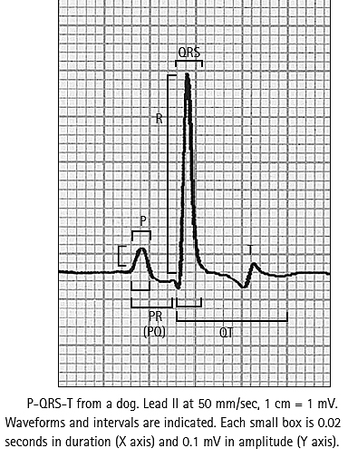
- The electrocardiogram (ECG) records the electrical activity of cardiac muscle from the body surface and provides information on heart rate, rhythm, and intracardiac conduction
- ECG findings may also suggest the presence of specific chamber enlargement, myocardial disease, ischemia, pericardial disease, certain electrolyte imbalances, and some drug toxicities
- The ECG does not record cardiac mechanical activity
- The normal cardiac rhythm originates in the sinoatrial (SA) node and follows the cardiac conduction pathway
- ECG waveforms, P-QRS-T , are generated as the heart muscle is depolarized and then repolarized
- The QRS complex represents electrical activation of ventricular muscle, regardless of whether individual Q, R, or S components, or variations thereof, are present or absent
ECG Lead System
- Several standard leads are used to evaluate cardiac electrical activity
- The orientation of a lead with respect to the heart is called the lead axis
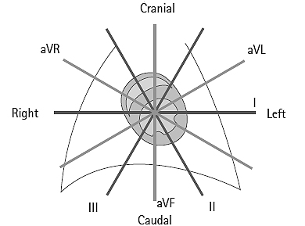
- If the direction of myocardial activation parallels the lead axis, a relatively large deflection will be recorded
- The ECG deflection is isoelectric when the activation wave is perpendicular to the lead axis
- A positive ECG deflection will be recorded if the cardiac activation wave moves toward the positive pole (electrode) of the lead
- The standard limb lead system records cardiac electrical activity in the frontal plane
- Left-to-right and cranial to caudal currents are recorded
Recording the ECG
- Animal is placed in right lateral recumbency on a nonconducting surface
- Forelimb electrodes are placed at or slightly below the elbows, not touching the chest wall or each other
- Hindlimb electrodes are placed at the stifles or hocks
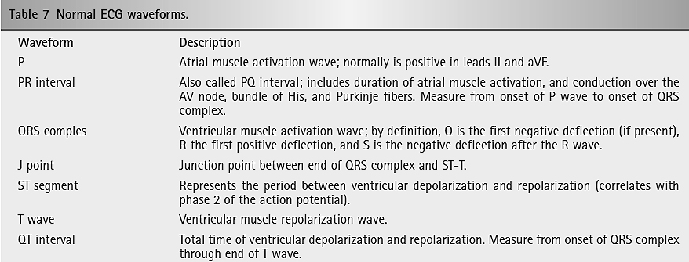
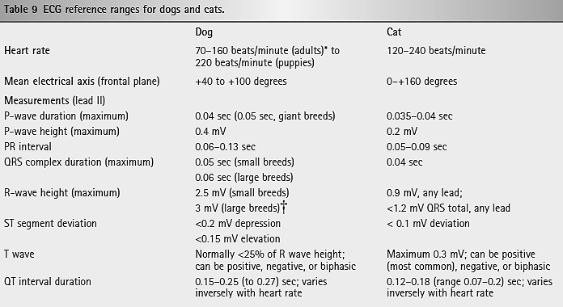
Cardiac Rhythm Assessment
- Sinus rhythm is the normal cardiac rhythm, manifested by the P-QRS-T waveforms
- The P waves are positive in the caudal leads (II and aVF), the PR (PQ) intervals are consistent, and the QRS to QRS intervals occur regularly, with less than 10% variation in timing
- Sinus arrhythmia is a normal variation
- Normal sinus-origin QRS complexes are narrow and upright in leads II and aVF
- Intraventricular conduction disturbance or ventricular enlargement can change this
Sinus arrhythmia
- This normal rhythm variation is characterized by a cyclic slowing and speeding of the sinus rate
- It is usually, but not always, associated with respiration
- With respiratory sinus arrhythmia, the sinus rate increases on inspiration and decreases with expiration as a result of fluctuations in vagal tone through the respiratory cycle
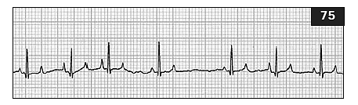
- The term ‘wandering pacemaker’ refers to a cyclic change in P wave configuration, related to a shift in pacemaker location, that may accompany sinus arrhythmia
- The P waves become taller and spiked during inspiration and flatter in expiration
- Sinus arrhythmia occurs commonly in dogs, especially brachycephalic breeds and exaggerated sinus arrhythmia occurs in some dogs with chronic pulmonary disease
Sinus arrest
- A pause in sinus activity lasting at least twice the duration of the patient’s usual QRS to QRS interval is known as sinus arrest
- Either an escape or resumption of sinus activity can follow

Abnormal Cardiac Rhythms
- Depolarizations originating from outside the sinus node are abnormal and cause an arrhythmia (dysrhythmia)
- Described by their site of origin and their timing, supraventricular (atrial, AV junctional) or ventricular
- Impulses of supraventricular origin are usually conducted through the ventricles via the normal conduction pathway, so their QRS is like that of sinus complexes
- The configuration of ventricular origin complexes reflects their abnormal pattern of conduction through the ventricular muscle
- Timing refers to premature or after a longer pause (late or escape)
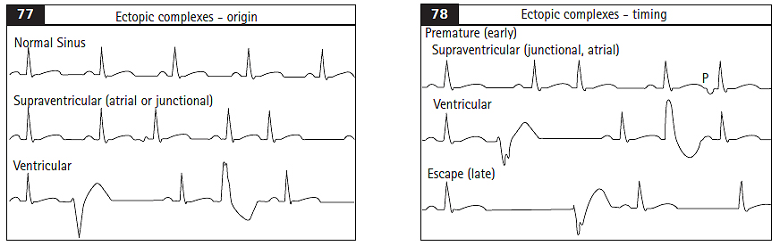
Premature supraventricular complexes
- Originate above the AV node
- Premature complexes that arise within the atria are usually preceded by an abnormal P wave
- Sometimes the premature impulse is conducted slowly or with a bundle branch block pattern
- Junctional complexes are usually not preceded by a P wave however, conduction backward into the atria can cause a negative P wave after, superimposed on, or even preceding the resulting QRS complex
- Supraventricular is used if it is unclear whether the origin of ectopic complexes is atrial or junctional
Atrial tachycardia
- Atrial tachycardia originates from an abnormal atrial focus or atrial reentry
- P waves are often hidden within the QRS-T complexes
- Atrial tachycardia is usually a regular rhythm unless the rate exceeds the AV node’s ability to conduct every impulse then AV block and irregular QRS intervals result
Reentrant supraventricular tachycardia
- Supraventricular tachycardia may involve a re-entrant pathway incorporating the AV node
- A premature supraventricular or ventricular impulse can initiate this tachycardia, which is maintained by impulses looping around the functionally divided AV node or the AV node and accessory pathway
- Persistent tachycardia eventually leads to myocardial failure

Atrial flutter
- Atrial flutter results from a single re-entrant wave of electrical activation regularly cycling through the atria, usually at >300–400 cycles/minute
- Ventricular response rate depends on AV conduction
- Sawtooth flutter waves, representing recurrent atrial activation, are seen between QRS complexes on the ECG
- Atrial flutter is not a stable rhythm; it often degenerates into atrial fibrillation
- Atrial enlargement is a common underlying factor
Atrial fibrillation
- Atrial electrical activation is rapid and chaotic because of multiple small reentrant circuits in AF
- AV node is bombarded by electrical impulses; AV conduction velocity and recovery time determine the HR
- No P waves are seen on ECG because no uniform atrial depolarization wave occurs
- baseline usually shows irregular undulations known as fibrillation (f) waves
- Most often the QRS complexes are normal in configuration because intraventricular conduction is normal
- Intermittent or sustained bundle branch blocks can occur
- Tends to be a consequence of severe atrial disease and enlargement in dogs and cat
- Sometimes, AF occurs spontaneously in giant breed dogs without evidence of underlying heart disease
Premature ventricular complexes
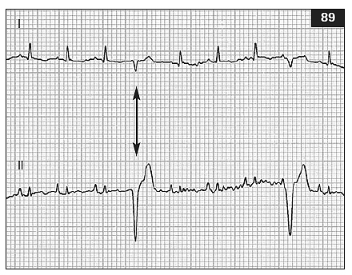
- Premature ventricular complexes (PVCs or VPCs) originating below the AV node have a different and usually wider QRS configuration compared with the patient’s sinus complexes
- VPC is followed by a ‘compensatory pause’ in the sinus rhythm
- When VPC configuration is consistent, the complexes are described as uniform, unifocal, or monomorphic
- When the VPCs in an individual have differing ECG configurations, they are said to be multiform or polymorphic
- Multiform VPCs (or ventricular tachycardia) may indicate greater electrical instability
Ventricular tachycardia
- Three or more sequential PVCs, generally at a rate >100/minute, constitutes ventricular tachycardia
- Nonconducted sinus P waves may be seen superimposed on or between the ventricular complexes
- Successful conduction of a sinus P wave into the ventricles, uninterrupted by another PVC, is known as a ‘capture beat’
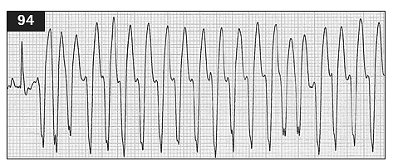
- If the normal ventricular activation sequence is interrupted by another VPC, a ‘fusion’ beat results
- Fusion complexes are preceded by a P wave and shortened PR interval
- Polymorphic ventricular tachycardia has QRS complexes that vary in size, polarity, and often rate
- Sometimes, the QRS configuration appears to rotate around the isoelectric baseline

Accelerated idioventricular rhythm
- Occurs at a rate of about 60–100 beats/minute
- Commonly observed in dogs recovering from motor vehicle trauma
- Clinically, the arrhythmia may cause no deleterious effects
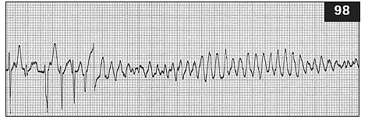
Ventricular fibrillation
- Characterized by multiple reentrant circuits causing chaotic electrical activity in the ventricles
- Ventricles have no coordinated mechanical activity and cannot function as a pump
- Ventricular asystole is the absence of ventricular electrical (and mechanical) activity
Escape complexes and rhythms
- Escape complexes occur after a pause in the dominant rhythm
- If sinus rhythm does not resume, the escape focus continues to fire at its own intrinsic rate
- Can originate from automatic cells in the atria, the AV junction, or the ventricles
- Ventricular escape rhythms usually occur at a rate <40–50 beats/minute in the dog and <100 beats/minute in the cat
- Junctional escape rhythms usually range from 40–60 beats/minute in the dog
Abnormal Cardiac Conduction
Atrioventricular (AV) conduction disturbances
- First-degree AV block is abnormally prolonged conduction from atria to ventricles, although all impulses are conducted
- Second-degree AV block is characterized by intermittent AV conduction; some P waves are not followed by a QRS complex
- Many nonconducted P waves constitute high-grade 2nd degree heart block
- Mobitz type I (Wenckebach) is characterized by progressive prolongation of the PR interval before a nonconducted P wave occurs
- Mobitz type II is characterized by uniform PR intervals preceding the blocked impulses and is more often associated with disease lower in the AV conduction system (bundle of His or major bundle branches)
- Third-degree or complete AV block is present when no sinus (or supraventricular) impulses are conducted into the ventricles
- P waves often indicate a regular sinus rhythm or sinus arrhythmia, the P waves are not related to QRS complexes, which result from a (usually) regular ventricular escape rhythm
Intraatrial conduction disturbances
- In atrial standstill, diseased atrial muscle prevents normal electrical and mechanical function regardless of sinus node activity
- P waves are absent
- Hyperkalemia interferes with normal atrial function and can mimic atrial standstill

Intraventricular conduction disturbances
- Slowed or blocked impulse transmission within any of the major bundle branches causes an intraventricular
- conduction disturbance (aberrant conduction)
- The region of ventricular muscle served by a diseased bundle branch is activated late and slowly, causes QRS widening and orientation of the terminal QRS forces toward the area of delayed activation
- The right bundle branch or the left anterior or posterior fascicles of the left bundle branch can be affected singly or in combination
- Right bundle branch block (RBBB) is sometimes identified in otherwise normal dogs and cats, although it can result from disease ordistension of the RV
- Left bundle branch block (LBBB) is usually related to clinically relevant underlying disease of the
- The left anterior fascicular block (LAFB) pattern is common with LV hypertrophy, such as in cats with hypertrophic cardiomyopathy

Ventricular preexcitation
- Early activation (preexcitation) of part of the ventricular myocardium can occur when an accessory conduction pathway bypasses the normal slow conducting AV nodal pathway
- Most cause a shortened PR interval
- When the accessory pathway lies outside the AV node (extranodal), there is early depolarization of the ventricle distant to where ventricular activation normally begins
- This causes early widening and slurring of the QRS by a so-called delta wave and is characteristic of Wolff–Parkinson–White(WPW) type preexcitation
Mean Electrical Axis
- Describes the average direction of the ventricular depolarization process in the frontal plane
- Summation of the various instantaneous vectors that occur from the beginning until the end of ventricular muscle activation
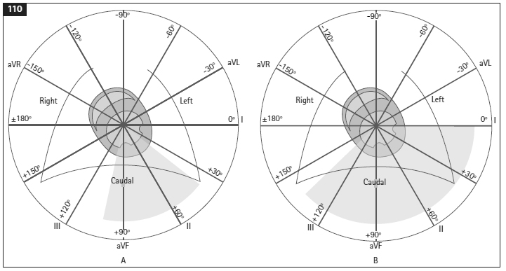

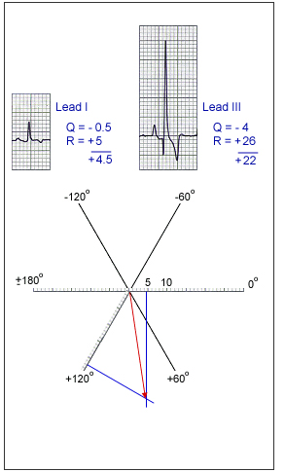
- MEA estimation:
  - Find the lead (I, II, III, aVR, aVL, or aVF) with the largest R, the positive electrode of this lead is the approximate MEA orientation
  - Find the lead (I, II, III, aVR, aVL, or aVF) with the most isoelectric QRS, identify the lead perpendicular to this lead. If QRS in this perpendicular lead is mostly positive, MEA is toward the positive pole of this lead. If the QRS in the perpendicular lead is mostly negative, the MEA is oriented toward the negative pole
  - The Vector Method: Using leads I, II or III and the frontal plane diagram, calculate the algebraic sum of the QRS deflections in any two leads (this does not include the P wave or the T wave). Let us for example consider using the complexes of leads I and III. Plot the algebraic sum of lead I on its axis on the frontal plane diagram. Similarly plot the algebraic sum of the QRS complex of lead III on its axis on the frontal plane diagram. Draw lines perpendicular to their respective axes at the points plotted on the lead axes I and III. Note the point of intersection of these two perpendicular lines. A line drawn from this intersect to the center of the diagram describes the MEA. See the example.

Cardiac Chamber Enlargement
Atrial Enlargement
- LA enlargement commonly prolongs the P wave duration (also known as ‘p mitrale’)
- RA enlargement may be manifest by tall, spiked P waves (‘p pulmonale’)
- Atrial enlargement also often magnifies the usually obscured atrial repolarization (Ta) wave
Right Ventricular enlargement
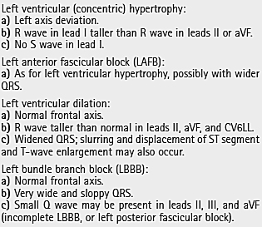
- Right axis deviation and an S wave in lead I are strong criteria for RV enlargement (or right bundle branch block) Other ECG changes can usually be found as: a) Right axis deviation b) S wave present in lead I c) S wave in V3 (CV6LL) larger than R wave or greater than 0.8 mV d) Q-S (W-shaped QRS) in V10 e) Positive T wave in lead V10 (except Chihuahuas) f) Deep S wave in leads II, III, and aVF
- Three or more of the criteria listed are generally present when marked RV enlargement exists
Left ventricle
- LV dilation and eccentric hypertrophy often increase R-wave voltage in the caudal leads (II and aVF) and may widen the QRS
- A complete LBBB or left posterior fascicular block pattern can mimic or accompany LV dilation
- LV concentric hypertrophy is inconsistently associated with left axis deviation (left anterior fascicular block pattern)

Other abnormalities
- In dogs, small voltage QRS complexes have been associated with pleural or pericardial effusions, obesity, intrathoracic mass lesions, hypovolemia, and hypothyroidism
- They are normal in cats
- Every other beat alteration in QRS complex size is known as electrical alternans and is most often associated with large volume pericardial effusions
ST-T abnormalities
- Elevation (>0.15 mV in dogs or >0.1 mV in cats) or depression (>0.2 mV in dogs or >0.1 mV in cats) of the J point (End of QRS) and ST segment in leads I, II, or aVF can be caused by ischemia or other myocardial injury
- Secondary ST segment deviation occurs with ventricular hypertrophy, aberrant conduction, and some drugs (e.g. digoxin)
The Q-T interval
- The QT interval represents the total time of ventricular activation and repolarization
- Autonomic nervous tone, various drugs, and electrolyte disorders influence the duration of the QT interval
- Inappropriate prolongation of the QT interval can facilitate development of serious re-entrant arrhythmias when the ventricular repolarization process is not uniform
Hyperkalemia
- Rapid or severe increases in serum potassium concentration can cause arrhythmias, mainly because of slowed conduction velocity and shortened refractory period
- Narrow and peaked (tented) T wave, beginning as serum K+ rises to near 6 mmol/l (6 mEq/l)
- P waves tend to flatten as serum K+ approaches 7mmol/l (7 mEq/l) and disappear above about 8mmol/l (8 mEq/l)
- Progressive QRS widening from slowing of intra-ventricular conduction also occurs as serum K+ risesabove 6mmol/l (6mEq/l)
- With severe hyperkalemia (>10 mmol/l [>10 mEq/l]) there may be activation of ectopic pacemakers, but eventually asystole occurs

Hypokalemia
- Hypokalemia can cause progressive ST segment depression, reduced T-wave amplitude, and QT interval prolongation
- Severe hypokalemia can also increase QRS and P-wave amplitudes and durations

Questions:

- Your colleague brings in his Bulldog after ausculting an abnormal rhythm. He runs the following ECG and brings it to you in tears.
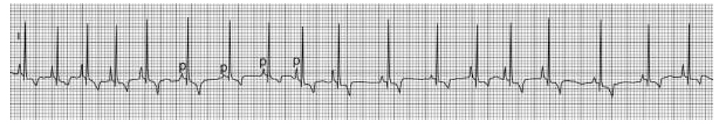
Lead II 25mm/s 1cm=1mV
Based on your rhythm diagnosis you tell him
- Probably just has an enalapril deficiency
- Chill out, this is normal
- Based on this ECG your dog has rabies and you should Ol Yeller it
- I think this ECG is upside down
What is your rhythm diagnosis:

- Evaluate the following two tracings for chamber enlargement
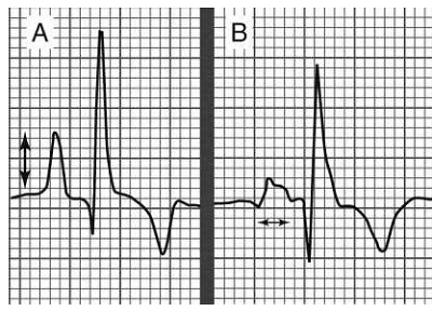
Lead II 50mm/s
1cm = 1mV

- A 4mo FI Miniature schnauzer presents to your clinic for a routine vaccination. On physical exam you auscult a systolic ejection murmur, with a point of maximal intensity near left cranial sternal border. You decide to run an ECG.
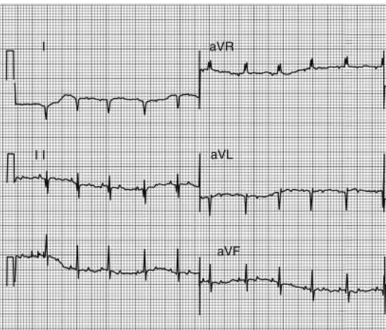
What is the MEA?
Based on the breed what is your most likely cause?
- In the following ECG what are the arrows pointing to and are they normal?
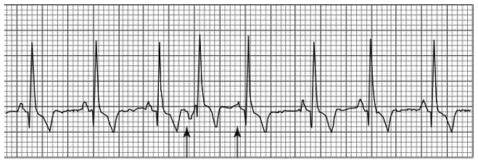
Given this what is the diagnosis?

- A dog walks into a bar your clinic because he ain’t doin’ right. You auscult what you feel is an irregularly irregular rhythm and record the following ECG.
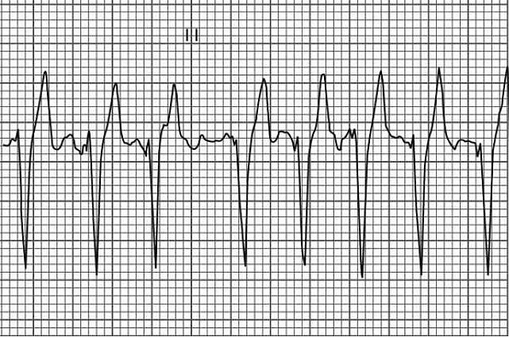
Lead II
25mm/s
1mm=1mV

You are a bit perplexed so you press on his eyes and his HR decreases. Based on this you have your answer to this tricky ECG, which is?

