Chapter 10: Cardiovascular Responses to Physiological Stresses
- Blood flow to the brain and the heart muscle is maintained in any circumstance
Effect of Respiratory Activity
- In normal inspiration intrathoracic pressure falls by about 7 mmHg as the diaphragm contracts and the chest wall expands
- Periodic pressure fluctuations not only promote air movement into and out of the lungs but also through veins in the thorax and influence venous return to the heart from the periphery
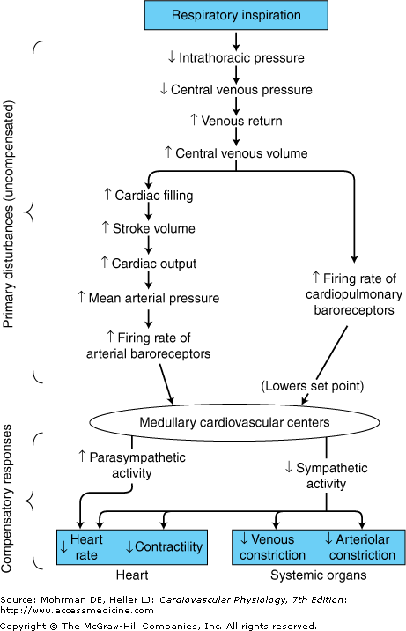
- The net effect is that venous return from the periphery is generally facilitated by the periodic by respiration, a phenomenon referred to as the "respiratory pump"
- Because of these changes in venous return, normal breathing is associated with transient cyclical changes in cardiac normal individuals also fluctuates in synchrony with the respiratory rate, "normal sinus arrhythmia"
- Filling of the right side of the heart is transiently increased during inspiration and, by Starling's law, stroke volume is transiently increased
- This will lead to a transient increase in firing of the arterial baroreceptors
- These baroreceptor inputs will act on the reflex adjustments to lower arterial pressure:, increase cardiac parasympathetic nerve activity and decrease sympathetic conditions
- The cyclic change in heart rate is the most apparent cardiovascular response to respiration
- When the lungs are inflated artificially, intrathoracic pressure goes up (rather than down, as occurs during normal inspiration)
- Positive pressure ventilation decreases venous return during lung expansion
- Intrathoracic pressure tends to compress the pulmonary microcirculation and this increases right ventricular afterload

Responses to Acute Exercise
- The specific alterations in cardiovascular function that occur during exercise depend on several factors
1) the type of exercise "dynamic" (rhythmic or isotonic) vs "static" (isometric)
2) the intensity and duration of the exercise
3) the age of the individual
4) the level of "fitness" of the individual

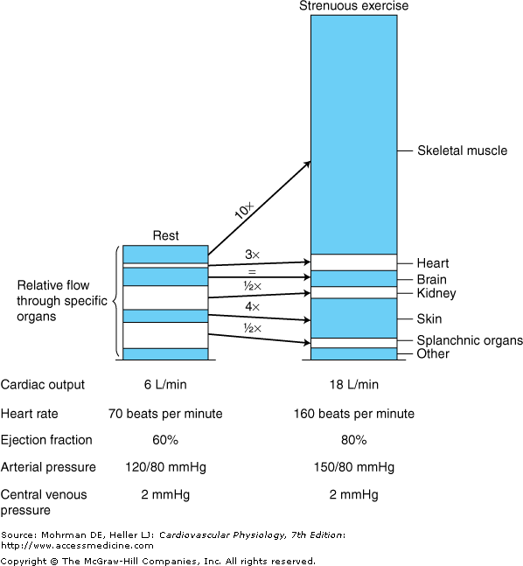
- Many of the adjustments to exercise are due to a large increase in sympathetic activity
- One of the primary disturbances associated with the stress of exercise originates within the cerebral cortex and exerts an influence on the medullary cardiovascular centers through corticohypothalamic pathways
- This set-point-raising influence, referred to as the "central command," causes mean arterial pressure to be regulated to a higher than normal level
- A second set-point-raising influence may reach the cardiovascular centers from chemoreceptors and mechanoreceptors in the active skeletal muscles
- A major primary disturbance on the cardiovascular system during dynamic exercise is the great decrease in total peripheral resistance caused by metabolic vasodilator accumulation and decreased vascular resistance in the active skeletal muscle
- Mean arterial pressure is above normal during exercise
- Decreased total peripheral resistance causes it to fall below the elevated level to which it would be regulated by the set-point-raising influences on the cardiovascular center alone
- The arterial baroreceptor reflex pathway responds to this circumstance with a large increase in sympathetic activity
- Increases in skeletal muscle and skin blood flow
- Coronary blood flow increases substantially during strenuous exercise, primarily due to local metabolic vasodilation of coronary arterioles as a result of increased cardiac work and myocardial oxygen consumption
- The skeletal muscle pump is important in promoting venous return during dynamic exercise preventing the reflex-induced increase in cardiac output from drastically lowering central venous pressure
- The respiratory pump promotes venous return during exercise; exaggerated respiratory movements that occur during exercise increase the effectiveness of the respiratory pump and thus enhance venous return and cardiac filling
Responses to Chronic Exercise
- Cardiovascular alterations associated with conditioning may include increases in circulating blood volume, decreases in the heart rate, increases in cardiac stroke volume, and decreases in arterial blood pressure at rest
- During exercise, a trained individual will be able to achieve a given workload and cardiac output with a lower heart rate and higher stroke volume
- These changes produce a general decrease in myocardial oxygen
Cardiovascular Changes during Pregnancy
- Pregnancy causes alterations in vascular structure and blood flow to many maternal organs in order to support growth of the developing fetus
- There is a nearly 50% increase in circulating blood volume
- The placenta, being a low-resistance organ added in parallel with the other systemic organs, reduces the overall systemic total peripheral resistance by approximately 40%
- At birth, the loss of the placenta contributes to the return of maternal total peripheral resistance back toward normal levels

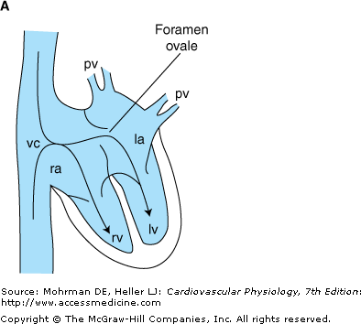
Fetal Circulation and Changes at Birth
- During fetal development, the exchange of nutrients, gases, and waste products between fetal and maternal blood occurs in the placenta
- Occurs by diffusion between separate fetal and maternal
- Blood circulation in the developing fetus completely bypasses the collapsed fetal lungs
- No blood flows into the pulmonary artery because the vascular resistance in the collapsed fetal lungs is essentially infinite
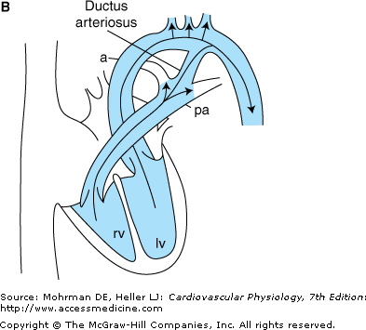
- The right and left sides of the fetal hearts actually operate in parallel to pump blood through the systemic organs and the placenta
- Returning blood fills both the left and right sides of the hearts together because of an opening in the intra-atrial septum called the foramen ovale
- Blood does not enter pulmonary circulation, it is diverted into the aorta through a vascular connection between the pulmonary artery and the aorta called the ductus arteriosus
- An abrupt decrease in pulmonary vascular resistance occurs at birth with the onset of lung ventilation
- This permits blood to begin flowing into the lungs from the pulmonary artery and tends to lower pulmonary arterial pressure
- Total systemic vascular resistance increases greatly because of the interruption of flow through the placenta
- Rise in aortic pressure, which retards or even reverses the flow through the ductus arteriosus
- The ductus arteriosus gradually constricts and completely closes over time(hrs to days)
- Left atrial pressure increases above that in the right atrium so that the pressure gradient for flow through the foramen ovale is reversed, which prevented by a flap-like valve that covers the opening in the left atrium
- The foramen ovale is eventually closed permanently by the growth of fibrous tissue
Pediatric Cardiovascular Characteristics
- A healthy neonate has, by adult standards, a high resting heart and a low arterial blood pressure (average of 60/35 mmHg- human)
- Differences between right and left ventricular mass and wall thickness develop only after birth,likely from hypertrophic response of the left ventricle to the increased afterload
- The electrocardiogram of children shows an early right ventricular dominance (electrical axis orientation) that converts to the normal left ventricular dominance during childhood
Questions:
- The "iron lung," used to help polio victims breathe in the mid-20th century, applied an external intermittent negative pressure to the patient's thoracic cavity. How is this better than positive-pressure ventilation of the patient's lungs
- Total systemic peripheral vascular resistance of a newborn baby undergoes an abrupt and sustained increase at birth. This is because:
  - Circulating blood volume increases.
  - The high-resistance lungs inflate.
  - The low-resistance placental circulation is removed.
  - Sympathetic neural stimulation is elevated.
  - Cardiac output rises.
- Explain how the foramen ovale closes
- Explain how the ductus arteriosus closes

