BOARD REVIEW September 25, 2012

Surgery of the large intestine

Colopexy – surgical fixation of the large intestine
Colectomy – partial or complete resection
Typhlectomy – resection of the cecum
Colostomy – creation of an opening between the colon and the surface of the body

Causes for surgery:
Obstruction
- tumors, intusussception, , granulomatous disease (masses), fb tend to be expelled once in the colon

Perforation
Colonic inflammation/ulceration
Colonic inertia/megacolon

Preoperative concerns:
- Contains the largest number of bacteria within the intestinal tract (> 10^10/g feces)
- Mechanical emptying and cleansing are indicated to reduce bacterial numbers (unless perforation or obstruction)
- Feed an elemental diet (requires minimal digestion) 2-3 days prior to surgery to reduce bacterial load (10^3/g)
- Withhold food 24hrs prior to surgery
- Laxatives, cathartics and warm water enemas 24hours prior to surgery
- Colonic electrolyte solutions (Coltye, GoLytely) contraindicated with obstruction
- 10% povodone iodein enema 3 hrs prior to surgery; no enemas within 3 hrs of surgery
- High risk of infection. Systemic peri-operative antibiotics are recommended. Consider spectrum for gram negative aerobes and anaerobic bacteria
- 2nd generation cephalosporins
- aminoglycoside + cefazolin
- aminoglycoside + metronidazole
- metronidazole + cefazolin

Surgical Anatomy:
Layers of the large intestine:
- muscosa, submucosa, muscularis, serosa

Cecum:
- Cecum, ascending colon, transverse colon, descending colon, rectum
- Cecum in dogs: S shaped blind pouch located to the right of the mesenteric root
- Cecum in cats: short straight blind pouch
- Location: ventral to the right kidney, dorsal to the SI, medial to descending duodenum

Colon:
- Ascending colon lies to the right of the mesenteric root
- ileocolic junction (orifice) - ileum connects with the ascending colon
- cecocolic junction (orifice)
- Right colic flexure (hepatic flexure) – ascending colon turns from right to left transverse colon (travels cranial to the mesenteric root)
- Left colic flexure (splenic flexure) colon turns caudally and becomes the descending colon (this is the longest segment of large intestine)
- Colorectal junction: landmarks pubic brim, pelvic inlet, 7th lumbar vertebra, and cranial rectal artery
- Mesocolon – short mesenteric attachment of the colon to the body wall

Blood supply:

Major blood supply via the ileocolic artery – a branch of the crania mesenteric artery and caudal mesenteric artery.

Major branches run parallel to the intestine giving off short vasa recta vessels which penetrate the intestinal wall.

Branches of the ileocolic and left colic artery anastomose; the ileocolic artery supplies the ileum, cecum, ascending and transverse colon.

Ileocolic artery gives rise to the right colic and middle colic arteries; right colic artery supplies part of the transverse colon and half of the descending colon. It anastomoses with the left colic artery which supplies the distal half of the descending colon.

The left colic and cranial rectal arteries originate from the caudal mesenteric artery.

The cranial rectal artery primarily supplies the cranial rectum but also sends several vasa recta to a short segment of the terminal colon.

Internal iliac artery supplies branches to the rectum via prostatic or vaginal artery branches.

Venous drainage mirrors arterial supply. Caudal mesenteric vein portal vein.

Innervation:
Parasympathetic innervation: vegus and pelvic nerve
Sympathetic innervation: paravertebral sympathetic trunk via sympathetic ganglion

Principles of Large Intestinal Surgery:

- Reduce colonic bacterial numbers by eliminating oral intake, preparing the colon and giving Abx
- Early diagnostics and good surgical technique prevent most complications
- Perform surgery ASAP after Dx made in pts with perforation, strangulation or complete obstruction
- Optimal healing requires a good blood supply, accurate mucosal apposition and minimal surgical trauma
- Systemic factors (eg. Hypovolemia, shock, hypoproteinemia, debilitation, infection) may delay healing and increase risk of dehiscence
- Use approximating suture patterns: simple interrupted Gambee, crushing, or simple continuous
- Engage submucosa in all sutures
- Select a monofilament, synthetic absorbable suture (PDS)
- Cover surgical sites with omentum or a serosal patch
- Replace contaminated instruments and gloves before closure

Colopexy

- Usually indicated to prevent recurrent rectal prolapse.
- Incisional and non-incisional techniques are equally effective
- Complications include infection from penetration of suture into colonic lumen
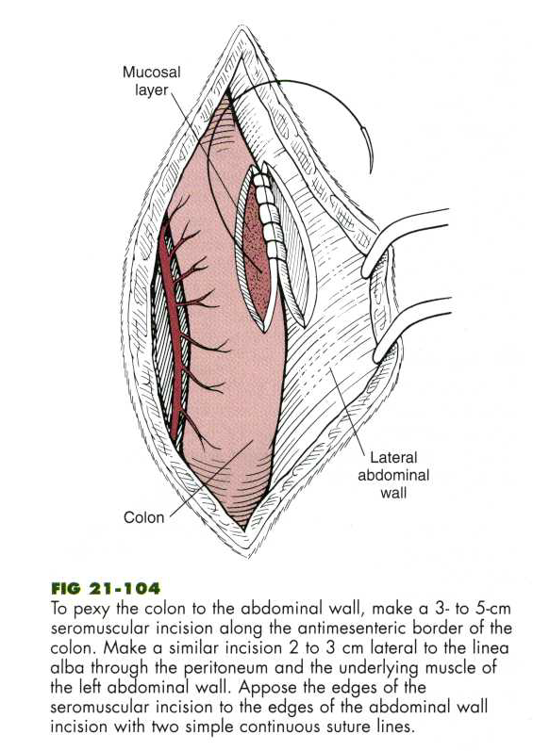

Colectomy or Colonic R’nA

- primarily indicated to excise colonic masses or treat megacolon. Other indications include trauma, perforation, intussusception and cecal inversions.
- Procedure is the same as for small intestinal R’nA with the exception of vascular ligation (ligate only the vasa recta vessels, not the major colonic arteries ie: the ileocolic, left and right colic or colorectal UNLESS performing subtotal colectomy).
- 70% of the colon can be resected without side effects. Subtotal colectomy involves resection of 90 to 95% of the colon. Diarrhea and soft stool is a frequent complication.
- RnA may be performed using sutures or staples. Stapled anastomoses show less tissue reaction, more mature fibrous connective tissue, greater tensile strength, fewer mucoceles and necrotic areas and less luminal stenosis than sutures techniques. Contraindications to stapled anastomoses include dilated tissue that may be too thin to engage staples adequately. Sutured anastomoeses should be employed in these cases.

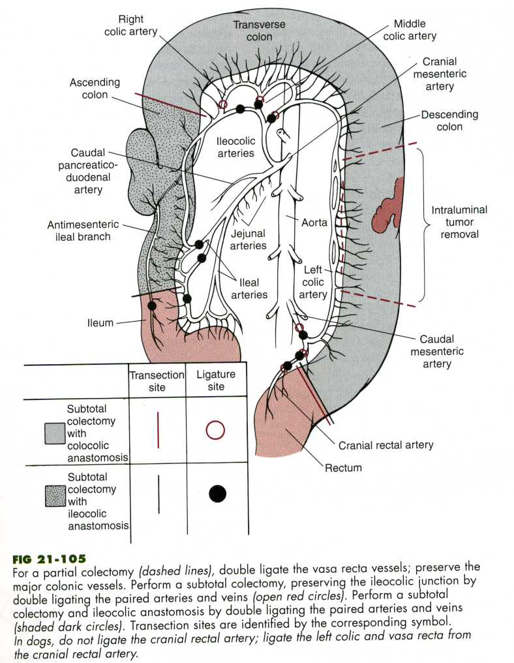
Typhlectomy

- indicated for cecal impaction, cecal inversion, perforation or neoplastic/inflammatory typhlitis

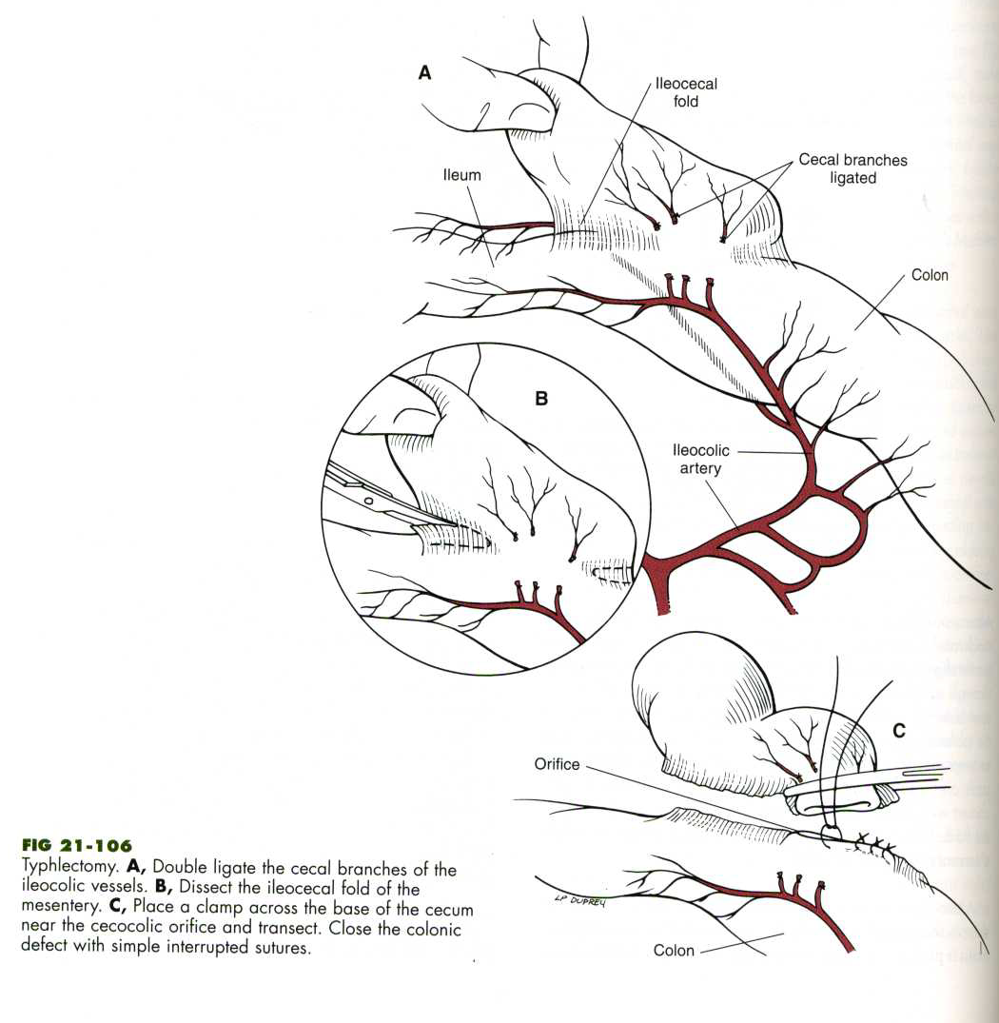

Colostomy

- seldom indicated in animals and is not considered an emergent procedure.

Healing of the Large Intestine

Similar to that of the small intestine but delayed. Wound tensile strength lags behind return of strength in the small intestine, and dehiscence is more likely. Optimum healing depends on a good blood supply, accurate mucosal apposition, minimal surgical trauma and tension-free closure. Factors that delay healing include: collateral circulation to the large intestine is poor compared with the small intestine, and large numbers of aerobic and anaerobic bacteria compose up to 10% of dry fecal weight, high intraluminal pressure develops during BMs and mechanical stress on the suture lines may lead to dehiscence. Risk of dehiscence is high during the first 3-4 days because collagen lysis exceeds synthesis. ABx use and placing sutures that do not strangulate tissue may improve healing.

Complications

Hemorrhage and fecal contamination of the abdomen are the most common complications. Other possible complications include shock, leakage, dehiscence, perforation, peritonitis, stenosis, incontinence or death.

