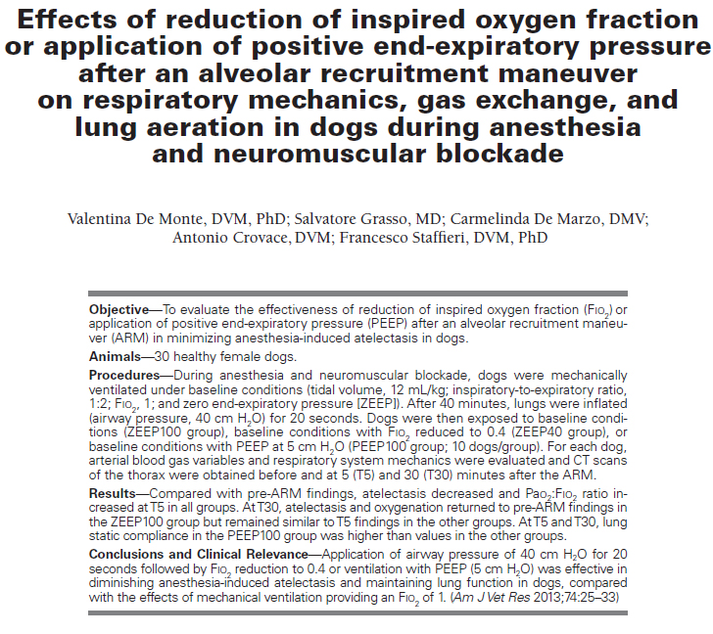
Key Points:
- The major forms of atelectasis under anesthesthesia are absorption atelectasis and compression atelectasis and surfactant impairment
- Healthy dogs develop pulmonary atelectasis when breathing high concentrations of oxygen in inspired gas during anesthesia
- Reducing FIO₂ to 0.4 without applying PEEP or maintaining ventilation with pure oxygen while applying PEEP at 5 cm H₂O is an effective strategy for prolonging the positive effects of an ARM for up to 30 minutes
Questions:
- What is the recommended airway pressure in ARM in people
  - 27 cm H₂O
  - 5 cm H₂O
  - 40 cm H₂O
  - Whatever the machine goes up to

