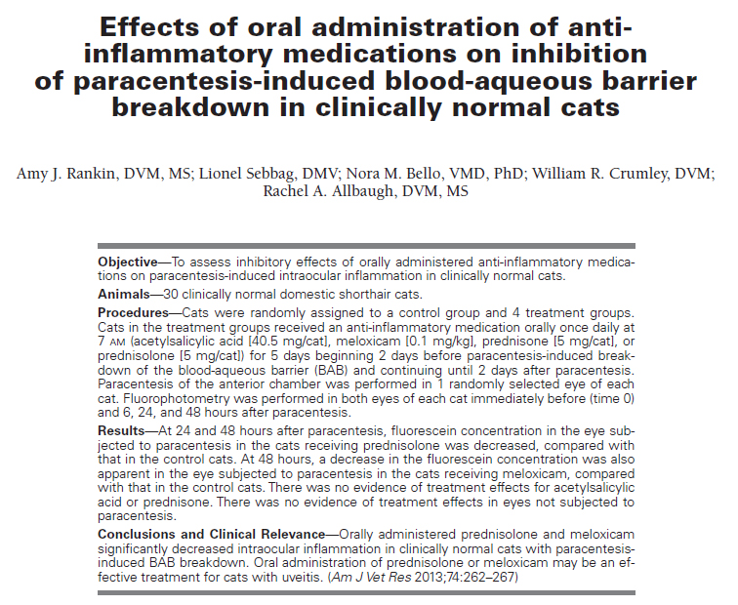
Key points:
- Uveitis is a common and clinically important ophthalmic disorder in domestic cats, and the cause often is not determined
- Topical and systemic administration of anti-inflammatory medications is commonly used in the treatment of uveitis in veterinary medicine
- Topical administration of anti-inflammatory medications does not result in therapeutic concentrations in the posterior segment of the eye
Questions:
T or F: Dogs more commonly have side effects associated with oral corticosteroid administration
T or F: Prednisone is hepatically metabolized to prednisolone in dogs
T or F: Paracentesis commonly results in corneal ulceration
Of the 4 medications used which were most effective in controlling anterior uveitis
Key points:
- Aqueocentesis is a safe emergency procedure for refractory glaucoma
- Aqueocentesis is accomplished by inserting a 25- to 30-gauge hypodermic needle through the limbal cornea into the anterior chamber, with the needle passing parallel to the iris while avoiding contact with the iris, lens, or corneal endothelium
- With proper aqueocentesis technique, the risk of complications is exceedingly low

