Heidi Rausch
Final Design Report
Due 5/5/12
Plumbing Functions
Problem Definition

Introduction
For my first tasks this semester I worked on the functions for a wye, to be used in the stacked rapid sand filter’s sand drain and functions that will draw reducers, which will also be used for the chemical dosing system and possibly other locations in the plant in the future. I determined what dimensions of wyes and reducers are available and updated the pipe database pipefittings matrix accordingly.

Design Details
Both the wye function and the reducer functions will be added to the PlumbingF file once they are completed. The wye function has inputs of an origin point, angle vector, nominal diameter and EN (thickness of the pipe). The reducer function will have the same inputs, except instead of just having nominal diameter it will have nominal diameter in and nominal diameter out. Once these functions have been created they will be able to be used in drawings of the plant. My functions in PlumbingF will depend on dimensions that are defined in the pipefitting matrix and assignment statements that are in the Pipe Database. To complete my tasks I based my functions for the wye mostly on the current TeeF function found in PlumbingF. I approached drawing the reducers by looking at the MaleAdapterF and CouplingF functions in the PlumbingF file. This function is also restricted by the fact that there are only certain combinations of nominal diameter in and nominal diameter out exist. The user must therefore look in the Pipe Database to see if the reducer they want to create actually exists before using the function.

Documented Progress

Accomplishments
As seen in figures 1 and 2 the WyeF function has been completed. It has been incorporated into the PlumbingF file and can be used for a variety of nominal diameters, which I found data for on the following website http://www.spearsmfg.com/prod_dimensions_spec/40-4-0511_0511_web.pdf. Dimensions for wyes proved difficult to find online and the website I have cited has not been used for dimensioning for AguaClara previously. The pipe database has also been updated to include 3 new variables. These variables are LongWyeLength, which is the length from the origin point to the beginning of the left hand socket, ShortWyeLength, which is the length from the origin point to point where the diagonal length of the wye extends from, and DiagWyeLength, which is the length of the diagonal part of the wye (not including the socket). Three new columns were introduced into the pipefittings matrix to include these variables. I have also created a WyeSUBF function but it may need some debugging. (See figure 3)

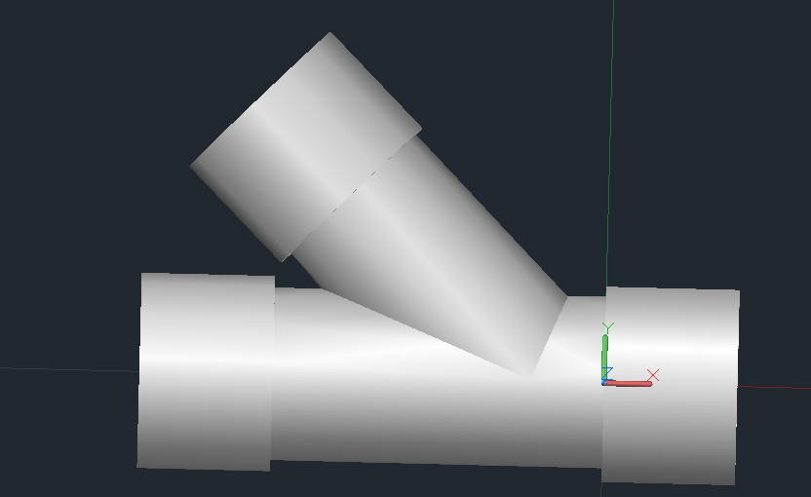
Figure 1: Final AutoCAD wye drawing

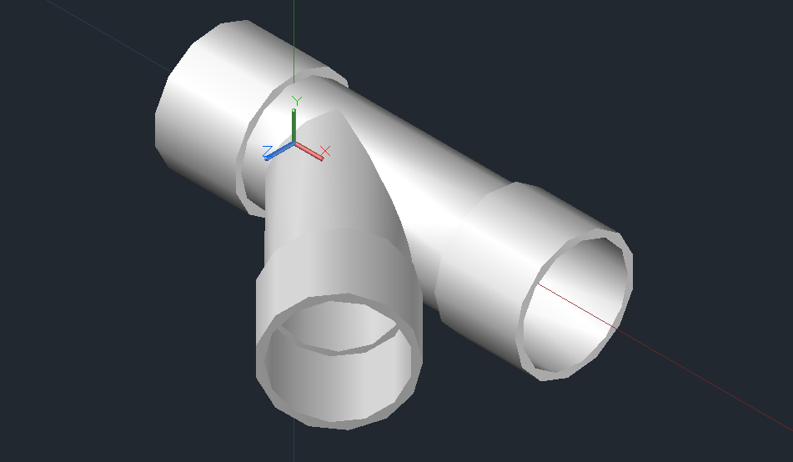
Figure 2: Alternate view of figure 2 (so correct subtractions can be seen)

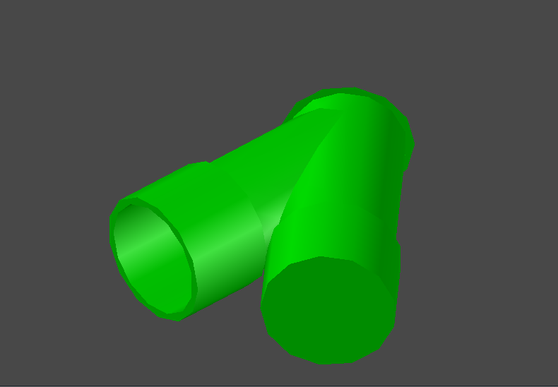
Figure 3: Example of the problem with wyeSUBF

As seen in Figures 4-7 below I have successfully written a ReducerF function and a ReducerSUBF function. Both of these functions have been added to the PlumbingF file in a new reducer functions section. I also added the needed dimensions for these two functions to the pipe database, in a reducer dimension section. For these two functions the user must know two dimensions, ND.in (the nominal diameter of the entrance pipe) and ND.out (the nominal diameter of the exit pipe). The user must then go to the pipe database before they use the function and check to see that that size reducer actually exists. If the reducer the user wants does exist, the user then must look to see what the corresponding ReducerLength is, and use ND.in, ND.out, and ReducerLength as inputs for both the reducerF and reducerSUBF functions.

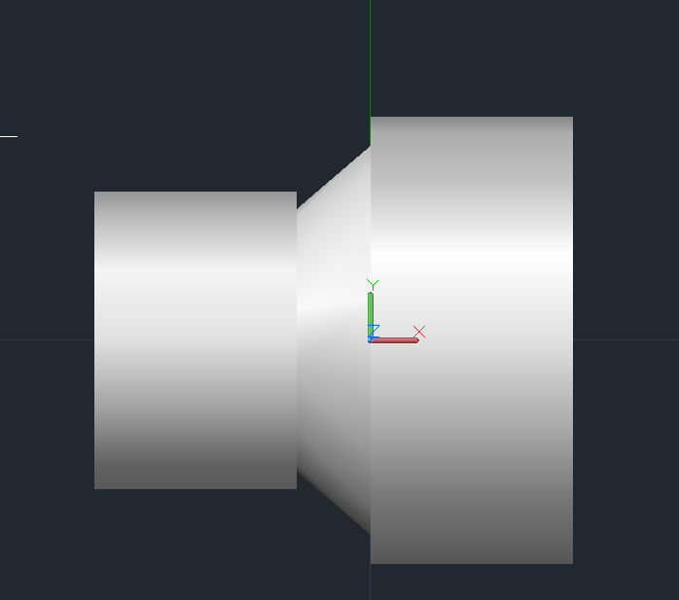
Figure 4: Drawing of completed reducer

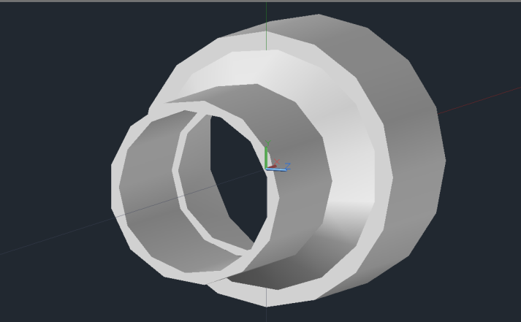
Figure 5: Alternate view of completed reducer

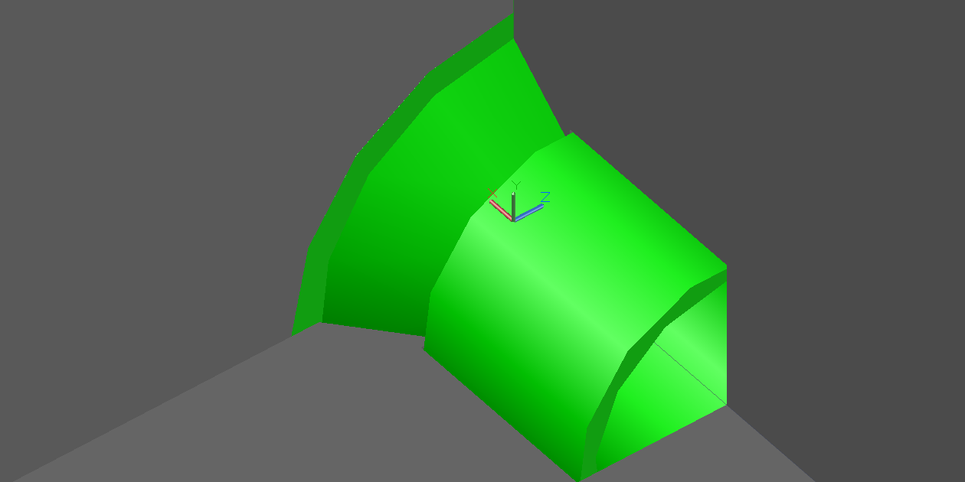
Figure 6: Example of use of ReducerSUBF

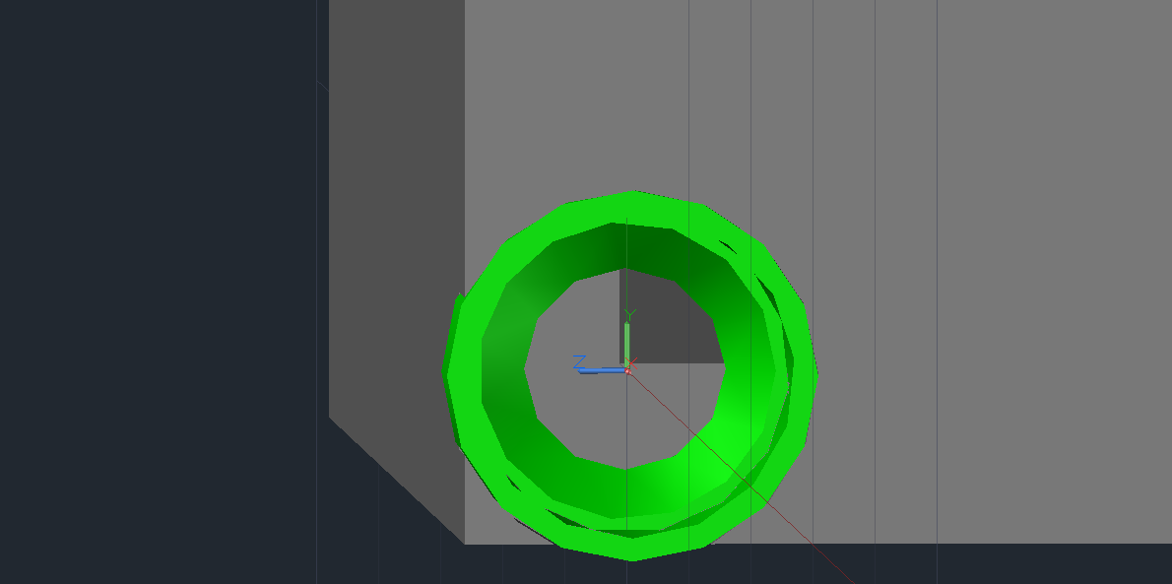
Figure 7: Alternate view of figure 7

Future Work
To finish the work on these new plumbing functions a few issues must be addressed. In the WyeSUBF function there is still one subtraction that needs to be fixed. Hopefully this can be accomplished by correctly breping the object. Another problem that needs to be looked into would be the fact that it is still unknown whether or not the dimensions I added to the Pipe Database are accurate. One way to check on this would be to ask one of the engineers on the ground in Honduras. Finally, another task that needs to be accomplished within the category of plumbing functions is to draw another type of reducer. This new reducer is used in the stacked rapid sand filter and would be a bushing type reducer. This new function would also more accurately represent some of the reducers in the plant better than the reducer I recently created.

ChemStockTanksAC Updates

Problem Definition

Introduction
My second task was to rewrite the code that draws the chemical stock tanks and platform so that there is an option of leaving off the filter coagulant tanks. This involves mainly working in the ChemStockTanksAC file, but also changing some things in the CdcAC file as well. This was added as a design challenge recently because it was discovered that because our stacked rapid sand filter works so well that we may not need to use filter coagulant in all our plants.

Design Details
For this challenge the main goal is to be able to allow for a choice between having filter coagulant and not having filter coagulant. To do this it was decided that it would be easiest to change the location of tanks from how they are currently drawn. In plant designs as of now the chlorine stock tanks and the filter coagulant stock tanks are drawn right next to each other, however in the updated version they will be drawn across from each other. This orientation will allow for the filter coagulant tanks to be removed by simply taking them off and shortening the platform.
Documented Progress

Accomplishments
The ChemStockTanksAC file that I have created now contains an option for not having filter coagulant tanks or plumbing. Also, both the chlorine tanks and the filter coagulant tanks are now across from one another instead of next to each other, as in the code that is currently in use. To create the option of including filter coagulant tanks I created a variable called FilterCoag at the beginning of the file and if this variable is equal to one then there will be filter coagulant tanks drawn but if the variable is 0 (or any other number) the filter coagulant tanks will not be drawn. Below Figures 8 and 9 show all three pairs of chemical tanks and Figures 10 and 11 show the drawing with only the coagulant and chlorine tanks. This redesign of the chemical stock tanks is almost complete and will be committed to the repositories as soon as the code is debugged.

- Future Work

I will be continuing to work on this challenge over the upcoming summer. One of the remaining tasks is to accommodate these changes by changing both the CdcAC file and ChemStorageTanks design file slightly. The variable FilterCoag will be added to ExpertInputs as soon as the changes to ChemStockTanksAC, CdcAC, and ChemStorageTanks have been made and committed to the repositories. Also it has been suggested to move the drain valves for each tank from where they currently are (in the walkway) to directly under the platform. Finally I will debug the code to fix some small problems it is currently having. I hope to be able to make these changes as soon as possible.

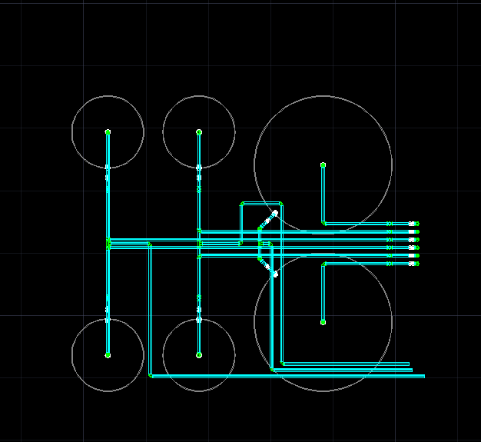
Figure 8: Top view with all three pairs of tanks

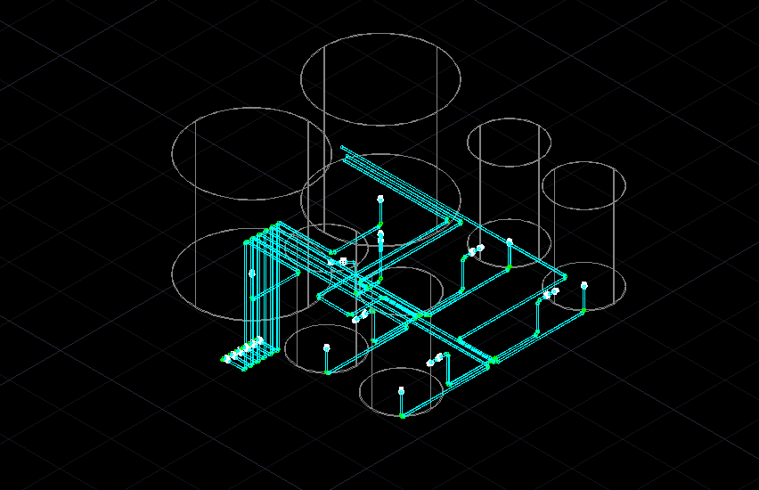
Figure 9: Corner view from the top, left/back, all three pairs of tanks

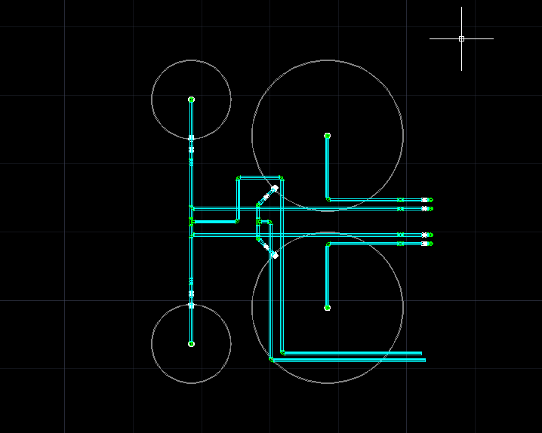
Figure 10: Top view with no filter coagulant

Corner view from top, left/back with no filter coagulant

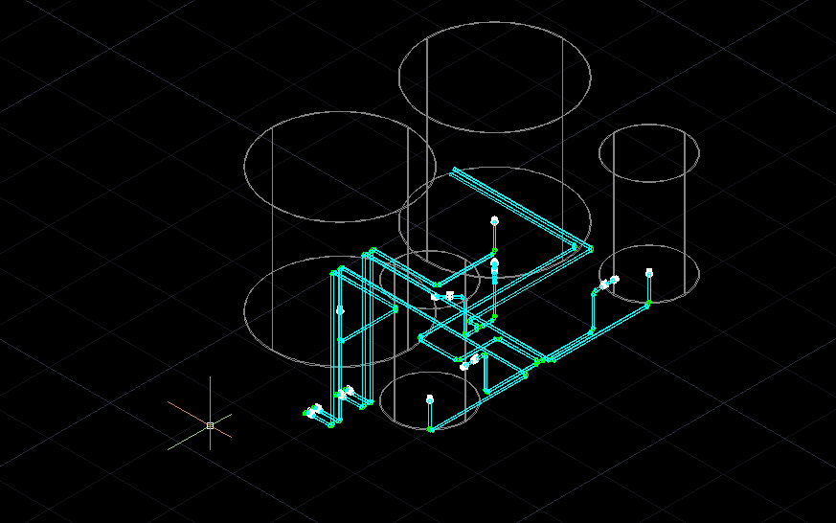
Figure 11: Corner view from top, left/back with no filter coagulant

