Low Flow Sedimentation Tank

Julia Morris & Joseph Fallurin

Introduction
There is high demand for low flow AguaClara plants. Many small communities would like to implement an AguaClara design but their water demand is too low for the current AguaClara design to function properly. Currently, for plants under 6 L/s the design tool produces a design with several failure modes. One of the issues is that under 6 L/s the flocculator’s H/S ratio is too large and it then becomes too difficult to construct. Another problem is that with a flow rate of 3 L/s or lower it is only necessary to have one sedimentation tank. Therefore certain components of the original sedimentation tank design become irrelevant and will only increase cost. Therefore the design code that designs a sedimentation tank for these low flow rates needs to be changed to reflect these changes.

Design Details
Background
In the conventional AguaClara sedimentation tank design, water flows from the flocculator to the inlet channel where the flow rate is distributed evenly into each sedimentation bay. From there water flows into each inlet manifold to distribute the water evenly throughout the bay though diffusers. The water then flows up into the plate settlers where the remaining particles are captured. The settled water then flows into the launder at the top of the tank and then flows to the exit channel. The exit channel collects the settled water and sends it to the filter.
The length of the sedimentation tank is dependent on the upflow length. The upflow length can be determined from the minimum upflow velocity for floc blanket formation, width of the sedimentation tank (constant), and Q.SedBay.
For flow rates of 3 L/s and lower there will only be one sedimentation tank. Because of this the inlet channel is unnecessary because the flow rate will not have to be divided. Instead the inlet channel will need to be replaced with just a pipe coming from the flocculator and into the inlet manifold. To carry the settled water to the filter, a single exit channel with a weir will be used. The water will flow from the launder into the exit channel and then over the weir and into the filter inlet pipe. This will ensure that the flow into the filter pipe is hydraulically disconnected from the sedimentation tank. The the floc hopper, weir, and drains will be kept in the same place due to the fact that the main drainage line runs down the center of the plant.
We will also need to figure out the best way to implement this specific design into the design code. Although it may be easier to make entirely separate Low Flow SedimentationTank files, incorporating our low flow sedimentation tank changes directly into existing SedimentationTank files would reduce MasterProgram complexity and better modularize the code. This can be accomplished using if statements for relevant variables within existing code.

Piping Changes
The inlet manifold length and elbows must be adjusted to appropriately accommodate all the diffusers. The floc drain from the hopper must be moved to avoid overlap with the new inlet manifold system.

Concrete Changes
Since the inlet channel and its subsequent piping needs to be removed, the length of the tank will need to be updated. The hopper also needs to be reshaped to allow for effective floc collection and removal after inlet manifold and sedimentation tank length changes have been implemented.

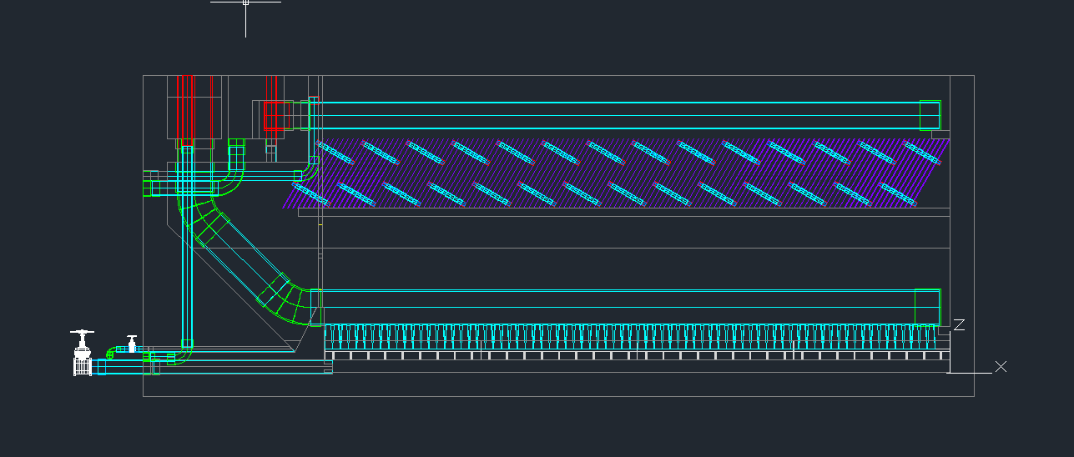
Figure 1: Current Low Flow Design provided by Design Tool
Design Progress
The current design for the low flow sedimentation tank can be seen in Figure 2 below.
The inlet channel and the piping connecting the inlet channel to the inlet manifold have been removed. An elbow has been placed so that water from the flocculator can flow into the side the sedimentation tank directly into the inlet manifold. The inlet manifold has also been extended so that the diffusers do not connect into the elbow. Although this extension buries the elbow into the hopper concrete, the elbow will be buried regardless of the inlet manifold length due to the sloped inward sides of the sedimentation tank. The coupling and pipe connecting the coupling and elbow for the inlet channel have also been added to the design file. All inlet piping changes have been completed.
The lengths of the hopper and sedimentation tank have been updated so that the width of the inlet channel is no longer included. We are working on moving the trough of the hopper to a higher position so that the hopper floc drain does not interfere with the inlet piping. We are currently working on doing so by moving the concrete slope closer to the active area.

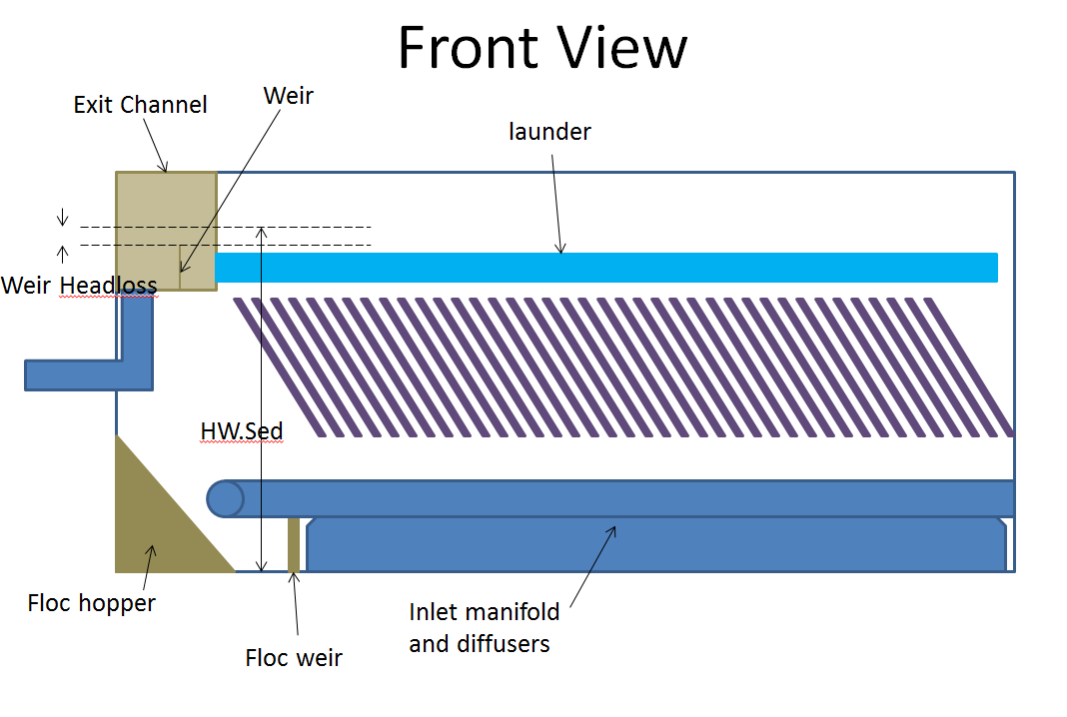
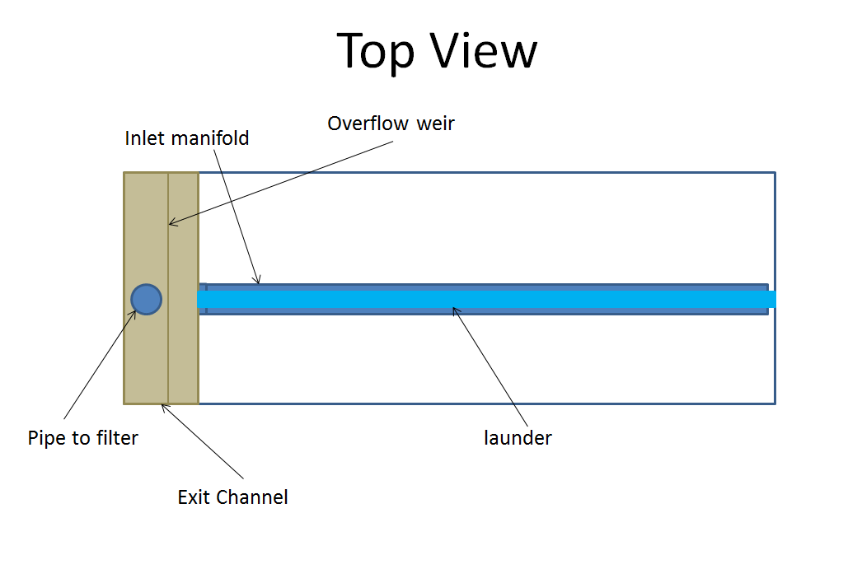

Figure 2: Current Proposed Design of Low Flow Sedimentation Tank
Future Work
- Finalize exit channel design
- Ensure proper floc hopper shape and floc drain/inlet piping interactions for low flow range
- Add any additional low flow design considerations
- Implementing the transition from regular to low flow into the design code.

