AguaClara Spring 2012 Design Improvements: Joseph Fallurin
Flocculation
Introduction
The flocculator is one of the major components of past and present plant designs. In conjunction with the sedimentation tank, this unit is responsible for the most significant particle removal within the plant. The previous version of the flocculator design did not integrate incremental code changes in the best way possible. Our goal was to reorient the flocculator without the use of one large mirror function and incorporate a cost algorithm into the flocculator design file. The previous flocculator design is shown below without the inserted gate valve drawings on the drain tubes:
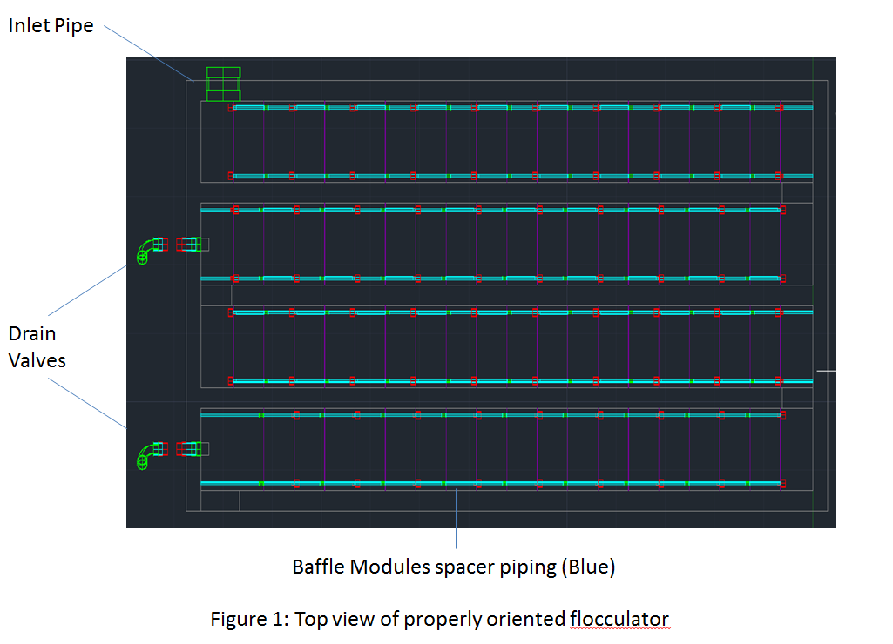

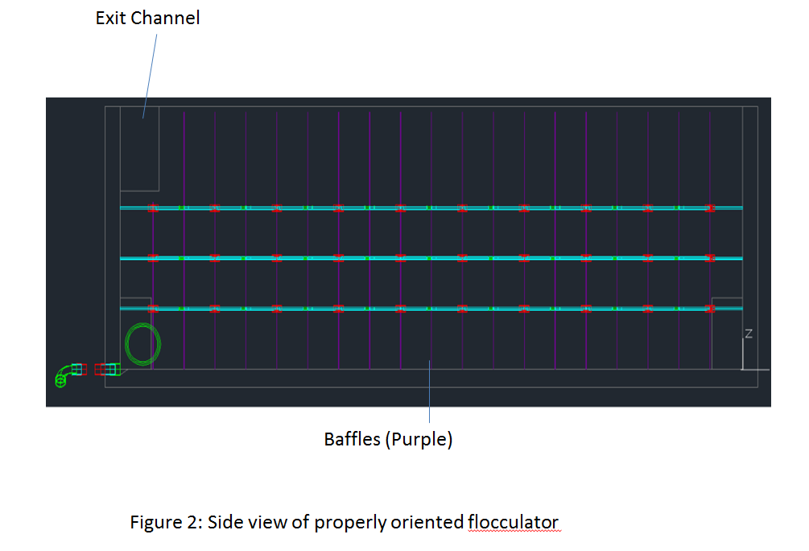
Design Details
The first goal was to integrate past improvements into the previous code more seamlessly by making the existing code more efficient. This included reorienting components of the flocculator tank such that there were no unnecessary mirrorings. It also meant fixing the last row of baffle modules so that water travels up and over the first baffle after the last Floc Port.
The second goal was to implement a new cost optimization algorithm into the revised code. The cost algorithm allows the formerly fixed channel width to scale with the size of the plant to keep fixed costs to a minimum. Allowing channel width to float with plant flow rate should also help create viable flocculator designs above 70L/s. After studying the 4540 algorithm, the relevant parts should be placed into the flocculator file. This task includes testing the resulting design output for potential scale breakdown and optimal collision potential for various plant sizes.

Design Progress

All non-module components, including channel ports, exit channel, floc drain wedges, and the floc drains have been positioned properly without mirroring. Progress on my first goal was initially accelerated by the discovery of EN.FlocDrains, however EN.FlocDrains has been removed as an option upon further considerations of drawing complexity. The baffle module components proved to be the most complex part of the flocculator to fix. The caps have been correctly positioned for the original module; however the array pattern must be fixed.
Underestimating the complexity of the baffle modules and changing deadlines significantly slowed progress on this project. The plan was passed on to AguaClara engineer Maysoon Sharif due to increased demands of high-flow plants.

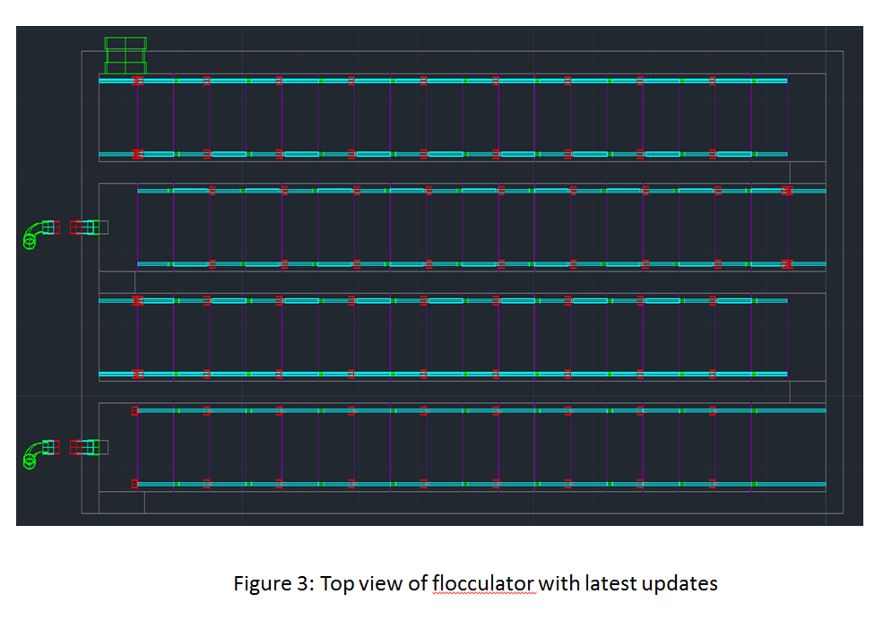

Fernco Fittings
Introduction
The next goal was to update the PipeFittings file to account for new rubber Fernco connections and caps. These fittings are currently used for the stacked rapid sand filter. The current Fernco connection matrix is partially filled for 6in and 8in nominal diameters; however other nominal diameters may be used in the future.

Design Details
The Fernco connections matrix must first be updated to include a full range of nominal diameters. This requires sorting through the collection of connector and reducer fittings that Fernco has on its website. The need for Fernco caps must be evaluated based on the Full Scale Stacked Rapid Sand Filter team’s recommendations. Fernco cap codes can then be developed from current cap fitting codes with modifications from the Fernco connections code and dimensions from the Fernco website.

Design Progress
The Fernco connections matrix has been completed for Nominal Diameters of 1 inch through 16 inches. The Full Scale Stacked Rapid Sand Filter team has been contacted about what Fernco fittings will be required by them in the near future. A reply has been received from the SRSF team recently assuring that Fernco caps will be necessary in the future.

Large Float Valve
Introduction
The new high flow plant (>70 L/s) requires several modifications, including the use of a larger float valve in the dose controller. The next task is to design an inserted drawing of a large float valve on AutoCAD.

Design Details
A large float valve shall be custom made in AutoCAD. The major components of the float valve will be developed from the following drawing:
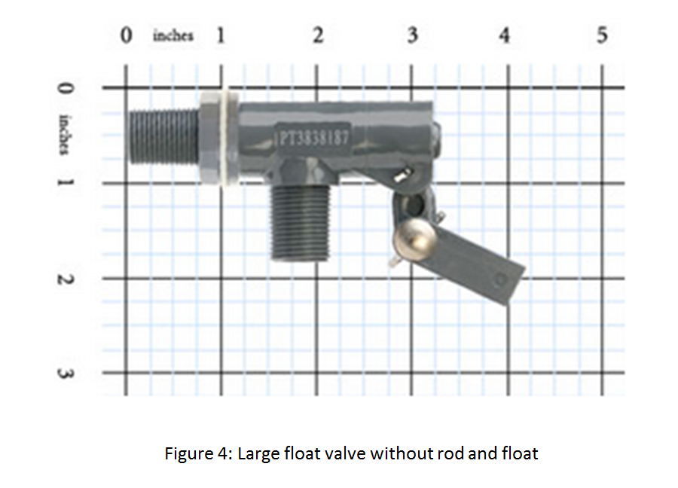
A rod and the corresponding float will also be added.

Design Progress

The large float valve has been completed and uploaded into the inserted drawings folder. The pivot connecting the rod and valve has been approximated as a simple cylinder and threads were not incorporated. These details could be further refined in the future.

