Chemical Dosage System Updates
Nicholas Parisi and Amanda Rodriguez
Final Design Report
May 4, 2012

Chemical Dosage System Updates

Problem Definition

In the Chemical Dose Controller (CDC) AutoCAD script, the entire CDC system is drawn using inserted drawings. Our task was to begin replacing these inserted drawings with algorithms that can draw these pieces from the command line. Specifically, we focused on replacing the Constant Head Tank, supporting L-Bracket, Lever Arm, Drop Tube, and supporting Lever Arm L-Bracket drawings.

Through these updates, we aim to increase the versatility of our design tool, because unlike inserted drawings, our code is scalable and can be easily modified. While inserted drawings can be scaled as a whole, specific parts cannot be manipulated. This is particularly problematic in the instance of the constant head tank drawings, where barbed fittings are incorrectly located on the sides of the tank rather than the side. In coding, this is easily changed, but more difficult to change within the inserted drawing. Additionally, in the code, the number of barbed fittings can be changed depending on the number of tubes between the constant head tank and drop tube, while it can’t be changed within the inserted drawing.

Ideally, the design tool should not use any inserted drawings and should draw all components from the command line. This would allow all our plant components to be scalable and accessible to all users.

Design Details

To complete this task we will add a simplified constant head tank (CHT) as a hollowed out cylinder supported by an L-Bracket attached to the chemical stock tank platform wall. This tank includes an orifice for the float valve, as well as holes on the bottom with inserted barbed fittings. These fittings will be arranged equidistant, depending on the number of tubes necessary to distribute chemicals.

This number, N.CoagCdcTubes and N.ChlorCdcTubes, is dependent on plant flow rate and chemical concentration and is defined in LinearCdc.
We will also add a lever arm and adjacent drop tube, which will be attached to the far wall of the entrance tank by an additional L-bracket and connecting horizontal bar.
This will require two new functions, ConstantHeadTank and LBracket2, which will be temporarily added to the PlumbingF file in AutoCAD scripts, and may be moved to a more fitting file in the future.
Documented Progress

We broke up the task into two separate areas: the Lever arm, L-bracket and drop tube on the entrance tank, and the Constant Head Tank and its own supporting L-brakcet.
To draw the lever arm, connecting bar and drop tube we used the previously defined functions BoxF, PipeF, and CylinderF in the MToAWrapped file. To correctly draw these figures we used the dimensions also previously defined in the CdcAC File such as H.LeverArm, L.CdcLever, L.LAOriginToDtCenterX, L.LAOriginToDtY, and L.DropTube for the respective lengths and distances of each object. The correct pipe information was located in the CdcAC file and the pipe database, and ND.DropTube and was used as the nominal diameter of the drop tube. The code correctly draws a vertical pipe as the drop tube with a horizontal thin box extending out over the entrance tank as the lever arm.

LA.Origin was changed to draw each part of the chemical dosing system in its proper location at the edge of the far wall of the entrance tank since our functions require different origin points than the inserted designs do. The x coordinates were not altered, however the y-coordinate of the LA.orgin was altered by (-L.LarmBar/2 +zc) and the z-coordinate was altered by (-L.LBracket + W.LBracket +D.ArmBar).

The code that draws these shapes was added to the CDC script and has successfully replaced the previous code that inserted drawings from their URL address. This code appears three times in the file to correctly draw each lever arm, drop tube and connecting bar. (Figure 1)
Next, to create the L-Bracket which holds the connecting bar in place, we tried writing code and repeating it several times as we did with the lever arm, drop tube and connecting bar. The L-Bracket, which sits flush against the edge of the far wall of the entrance tank, can be constructed by using simple functions in the MToAWrapped file such as BoxF, CylinderF and SubtractGeneral. However, because this object will be drawn repeatedly and requires unioning shapes and subtracting various parts, we decided to create a function LArmBracketF which is dependent on an inputted origin point. This new function was added to the PlumbingF file in AutoCAD Scripts and will correctly draw the Lever Arm L-Bracket. (Figure 2) The function call on LBracket2F was then added into the CdcAC script file to replace the call in the CDC script which previously added the inserted drawing. This function is called three times as well to construct three separate Lever Arm L-Brackets, based on the origin points LA. Origin, LA2.Origin, and LA3. Origin.

Figure 1: The completed Lever Arm, L-bracket and Drop Tube Assembly
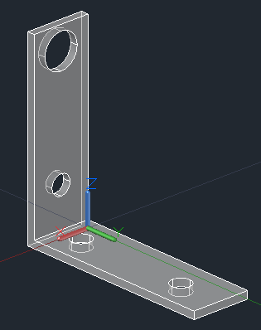
Figure 2: Completed Lever Arm L-bracket

For the constant head tank, we first constructed code to draw the L-Bracket with holds up the tank. This code was fairly simple and uses previously defined functions found in MToAWrapped such as BoxF, CylinderF, and SubtractF to construct the L-Bracket shape. (Figure 3)

Figure 3: The completed CHT L-Bracket Drawing
To draw the constant head tank from the command line, we added a function to PlumbingF called ConstantHeadTank, which generally draws a simpler version of the inserted drawing with an update to the barbed fittings. In the inserted drawing, there is one barbed fitting on the side. Not only should the fitting be on the bottom, but also the inserted drawing only depicts one fitting. This is incorrect as the number of barbed fittings is equal to the number of tubes extending from the tank, which varies as a function of plant size. The function takes the number of tubes as a function, and uses it to array the barbed fitting holes dependent on the number. When drawing the constant head tank with the L-bracket, we encountered the problem of the barbed fitting holes being blocked by the bracket as the number of tubes increased to more than three. One solution would be to array the barbed fittings so that if there were four tubes, the fourth tube would be added to the three-tube formation in the center of the tank. Although we have not found a good formation for the placement of five tubes, no existing AguaClara design thus far has needed more than four tubes going from one constant head tank to its drop tube, so this can be modified in the future.

In addition to the number of tubes extending from the tank, the function takes inputs of tank origin, radius, and height, as well as the diameters of the holes for the float valve and barbed fittings. There will be three tanks drawn for the three different chemicals. The center tank x coordinate is based on the origin of the chemical platform, the length of the chemical platform, thickness of the plant wall and the radius of the tank. The y coordinate is exactly that of the lever arm which is directly across on the entrance tank and is based of the entrance tank origin. The z coordinate is based off of the thickness of the chemical tank wall, B.StockOutlet, and the distance of the coagulant tank above the head tank, all of which are defined in ChemStorageTanks. The other two tanks will be drawn to the left and right of the center tank a distance away equal to the radius of the tank.
Generally, we are using the McMaster part 42955T2 for our constant head tank, so we are basing the tank radius and height off of the given dimensions of this particular part. The barbed fittings and the float valve will remain inserted drawings for now, so the function draws holes in the CHT for these inserted drawings. The location of the float valve is defined in ChemStorageTanks, and since the float valve and barbed fittings are inserted drawings, we are basing the thickness of the tank on these drawings.
The function also takes an input of a rotation vector, which serves to rotate the constant head tank around the z access, only altering the location of the float valves, not the position of the barbed fittings on the bottom.
Although we use SubtractGeneral to draw our tank and our cap, our function still requires LayerName as an input because we have not figured out how to apply SubtractGeneral to create the barbed fittings. We’ve arrayed the holes using ArrayLastPolar which doesn’t output origin points of the arrayed objects. Since the formation of the barbed fittings will likely change, this will be revisited after the barbed fitting designs are finalized.
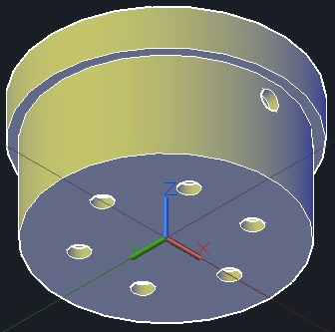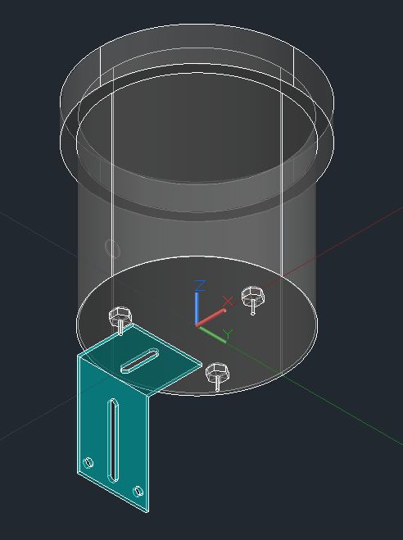
Figure 4: Completed Constant Head Tank with six barbed fitting holes Figure 5:The completed output drawing of the Constant Head Tank with its barbed fittings (3 coagulant tubes) and the supporting L-Bracket
Future Work

In the future, we hope to include the function that draws a reducer, if the number of chemical tubes connecting to an individual lever arm is four or more. Also, we would like to create code that draws simplified versions of the smaller parts involved in the Chemical Dosage System, such as lever arm sliders, and connecting bolts. Not all of our code has been incorporated into the design tool, but will be completed by the Design Team members over the summer.
We would also like to finish working with the flexible tubing function so that it takes an input of length of tubing and a point array of only the start and endpoints rather than the middle ones as well. Ultimately, this function will be used to draw the flexible tubing which connects the constant head tanks to the drop tubs e and lever arms. Right now, we have been looking to do this using a catenary function, which describes how tubing should drape. This may not be the best option, depending on research team work because they have been experimenting with weighing down the tubing with a weight to reduce head loss. If this is the case, a catenary function might not be the most accurate depiction of the flexible tubing path.

