Solar Cooker Proposal

CEE 3090
Instructor
Timothy K. Bond

Team Members
Kaitlyn Hoffman
Mehmet Akdag
Rodrigo Monsalve
Trang Pham

Small Solar Oven for Ithaca Weather
The solar cooker team will design and build a new, energy efficient, lightweight, waterproof, and durable oven for the city of Ithaca, New York. The cooker’s design will reflect the unique climate of upstate New York, particularly the weather that is found in and around Ithaca. It will have more or less of a trapezoidal shape (Fig.1), with a 42 degree inclination in order to gather and concentrate most of the sunlight’s energy into the oven (Ithaca is at 42 degrees north latitude). The goal is to generate as much heat and prevent heat as much loss as possible. Effective insulation will be installed inside of the cooker to prevent heat loss and significantly improve the effectiveness of the design. A small side door will be incorporated into the oven. This side door will be small to keep heat loss to a minimum when the door is opened.
The size of the solar oven and the use of lightweight materials will differentiate our design from previous Cornell ESW project team designs. To make a more transportable solar cooker, we have decided to use a high tech durable plastic frame instead of a glass window frame to capture the light into the inside of the oven. The team will also use thinner plywood to achieve an approximate weight less than 60 pounds. The solar cooker will also be waterproof. A membrane will cover the exterior of the design and the use of proper sealing will definitely help us achieve this goal.
The solar cooker will be tested and demonstrated throughout the Cornell campus and Ithaca community to show and promote sustainability. This version of the solar cooker will help future ESW teams design and construct solar cookers for Nicaragua and other parts of the world.

Figure (1) Solar Oven Design
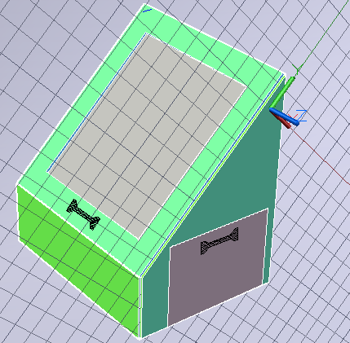

Project Tasks and Schedule
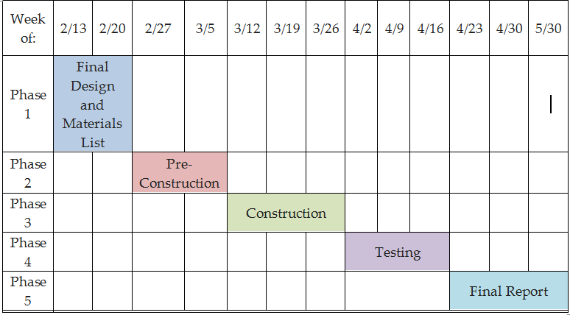

Phase 1
Design: For the first three weeks of February, the group will be researching and designing our solar cooker (i.e. shape and size of solar cooker, insulation, connections, and proper sealing).

Phase 2
Pre-Construction: We will procure the necessary materials and begin the building process. We will finalize the design and make any last minute changes during this phase.

Phase 3
Construction: In March, we will work, build the cooker and expect to finish by the end of this month or first week of April.

Phase 4
Testing: Testing the solar cooker will take place in mid-April. Wrapping up loose ends and the final completion of the device will occur by the end of April. Solar oven should be energy efficiency, durable, waterproof, lightweight, and transportable.

Phase 5
Final Report: The final report will be completed in May.

Project Budget
The group is providing a low cost efficient cooker to the city of Ithaca. The following table is the group estimate of the cost of the solar cooker.
Materials | Cost ($)
Plywood | $24
Plastic | $15
Fasteners | $10
Insulation | $20
Waterproof Membrane | $5
Sealing | $5
TOTAL | $79

This is an approximate budget cost analysis since the groups is still working in the design process. The total expected cost is $79.00. The value might change when the team starts the construction process of the solar oven.

Conclusion
The goal of our design is to promote and show sustainable energy solutions to the City of Ithaca. Throughout the semester, our team will design, research, and build a more reliable solar cooker. We will use and test our solar oven several times and make the necessary adjustments to achieve a more energy efficient and durable design.
Our principal goal is to contribute to the Cornell University Engineers for a Sustainable World chapter for future references in solar oven designs and help people in countries such as Nicaragua and other third world countries pioneer the development and implementation of renewable solutions to their energy needs.

