ADVANCING EDUCATION IN RENEWABLE ENERGY AND CLEANER FUELS
GRASS ROOTS GK-12 PROGRAM, CORNELL UNIVERSITY
NSF GK-12: Graduate STEM Fellows in K-12 Education

2014 Summer Course for Science Teachers

The NSF-funded Grass Roots GK-12 Program provides MS and HS physical science and engineering teachers:

A 5-week summer program (July 7th – August 8th, 2014) at Cornell University that includes:
  - Participation in an original research project under the supervision of a GK-12 doctoral student fellow
  - Faculty lectures and lab tours regarding state-of-the-art renewable energy research (solar, biomass,
fuel cells, batteries, and carbon capture strategies)
  - Development of renewable energy-related educational materials for teaching MS physical science and/or HS conceptual science/biology/chemistry/physics/earth science/engineering in collaboration with GK-12 doctoral student Fellows

A Cornell GK-12 graduate student fellow who will spend time in your classroom over the course of the 2014/2015 school year to:
- Share their love of science and renewable energy research with your students
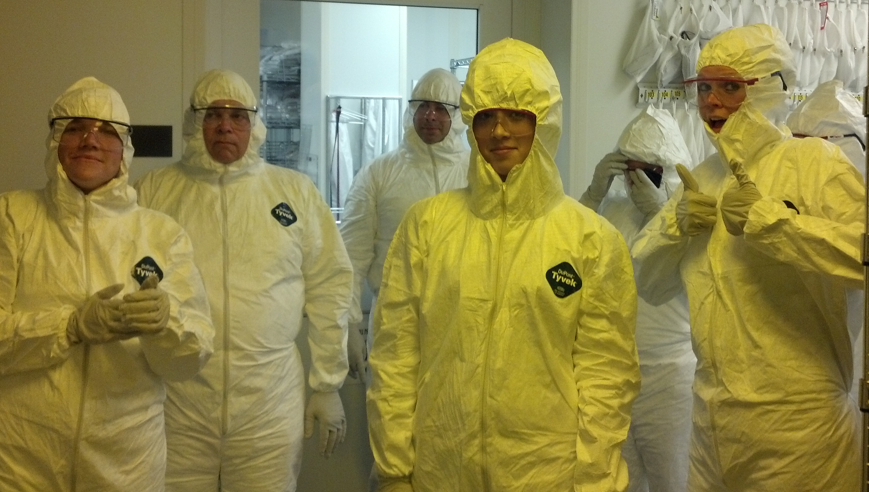

- Present educational materials created by the program

Note: Schools must be within a reasonable commuting distance of Cornell University
to facilitate regular visits.

Energy-related instructional materials created through the Grass Roots program will be designed by teacher-fellow teams to fit into NY state-mandated science/engineering curriculum and will be science process skill- driven, consistent with the Next Generation Science Standards (NGSS) currently under development for K-12
education nationwide. Since some projects will be computational, teachers with computational skills and interest in renewable energy are particularly encouraged to apply.

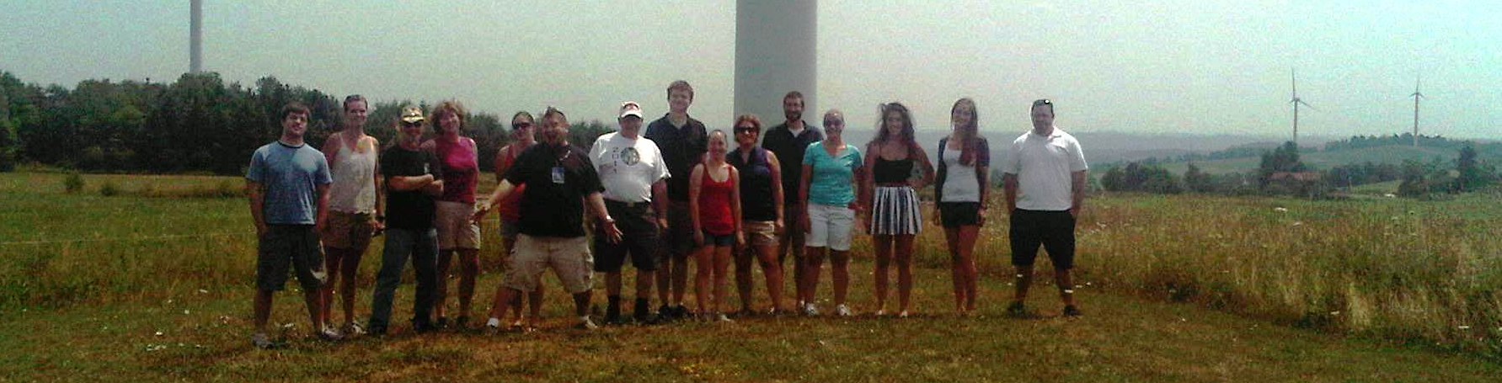

Tuition, Stipend, and Housing
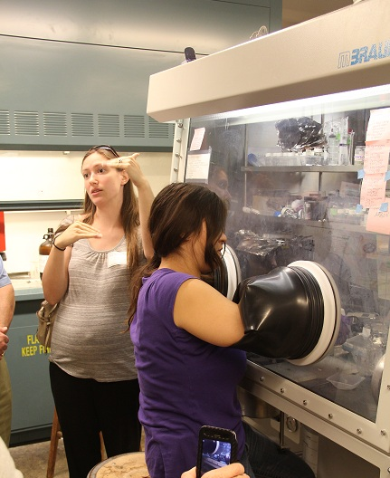
- Teacher’s Summer Stipend:
  - $3400 and a professional development certificate
OR
  - $3000 and three graduate credits with tuition and
fees paid by the Grass Roots program.
- Mileage reimbursement for project-related travel up to
$700. Local lodging arrangements may be made at no
cost to you. Please contact us for more details if interested.
- Summer equipment/supplies/curricular materials: up to
$400 reimbursed
- School year stipend: $800 to develop educational materials in collaboration with your GK-12 fellow.

Application Procedures
Please complete the entire application form in this brochure or download the application from the web (https://confluence.cornell.edu/display/gk12/APPLICATIONS) .In addition to your completed application, the following materials must be submitted:
- A statement of purpose explaining why you want to attend the program, your interest in alternative energy,
how you will bring your Cornell research experience into the classroom, and how renewable energy fits into
your curriculum.

- A résumé that includes your educational background, employment history, awards, and a list of your attendance
or participation in conferences, workshops, and courses.

- Two letters of recommendation from professional colleagues or school administrators.

- One letter of recommendation from a former student.

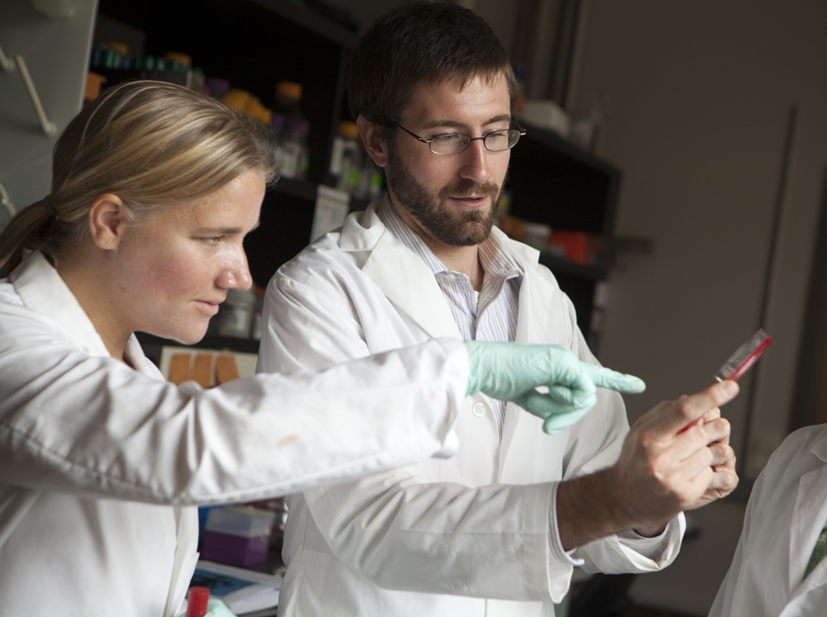
Mailing address/contact for Further Information

Dr. Julie Nucci
Program Manager, Grass Roots GK-12 Program
238 Thurston Hall, Cornell University, Ithaca, NY 14853-1501
Fax: 607 255-2365
Email: jn28@cornell.edu
Website: https://confluence.cornell.edu/display/gk12/

Application deadline: April 15st, 2014 Notification deadline: May 1st, 2014.

2014 Grass Roots Application
Applicant Information

Name: _______________________________________ E-mail:

Home/Cell telephone:_______________________________ Work telephone:

Home address: ________________________________ City: _____________________ State: ______ Zip:

Current Position/Title:___________________________________________________________________________________

Number of years teaching: ________________ Year tenure received:

Degree(s), Major(s) and Year(s) Received:____________________________________________________________________

Certifications:_________________________________________________________________________________________

Courses taught:
Years | Name of course | Number of sections | Level
2013 - 2014
Expected for

2014-2015

School/Institution Information:

High school/institution:

Address: _______________________________________ City: _______________________ State: ____ Zip:

Completion of the enclosed information is voluntary. This information is requested by the National Science Foundation (NSF) to determine how well the program serves all segments of the diverse population.

Locale: Urban Suburban Rural Total enrollment ______________ Grades
Student demographics: African American _____% Pacific Islander _____% Asian _____%
Native American _____% Latino/Hispanic _____% Caucasian _____%
Percentage of students eligible for free or reduced lunch _____%

THE INFORMATION IN MY APPLICATION IS ACCURATE TO THE BEST OF MY KNOWLEDGE.

Applicant’s signature:

Application checklist: enclosed are the application, résumé, statement of purpose, 3 recommendation letters
Your application will only be considered if we receive all of the above materials by April 15, 2014.

2014 GRASS ROOTS GK-12 PROGRAM

Advancing Education in Renewable Energy and Cleaner Fuels

Summer Course for Science teachers

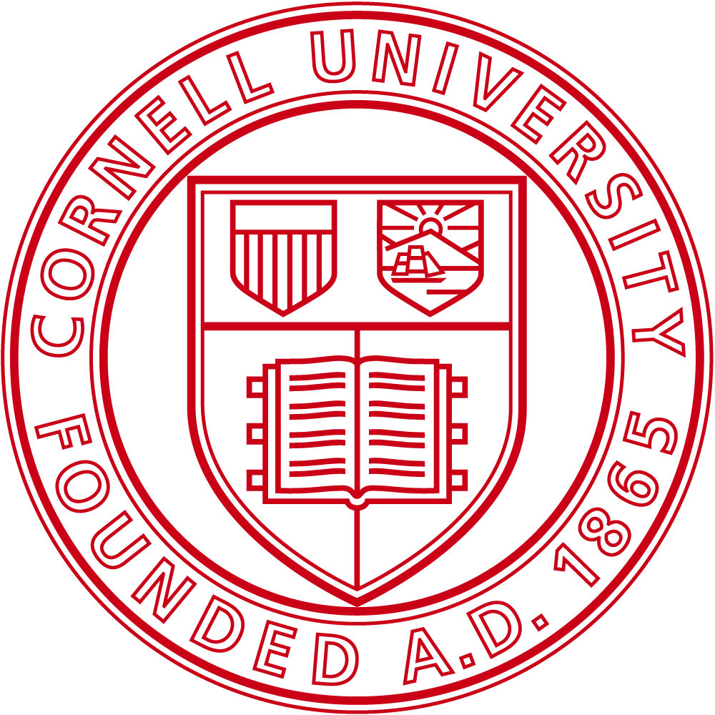

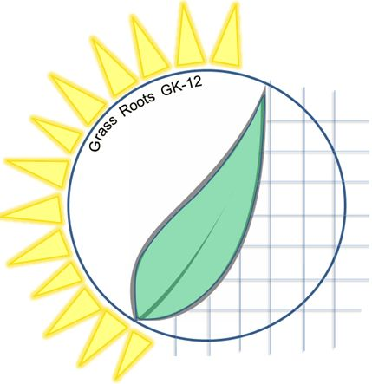
GRASS ROOTS GK-12 PROGRAM
Cornell University
238 THURSTON Hall
Ithaca, NY 14851-1501

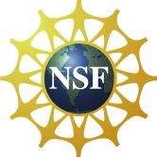
The School of Continuing Education and Summer Secessions reserves the right to change or cancel this program. Cornell University is an equal-opportunity, affirmative-action educator and employer. Support comes from the GK-12 Program of the National Science Foundation under NSF Award #DGE-1045513. PIs: Professors Paulette Clancy and Emmanuel Giannelis

