Title: | Aluminum-Air Battery Lab
Initial Version: Revision: | 6/8/2015
Authors: | Tiffany V. Williams and Brian P. Williams
Course &  Appropriate Level: | High school chemistry/physics
Abstract: | A developing energy storage technology – the metal-air battery – is a promising replacement for traditional battery technology. Metal-air batteries promise higher energy density through clever design, as half of the battery’s mass is reduced when O₂ is used as a reactant.  In this lab, students will make metal-air batteries using Al and Fe electrodes. The performance of these batteries will be evaluated through measurement and device implementation. Students will explore how the battery voltage changes by: (1) using different metals as the electrode, (2) using different electrolytes, and (3) by placing the cells in series. An additional demo focused on corrosion is also included in this writeup.
Time Required: | 90 minutes – 15 min for PowerPoint presentation, 60 min for activity, 15 min for follow-up corrosion experiment
NY Standards Met: | Physical Setting/Chemistry  3.2: Use atomic and molecular models to explain common chemical reactions  3.3: Apply the principle of conservation of mass to chemical  reactions
Special Notes: | This laboratory activity was created via Cornell University’s NSF GK12 Grass Roots Program: Award 1045513

Student Learning Outcomes:
Upon completion of this lab activity, students should be able to:
- Draw a schematic of a basic Al-air battery
- Write half-reactions associated with anode and cathode
- Understand how cells add voltages when arranged in series
- Describe the arrangement of metals in the electrochemical series
- Identify the factors that contribute to corrosion of a metal

Class Time Required: 90 minutes (15 for PowerPoint presentation, 60 for activity, 15 for followup corrosion experiment.

Teacher Preparation:
The following materials need to be secured/prepared:

- 0.1M NaCl solution (15 mL/group)
- 0.1M NaOH solution (15 mL/group)
- Paper towels, cut into 3”x 3” squares
- 5”x 3” Al foil squares (4 squares/group)
- 4”x 4” cleaned Fe squares (4 squares/group)
- Plastic dropper
- Activated carbon (9g/group)
- Balance
- Buzzer to produce sound (1/group)
- Red LED (1/group)
- Wires to connect cells (3/group)
- Digital multimeter (1/group)
- Petri dishes for corrosion experiment
- Steel wool
- Goggles
- Gloves

Tips/Notes for the Teacher:
- Ensure that surface oxides have been removed from Al, Fe metals before running the lab
- Voltages from students’ cells will vary, depending upon how well the wires make contact with the C, Al foil
- Do not oversaturate the carbon with electrolyte, as cell will not perform efficiently
- 0.1M NaOH should be rinsed off of skin with water, should contact occur
- Suggested to perform lab over two days. Day 1: Presentation + battery exercises + corrosion experiment setup. Day 2: examine corrosion experiment, evaluate hypotheses made by the students.

Al-Air battery Experiment Questions and Answers:
- Record the voltage here: ___~1.5__Volt
- Write down your observations. The red LED does not light.
- Given that red LEDs take roughly 1.7 V to light, does this observation make sense? Yes, the red LED doesn’t light since it has insufficient voltage.
- Predict what will happen to the voltage for the two batteries in series. The voltage will add for the two cells. If the cells are similar, it will approximately double.
- Measure the voltage of the series of cells by placing the probes on the carbon of the first cell and the foil of the second cell. Record the voltage here: __~3.0__ Volts
- Write down your observations: Now the red LED lights.
- Measure the voltage of the each individual cell separately. Record the voltages here:
Cell 1: ___0.7-0.9 ___Volt Cell 2: __0.7-0.9 __Volt
- Connect the cells in series as previously done and measure the voltage of the series. Record the voltage here: ___1.4-1.8 ___Volts
- Is this enough voltage to light the LED? The buzzer requires about 1.2V-1.5V to operate. Would this be enough voltage to make the buzzer work? Should definitely operate buzzer. LED may light depending upon voltage attained for both cells.
- Record your observations: They should observe the buzzer working and maybe the red LED lighting.
- How could you modify the battery setup to make the LED light? Add another Al cell (+ NaCl or NaOH electrolyte) in series to the existing setup.
- Measure the voltage of each individual cell with the red probe on the carbon and the black probe on the iron. Record the voltages here:
Cell 1: 0.2-0.3 Volts Cell 2: 0.2-0.3 Volts Cell 3: 0.2-0.3 Volts Cell 4: 0.2-0.3 Volts
- By placing the red probe on the carbon of the first cell and the black probe on the iron of the fourth cell, measure the voltage of the entire series of cells. Record the voltage: 0.8-1.2 V
- Which device could this series of electrochemical cells power? Should operate buzzer if students’ cells have sufficiently high voltage.
- Carbon steel is the dominant type of structural steel used in construction and industry. Steel is made by mixing a small amount of carbon with iron to increase the iron’s strength, which also reduces its ductility, but has little effect on the steel’s electrochemistry. What implications does this experiment have for uncoated carbon steel structures in a natural environment? Uncoated carbon steel will corrode over time, eventually leading to structural degradation.

Steel Wool Corrosion Experiment Questions and Answers
- Steel wool in air: Depending on humidity, may see some corrosion but not likely.
- Steel wool in deionized water: Will corrode slightly due to dissolution of CO₂ in water.
- Steel wool in salt water: Should see significant corrosion since the metal is in contact with an electrolyte solution.
- Steel wool connected to Al foil in salt water: Steel wool should not corrode significantly, due to the presence of Al (sacrificial electrode).
- Steel wool and Al foil in salt water: Both metals will corrode (though Fe oxide will be much more noticeable) since they are not connected via wire.
- Steel wool connected to Al foil in separate salt water containers: Both metals will corrode since they do not share electrolyte.

Post Lab Questions and Answers
- Using the general reaction equations below for a metal air battery, write the balanced two half reactions and the subsequent reaction for an Al-air battery. Then write the balanced net reaction equation.
Anode:
Cathode:
Net:
- What was the average voltage for an iron cell and aluminum cell in salt water? How does this compare with the galvanic series?
V_{avg, Fe (salt)}: 0.2-0.3V; V_{avg, Al (salt)}: 0.7-0.9V. Follows the galvanic series, as expected.
- Normally aluminum has a protective oxide layer that prevents corrosion. However, this is not the case for conditions that are physically or chemically harsh to the oxide layer. Is there anything you could say could about the two electrolytes used in this lab? Which electrolyte was better?
NaOH is a stronger electrolyte. (For reference: NaOH and NaCl have different mechanisms for overcoming the oxide layer – OH⁻ breaks it down and Cl⁻ diffuses through.)
- Consider the situation discussed in class where a stainless steel bolt is fastening a zinc coated carbon steel plate. Write the half reactions that are occurring at the bolts and the zinc coating. Then determine whether the bolt or zinc coated plate is the cathode. Is the cathode corroding and why or why not? How does this compare to the activated carbon cathode in a metal air battery?
Anode:
Cathode:
Bolts are cathodes, they do not corrode because no Fe ions are released.
- Before the 1960s, houses were constructed using steel pipe plumbing and as such many old houses still contain them. Today, the residential standard for hot fresh water plumbing is copper. Let’s say that an inexperienced plumber is doing work on an old plumbing system and wants to directly partially replace a portion of old steel pipe with new copper tubing. As a knowable homeowner, what concerns should you have about this job, and which pipe should the homeowner be most concerned about? Extra Credit: Should the homeowner have the same level of concern for a closed system (like in a base board heating system) and why or why not?
There are different metals (located in different regions of the electrochemical series) in contact with one another + possible water exposure, which could lead to corrosion of the pipe.
EC: Should not be as concerned though there is the risk of corrosion due to possible H2O exposure to the outside of the pipes. Within the pipes, as long as the oxygen is depleted (and the system remains closed) there should be no corrosion.


Grass Roots GK-12 Laboratory Activity

Aluminum Air Battery and Corrosion Worksheet

Purpose: To create simple batteries to power LEDs/low-voltage buzzers and demonstrate how electrochemistry affects the corrosion of metals.

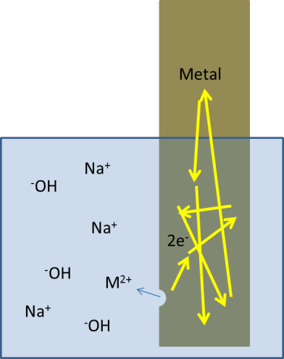
Introduction: Batteries are devices that convert chemical energy (stored in the form of chemical bonds) into electrical energy. In general, when a metal is exposed to a suitable electrolyte, some metal atoms will leave the solid phase in order to become positive ions in solution. The “extra” electrons left behind (due to the formation of cations) accumulate on the surface of the metal. This behavior comprises the half-reaction at the anode of a battery and is known as oxidation. By itself, this reaction does not progress very far because equilibrium is quickly established between forward and reverse reactions occurring at the metal-electrolyte interface.

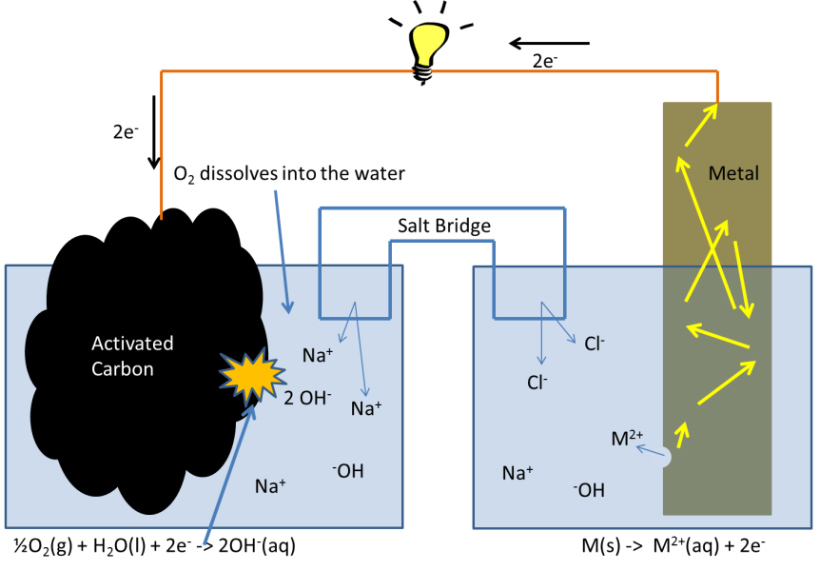
To drive this half reaction toward the formation of products, the electrons cannot be allowed to accumulate in the metal. Coupling this oxidation reaction at the anode to a reduction reaction at an additional electrode helps to drive the forward reaction since the “extra” electrons in the reaction are now being consumed. Consequently, because the half-reactions are separated, the electrons cannot flow directly to the reaction sites and so the energy in the flow of electrons traveling from one reaction to the other can be used. While the details of such an electrochemical can be complex, the setup and application of such a reaction can be quite simple and use common materials.

Materials (per group):

- 0.1M NaCl solution (15 mL)
- 0.1M NaOH solution (15 mL)
- Paper towel, cut into 8 squares
- 4 Al foil squares; 5”x3”
- 4 cleaned Fe squares
- Plastic dropper
- Activated carbon (9 g total)
- Balance
- Buzzer to produce sound
- Red LED
- 3 wires to connect cells
- Digital multimeter

Experiment 1: Use an Al-Air Battery to Sound a Buzzer
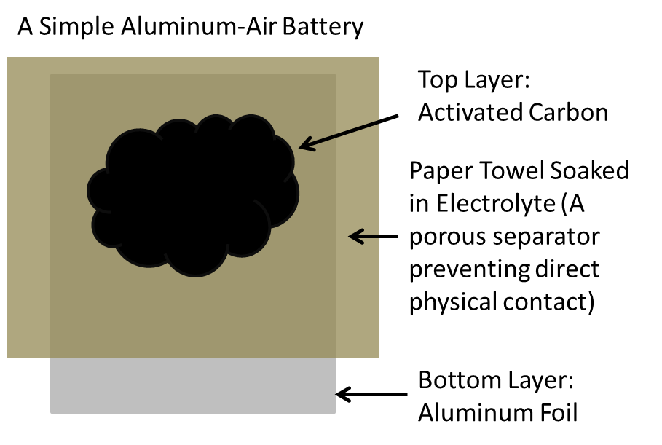
- Place a piece of aluminum foil down on the lab bench. Cut the foil to size if necessary.
- Using tweezers, dip the paper towel into 0.1M NaOH solution and place it onto the foil. Arrange the paper towel so that a piece of the aluminum foil is exposed. Remove any large air bubbles between the foil and the paper towel. If you find using the tweezers to be difficult, you may use your hands (but remember to wash them when you are finished).
- Measure roughly 1 gram of activated carbon and pour it onto the paper towel. Spread the carbon out evenly to the edge of foil under the paper towel. Using a pipette, place about 15 drops of the 0.1M NaOH solution spread evenly across the carbon.
- Set the voltmeter to a range appropriate to measure approximately 1 Volt. Measure the voltage of this single cell battery by placing the black probe on the foil and the red probe in the activated carbon. Wait a few seconds until the voltage reading settles down.
- Record the voltage here: __________ Volt
- Take the electric music buzzer, and press and hold the end of the red wire in the carbon and the black wire end to the aluminum foil. Soft music or buzzing should begin.

Experiment 2: Use an Al-Air Battery to Light an LED
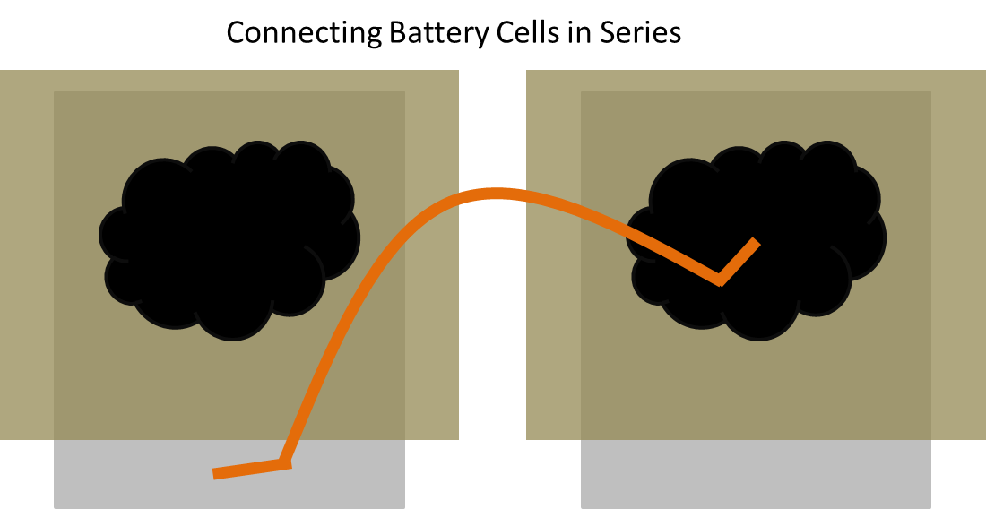
- Find the LED and ensure that the wires extending the LED’s leads are well attached.
- Connect the end labeled with a “C” to the carbon and the other end to the foil.

- Write down your observations.

- Given that red LEDs take roughly 1.7 V to light, does this observation make sense?

- Create an additional battery cell using the directions above. Connect the cells together in series by connecting the aluminum foil of the first cell to the carbon of the second cell.

- Predict what will happen to the voltage for the two batteries in series.

- Measure the voltage of the series of cells by placing the probes on the carbon of the first cell and the foil of the second cell. Record the voltage here: __________ Volts

- Connect the end of the LED labeled with a “C” to the carbon of the first cell and the other end to the aluminum foil of the second cell. Make to press and hold all the wire connections.

- Write down your observations.

- When you are finished with this section, discard the cells.

Experiment 3: Use an Al-Air Battery in Salt Water
- Construct two new cells using the process above except soak the paper towel in 0.1M NaCl solution. Also use the NaCl solution for the 15 drops onto the activated carbon.

- Measure the voltage of the each individual cell separately. Record the voltages here:

Cell 1: _________ Volt Cell 2: __________ Volt

- Connect the cells in series as previously done and measure the voltage of the series. Record the voltage here: ___________ Volts

- Is this enough voltage to light the LED? The buzzer requires about 1.2V-1.5V to operate. Would this be enough voltage to make the buzzer work?

- Connect the buzzer by placing the red wire end on the carbon of the first cell and the end of the black wire on the aluminum foil of the second cell and observe. Remove the buzzer and connect the LED as you previously did.

- Record your observations.

- How could you modify the battery setup to make the LED light?

- Discard the cells when you are done.
An Fe-Air Battery Using Salt Water
- Construct a total of four battery cells using the salt water and four small iron plates. Keep the carbon in a small even pile roughly 1.5” x 1.5” in the center of iron plate on top of the paper towel.

- Measure the voltage of each individual cell with the red probe on the carbon and the black probe on the iron. Record the voltages here:

Cell 1: _______ Volt Cell 2: _______ Volt Cell 3: _______ Volt Cell 4: _______ Volt

- Connect them all together in series with three pieces of wire like in the previous section.

- By placing the red probe on the carbon of the first cell and the black probe on the iron of the fourth cell, measure the voltage of the entire series of cells. Record the voltage here: __________ Volt

- Which device could this series of electrochemical cells power?

- Connect this device like previously and observe the result. It may take several students to firmly hold down all the connection points.

- Carbon steel is the dominant type of structural steel used in construction and industry. Steel is made by mixing a small amount of carbon with iron to increase the iron’s strength, which also reduces its ductility, but has little effect on the steel’s electrochemistry. What implications does this experiment have for uncoated carbon steel structures in a natural environment?

Steel Wool Corrosion Experiment
For each of the following 6 setups write a brief prediction and explanation as to what will happen after letting each setup sit out overnight.

- Steel wool in air

- Steel wool in deionized water

- Steel wool in salt water

- Steel wool connected to Al foil in salt water

- Steel wool and Al foil in salt water

- Steel wool connected to Al foil in separate salt water containers

Post Lab Questions
- Using the general reaction equations below for a metal air battery, write the balanced two half reactions and the subsequent reaction for an Al-air battery. Then write the balanced net reaction equation.
Anode
Cathode
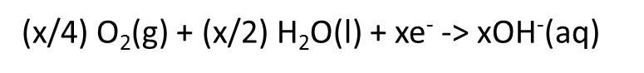


Solution
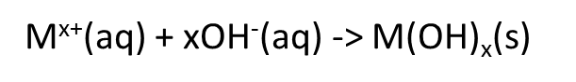

- What was the average voltage for an iron cell and aluminum cell in salt water? How does this compare with the galvanic series?

- Normally aluminum has a protective oxide layer that prevents corrosion. However, this is not the case for conditions that are physically or chemically harsh to the oxide layer. Is there anything you could say could about the two electrolytes used in this lab? Which electrolyte was better?

- Consider the situation discussed in class where a stainless steel bolt is fastening a zinc coated carbon steel plate. Write the half reactions that are occurring at the bolts and the zinc coating. Then determine whether the bolt or zinc coated plate is the cathode. Is the cathode corroding and why or why not? How does this compare to the activated carbon cathode in a metal air battery?

- Before the 1960s, houses were constructed using steel pipe plumbing and as such many old houses still contain them. Today, the residential standard for hot fresh water plumbing is copper. Let’s say that an unexperienced plumber is doing work on an old plumbing system and wants to directly partially replace a portion of old steel pipe with new copper tubing. As a knowable homeowner, what concerns should you have about this job, and which pipe should the homeowner be most concerned about? Extra Credit: Should the homeowner have the same level of concern for a closed system (like in a base board heating system) and why or why not?

