Importing the RDA Macros in Macro Express 3

Open the Macro Express program
After Macro Express is open …
Click on File, then Import, and then Import Macros
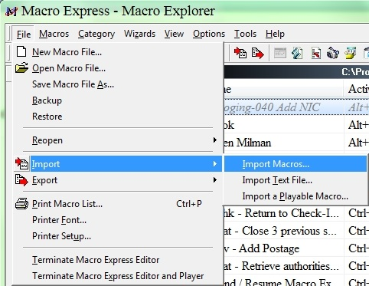

You should now see the Import Macros window below:
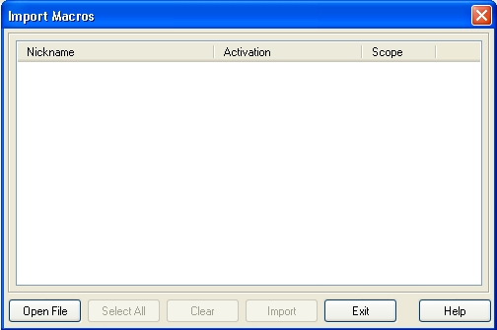
Click on the Open File button.
You should see the Import Macro File window:
NOTE: You may have to navigate to the correct location of the file you wish to import the macro from**.
If so, just use the drop-down arrow to navigate to the correct location.
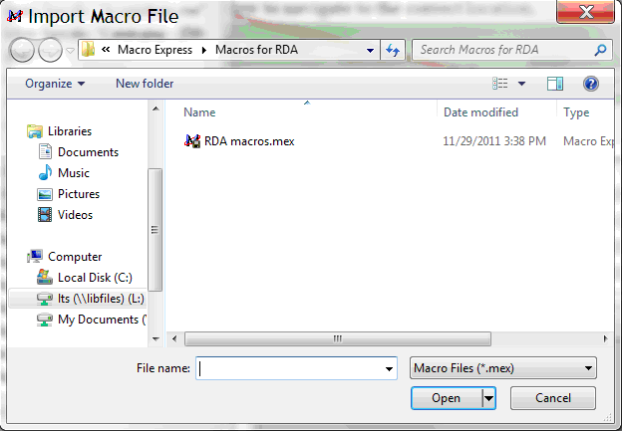
**The above screenshot is from Peter’s computer. The window you see may look slightly different. Navigation to the appropriate location of the RDA macros.mex file, may be needed.

Once located, highlight the RDA macros.mex file and click the Open button, the previous Import Macros window will now be populated with the RDA macros, see following window:
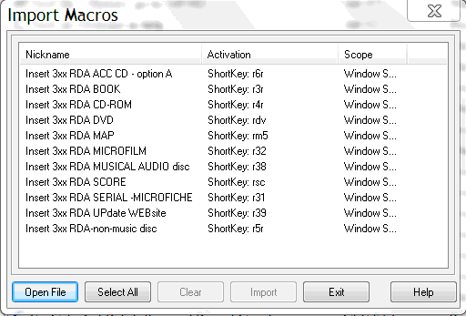
In the above window, just click on the Select All button.
The Import button should now be activated, just click the Import button.

Your macros should have been imported into your current existing .mex file.
You should double-check your original file to make sure that they did indeed get imported.

If you receive the following window:
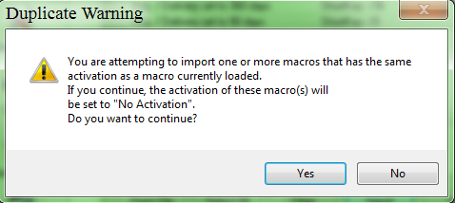
This means one or more of the macros you selected is already in the file you are trying to import to. Answer this according to your preference or need.

If you need help in this area, please do not hesitate to contact any of the Macro Express team members for assistance.

