Testing Protocol for GH Bladed 4.1
Open the program: Start>All Programs>Bladed 4.1 Educational>Bladed 4.1 Educational
Open the Demo Project: File>Open Project>demo_a.prj. The file location should be C:/Program Files (x86)/Bladed 4.1 Educational/demo_a.prj.
In the Calculations window (the lower window), the icon to the right of each calculation step should have changed from red/yellow to green, except for the Electrical Performance and Hardware Test calculations, which should still be yellow.
Run the Modal Analysis Calculation by selecting it from the calculation screen, under Supporting Calculations, and clicking Run Now at the bottom. When the calculation is complete Run completed normally should appear in the Calculation Progress window under Calculation Messages. Click Results, and the following screen should appear:
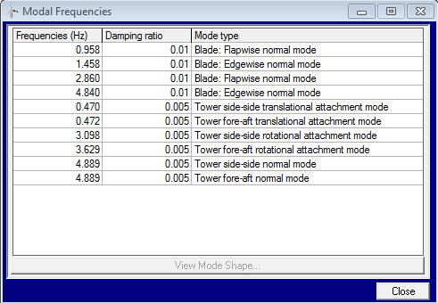

Run the Steady Operational Loads Calculation by selecting it from the calculation screen, under Steady Calculations, and clicking Run Now at the bottom. Use the default settings for output location and file name. After the calculation is complete, in the Calculation Progress window, the following should appear under Calculation Messages:
*** Note: Table of mechanical losses: out of range
Run completed: 1 warnings.
Run the Power Production Loading Calculation by selecting it from the calculation screen, under Simulations, and clicking Run Now at the bottom. Use the default settings for output location and file name. After the calculation is complete, in the Calculation Progress window, the following should appear under Calculation Messages:
*** WARNING: Bladed Educational: Only the longitudinal component of turbulence will be used
*** Note: With this passive actuator model, the actuator torque and bearing friction are not fully defined.
*** Note: 2 aerodynamic warnings generated.
Run completed: 2 warnings.

