 | ESW Solar Cookers
 | 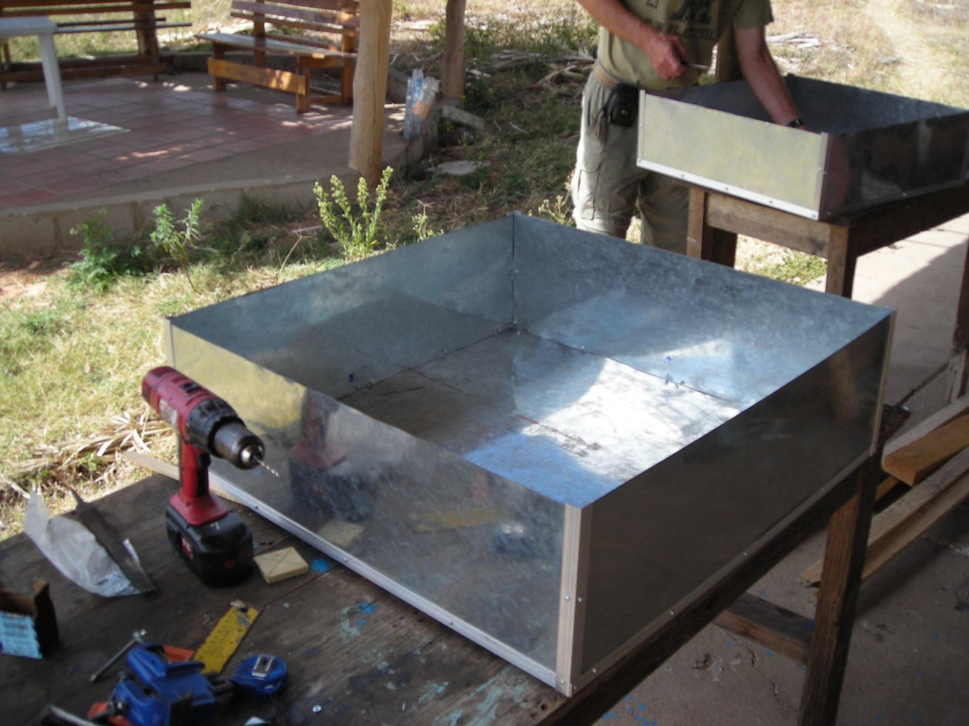
2/18/2013 | Spring 2013 Double Box Team Proposal
Team Members:
Alex Huang, Joon Hwang, Chris Perrotti, Michael Horsgield and Mark Henry

ESW Solar Cookers

Spring 2013 Double Box Team Proposal

Introduction

The first double box cooker was designed in the Spring of 2012 by the Solar Ovens group at Cornell University. The cooker was a response to the women group in Nicaragua’s request for a light, portable oven that could be easily constructed using methods and materials found in Nicaragua and easily transported. This design was implemented with a light aluminum angle frame in lieu of a heavy wooden frame and making a design that would allow for the two separate halves of the oven (inner box and outer box) to be worked on simultaneously to save time. The independent boxes of the cooker could be disassembled and reassembled easily. Once the first design was taken to Nicaragua, some major design flaws of the prototype surfaced, of which included a wall that was too high, which caused shadows to be cast on the cooking area, a cooking area that was too small, which didn’t allow enough sunlight to enter the oven, and a door that was too small for the oven, which, also, cast a shadow over the cooking area. To remedy these issues, we redesigned the oven to have a larger cooking area, a shorter wall height, and a door that actually fits on the oven.
Last semester the team's goal was to redesign the double box cooker to implement the changes that were noted after the Nicaragua trip in the spring of 2012. The overall goal was the make the oven larger and use materials that are available in Nicaragua. The general method of fabrication was the same as in the spring of 2012, where we used the aluminum angles to create a frame rather than use wood as is done in a traditional solar cooker. In this semester we managed to almost complete the redesigned oven. We managed to make everything except for the door, which will be redesigned and manufactured during this semester.

Semester Goals

The primary goal of the Spring 2013 semester will be to complete construction of the Fall 2012 double box oven. The main work remaining is to construct a door that will be able to effectively and easily implement polypropene solar oven bags. This new design will be properly documented and brought to Nicaragua.
After completing the double box oven, the team will establish a testing procedure to evaluate the effectiveness of the oven. We will use the ASAE’s “Testing and Reporting Solar Cooker Performance” standard as a basis for our testing procedures. By creating an effective testing procedure, the ESW Solar Cooker team will be able to test cooker performance across different styles of cookers.
The results of our testing process will provide ideas for improving the design. We hope to document these discoveries in an effort to continuously improve our design.

Timeline

2/18 | 2/25 | 3/4 | 3/11 | 3/18 | 3/25 | 4/1 | 4/8 | 4/15 | 4/22 | 4/29 | 5/6
Project  Proposal |  |  |  | Nicaragua | Revised  Construction  Manual |  |  |  |  |  | Final  Presentation
Make Door |  |  | Finalize oven and Test |  |  |  | Review Design & Improve
 |  | Edit Current  Construction Manual  for Nicaragua |  |  |  |  |  |  | Write Final  Report

We want to start off this semester with finishing up the double box oven that we started in the fall of 2012. As soon as the door is completed, we will edit the construction manual to account for the door and any changes that we might have made to the design in preparation for the trip to Nicaragua. Since we will be looking over the entire construction manual, we can start looking for places where we can improve the design and definitely improve the practicality of our design when we see what works and doesn’t work in Nicaragua. When we get back from Nicaragua, we will continue to design a new oven while revising our construction manual with things that we learn from Nicaragua. Once we design the new oven, we will begin the construction of the new oven and try to build as much of it as we can before we have to write up a final report and present our work from this semester. Weekly deliverables and project deadlines will be tracked through a Google Spreadsheet. Meeting minutes will be uploaded to the team’s ESW wiki page.

Materials and Cost

 | Materials List | Costs
Oven Frame | Aluminum Angles | $12.00
Glass | Reynolds Bags | $2.00
Door | Wood | $2.00
Glass Holder | Wood | $2.00
Insulation | Fiberglass Batting | $10.00
Metal Sides | Sheet Metal | $13.00
Metal Bottom | Sheet Metal | $10.00
Interior Case | Aluminum Sheet | $12.00
Bottom Metal Plate | Sheet Metal | $10.00
Total |  | $73.00

These are the materials used to construct all parts of the oven except the door. We aim to construct the new door using wood and simple hardware to keep the final cost affordable.

The material list will be updated at the end of the semester with the additional materials used to construct the door. As always, the team will keep in mind the availability of the material in Nicaragua when selecting materials.

Proposed Design
3D VIEW
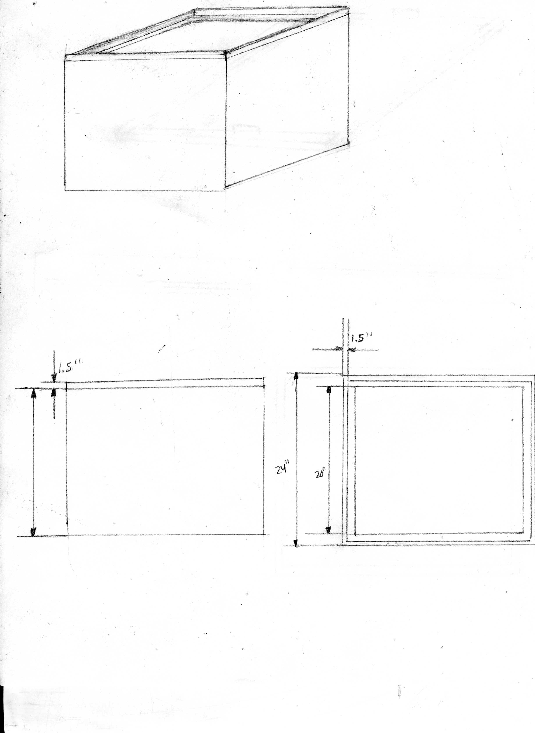

TOP VIEW
SIDE VIEW

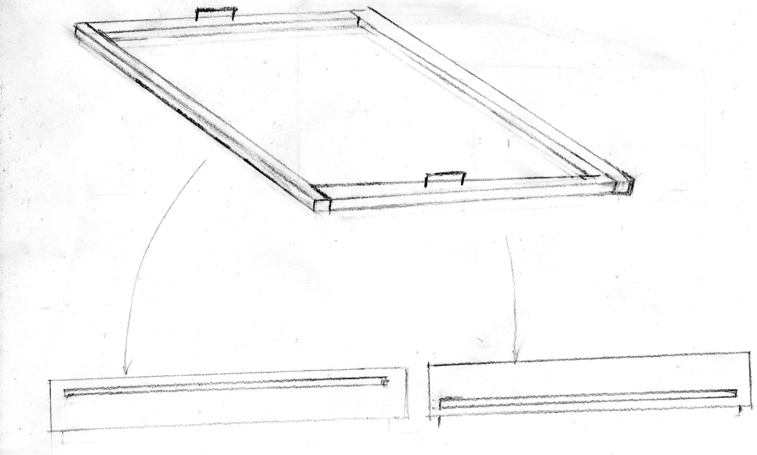

The above design is a detailed view of the removable door. The high temperature cooking bag material will be passed through the slot. This will form the doubled layer glazing for the cooker.

Desired Outcomes

The main goal of the semester will be to refine and improve our oven design. The biggest hurdle for our team is creating a design that will make the use of polypropylene glazing feasible. The main issues at hand include attaching the glazing material to the door and forming an airtight seal between the cooking area and the door.
Additionally, the new testing procedure we hope to create will provide the ESW solar cooker team with a method of benchmarking our cookers. This will also give us the opportunity to validate whether our design improvements actually increase the effectiveness of the oven.
Lastly, during the fall construction process, many complications arose. We hope to improve the construction manual to make the process as simple and clear as possible.
Ultimately, the double box oven team would like to complete construction and testing of the current double box design by March 1st, 2013, while maintaining a material cost of $73 or less. The team hopes that the oven operates with high efficiency while remaining lightweight and inexpensive. Finally, the double box oven team hopes to contribute to the overall mission of providing a sustainable option for Las Mujeres de Solares.

