 | ESW Solar Ovens
 | 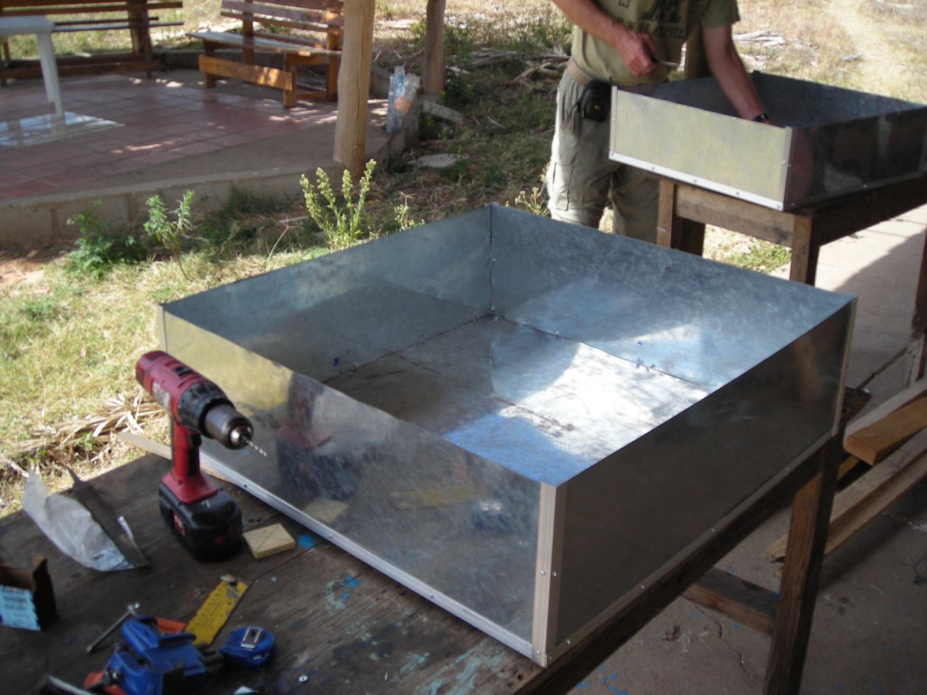
5/6/2013 | Spring 2013 Double Box Final Report
Team Members:
Mark Henry, Michael Horsfield, Alex Huang, Joonyoung Hwang, and Chris Perrotti

ESW Solar Ovens

Spring 2013 Double Box Final Report

tABLE OF cONTENTS

Introduction…………………………………………………………… | 2
Problem Definition and Goals………………………………………. | 5
Materials and Cost……………………………………………………. | 5
Timeline…………………………………………………………………… | 6
Results……………………………………………………………………. | 7
Conclusions……………………………………………………………. | 11
Appendix…………………………………………………….……………. | 12

Introduction

Background
The double box oven subgroup within the Solar Ovens group at Cornell University was formed in the spring of 2012 in response to Las Mujeres Solares de Totogalpa wanting a light, portable oven that could be easily constructed using materials found in Nicaragua. Once the first prototype was created and tested in Nicaragua, many flaws were found in the design and a second prototype was made in the fall of 2012. The second design consisted of a larger cooking surface area and a shorter wall height, which would remedy the two biggest flaws of the first prototype. We did not have time to finish designing a door during the fall of 2012, so we spent the beginning of this semester designing and building a door for the oven and used the rest of the semester to test our oven and take note of any areas that we could improve on. The primary focus this semester was the oven door, which we wanted to make in a way that would reduce manufacturing time and allow for easy access to the contents of the oven as well as quick changing of the solar cooker bags. From testing the oven, we may need to create a new door that won’t wear down the cooking bags as well as fill in any open cracks or gaps in the oven to allow for more heat retention.

Evolution of Double Box Oven Designs
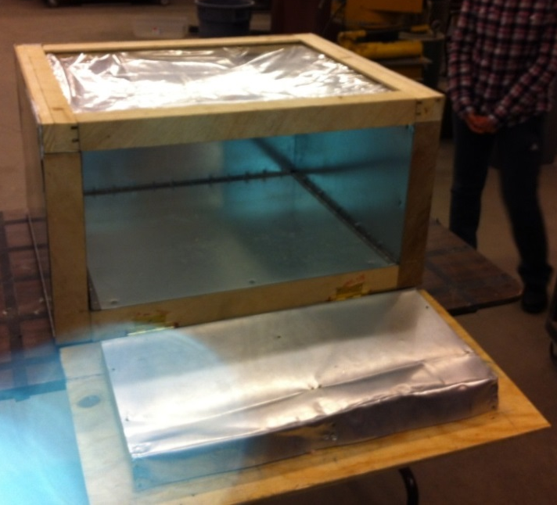 | Fall 2011  The first prefabricatable oven design was used piano hinges to hold the sheet metal sides forming the inner and outer boxes. This oven had a conventional front opening door and utilized wire frames to hold the glazing. Wooden columns at each corner were used to give the oven rigidity. The insulation used was fiberglass batting.
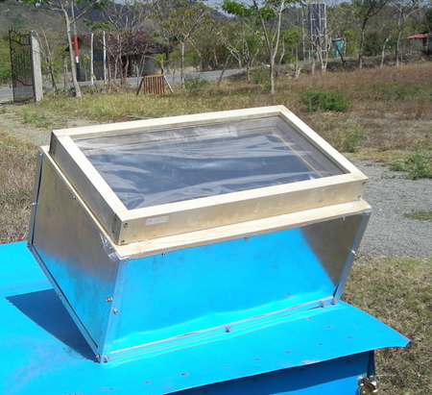 | Spring 2012  This design employed aluminum angles to make an inner and outer box. The only wood used was for the door and at the top to hold the inner and outer box together. Wire frames were also used to hold the glazing. The insulation used was fiberglass board.
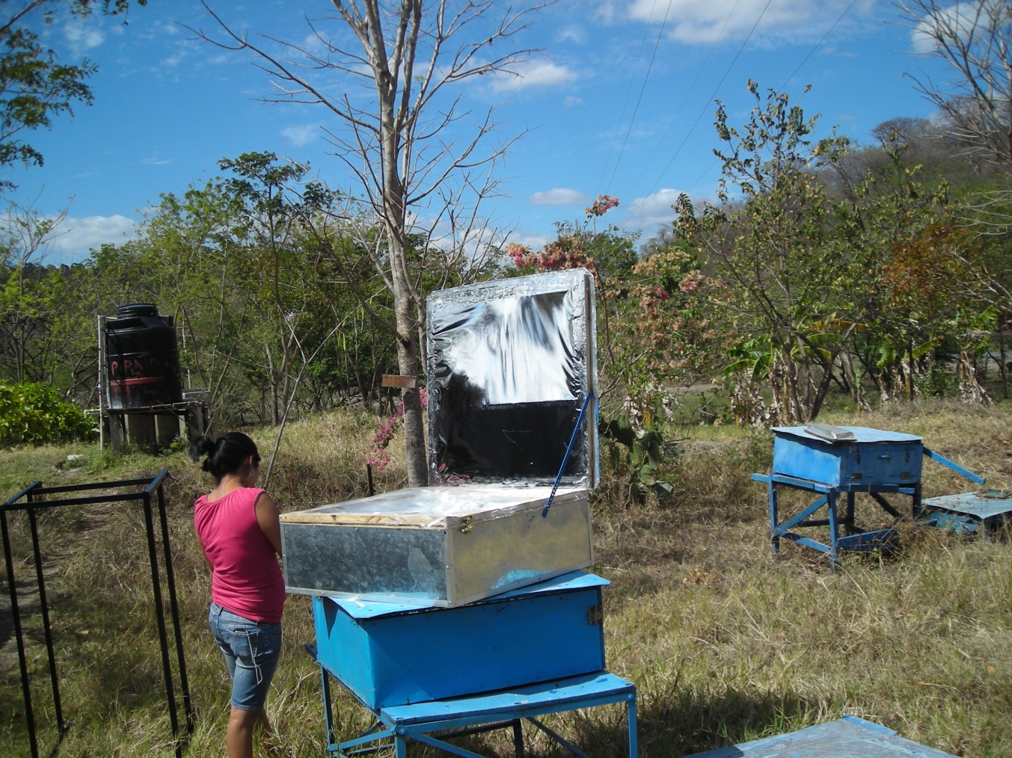 | Spring Break 2012  The two previous designs were brought to Nicaragua. The team set out to build an improved oven using the aluminum angle double box technique, but with a lower wall height and larger cooking area. Steel wire of the size we used and fiberglass board insulation were not available in hardware stores in northern Nicaragua. For this reason, the glazing was stapled to the frame and fiberglass batting was used for insulation.
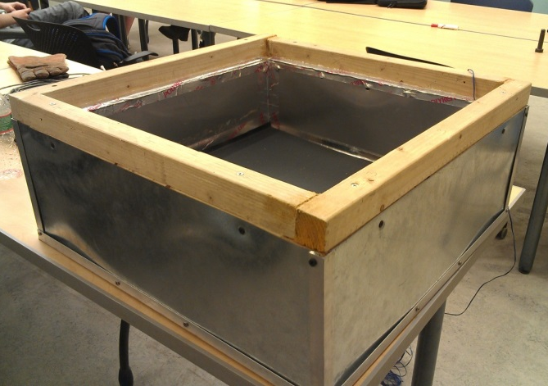 | Fall 2012/Spring 2013  Using the design from Nicaragua, the team set out to replicate the results and design an improved door that was simple to construct and allowed for easy installation of the glazing. The insulation used was fiberglass batting.

Problem Definition and Goals

Goals
The primary goal of the spring 2013 semester was to complete construction of the fall 2012 double box oven. The most significant component that needed to be implemented was a door with the ability to effectively and easily utilize polypropene solar oven bags. Initially, the team had planned to document and send the finished oven to Nicaragua. {You use ‘polypropene’ here and polypropylene elsewhere. Both are accurate, but the use of two different names without describing why might be confusing.}
Upon completing the double box oven, the team intended to establish a testing procedure to evaluate the effectiveness of the oven. The basis for testing procedures was to be ASAE’s “Testing and Reporting Solar Cooker Performance” standard. By creating an effective testing procedure, the ESW Solar Oven team would be able to test oven performance across different styles of ovens. In an effort to continuously develop our design, the results from the testing process would ultimately provide valuable ideas for modification.

Reflection on Goals

Fall 2012
Last semester our main goal was to redesign the double box oven to implement the necessary improvements that were noted after the Nicaragua trip in the spring of 2012. The overall goal was the make the oven’s cooking area larger and design the box in such a way that it could be constructed using only the materials that are available in Nicaragua. The general method of fabrication was the same as in the Spring of 2012, where we used the aluminum angles to create a frame rather than use wood as is done in a traditional solar oven. Last semester we made everything except the oven door.

Spring 2013
During the first half of the semester we designed a new door for the double box oven. The new door adds very little weight the oven. The design involves two rectangular frames. One frame is mounted on the top edge of the oven and the second frame is free to take on and off. The second frame is smaller than the first frame and fits snugly within the first frame (similar to a cookie jar). The overall idea was to wrap a cooking bag around the second frame so that it would be held in place when the second frame was inserted into the first. This would make it easier for the user to replace the cooking bag whenever it wore or got damaged. After finishing the door we noticed that there were two possible ways the bag could be wrapped around the door. We decided to design a testing procedure to see which bag placement is better suited toward our oven. This became the focus of the second half of the semester.

Materials and Cost

 | Materials List | Costs
Oven Frame | Aluminum Angles | $12.00
Glass | Reynolds Bags | $2.00
Door | Wood | $4.00
Door | Top | $4.00
Insulation | Fiberglass Batting | $10.00
Insulation | Thermal Tape | $3.00
Metal Sides | Sheet Metal | $13.00
Metal Bottom | Sheet Metal | $10.00
Interior Case | Aluminum Sheet | $12.00
Bottom Metal Plate | Sheet Metal | $10.00
Miscellaneous | Screws | $6.00
Total |  | $86.00

Shown at the left is a final list of the materials used in the double box oven. The implementation of the door and insulation tapes cost an additional $7.00, bringing the oven to a total of $86.00. This total remains well beneath the expected cost of $213.00, established in Spring of 2012. The weight of the oven was 17 lbs, achieving our goal of making the oven lightweight.

Timeline

1/21 | 1/28 | 2/4 | 2/11 | 2/18 | 2/25 | 3/4 | 3/11 | 3/18 | 3/25
Plan  Semester | Write  Project  Proposal | Write  Project  Proposal | Design  Door | Design  Door | Design  Door | Design  Door | Fabricate  Door | Fabricate  Door | Fabricate  Door

4/1 | 4/8 | 4/15 | 4/22 | 4/29 | 5/6
Fabricate  Door | Test  Oven | Test  Oven | Write  Report | Write  Report | Presentation

Results

Design
After brainstorming new ways install the polypropylene bags, the team came up with two new approaches to implementing the polypropylene bags.
Both designs revolved around adding an outer and inner frame to the top of the oven. The idea was to have the inner frame fit snuggly into the outer frame sealing the oven. The outer frame would be permanently attached and the inner frame would act as the door to the cooking area.

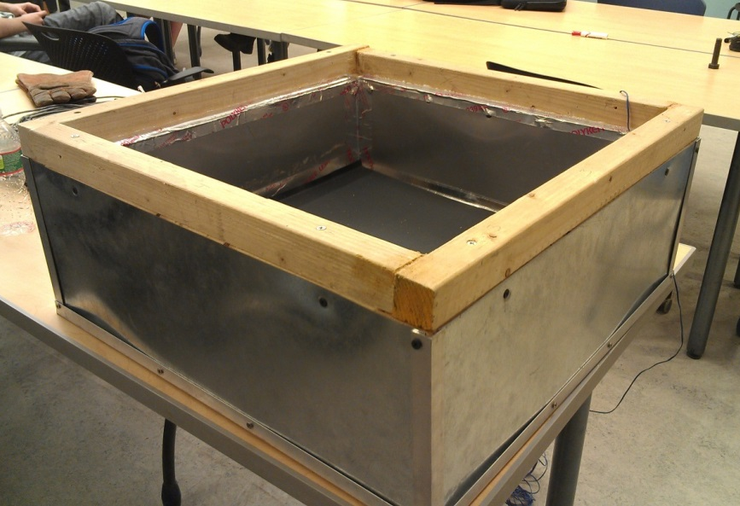
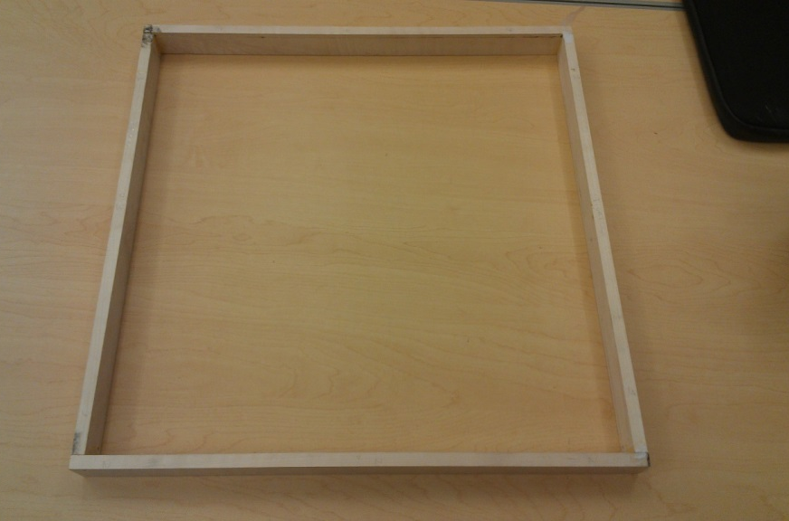
Figure 1. Pictured at top is the outer Frame attached to the oven. At the bottom is the inner frame which will hold the glazing. This frame fits snuggly at the top of the oven.

Using this new door design, the team came up with two different methods of utilizing the polypropylene bags. The two methods are described below.

Installation Method 1: “Double Slit”
This first method required cutting two slits into the inner frame. The construction of this door can be found in Appendix A. These slits allowed two sheets of the polypropylene bag be installed perpendicular to each other and separated by one inch.
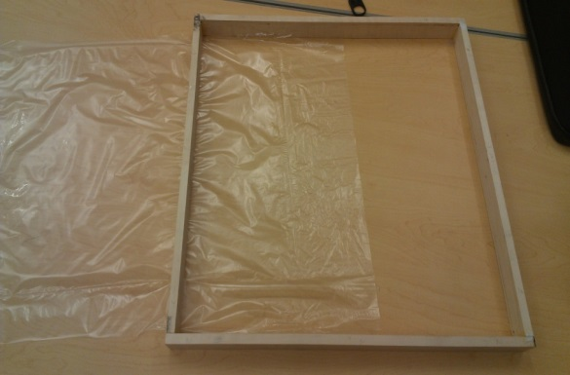
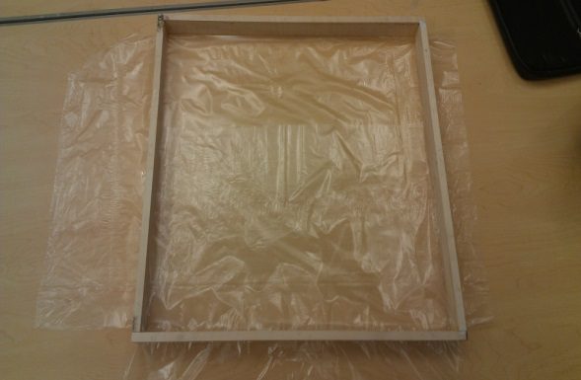
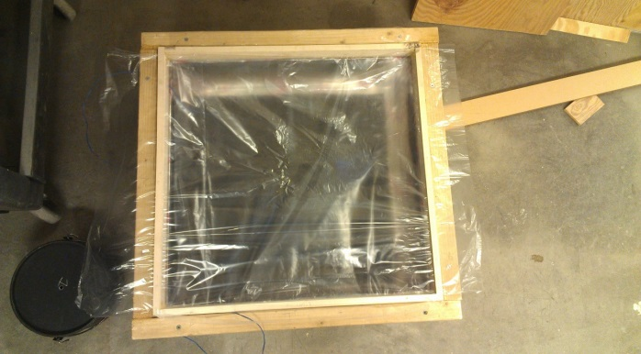
1
2
3

Figure 2. The “Double Slit” installation method uses two sheets of plastic. First, one sheet is installed at the bottom of the frame. Next, the second sheet is installed perpendicular to and above the bottom sheet. The frame is then placed onto oven.

Installation Method 2: “Full Bag”
The second method uses the same frame, but does not require cutting slits into the inner frame. Instead, the frame is placed within a bag.
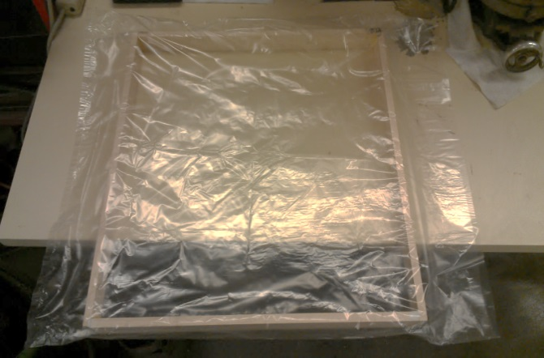
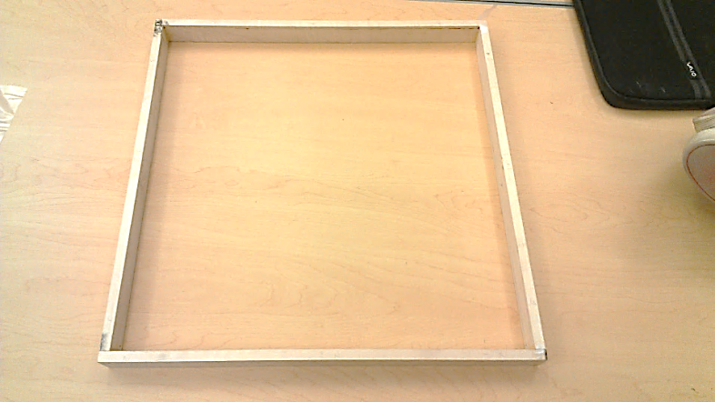
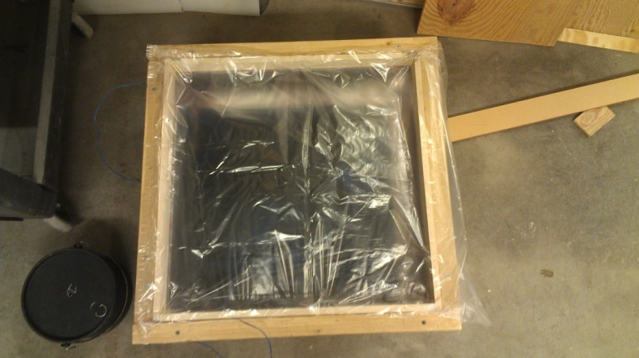
Figure 3. The “Full Bag” installation is simpler. Simple place the frame inside the bag, and then place the bag on top of the oven.
1
2
3

Testing
To evaluate the effectiveness of the oven in a quantitative manner, the team utilized ASAE’s “Testing and Reporting Solar Cooker Performance” standard and adapted the standard to test the ovens using the indoor light array in Winter lab. The procedure can be found in Appendix D. This testing procedure was used to compare the two different glazing installations.

Below the plots of Standardized Cooking Power against Temperature Difference are shown for both methods of installation.

Installation Method 1: “Double Slit”

Installation Method 2: “Full Bag”

Results
The single measure of performance for the Double Slit installation was 86.595 Watts, while the value for the Full Bag installations was 79.18 Watts. By this measure, the Double Slit oven should have a greater cooking power. However, these tests were only run once for each installation method. The tests should be repeated for multiple trials to establish if the results are consistent.
In general terms, both installation methods have their benefits and drawbacks. The double slit installation requires a more extensive construction process, but uses less polypropylene. The design has inherent air leaks where the glazing sides meet the frame. Even so, the double slit method worked better. The full bag installation has a very basic construction process, but does not have an effective seal between the two layers of glazing.
This “cookie jar” door design also has its benefits and drawbacks. Compared to previous door designs, the construction process is much simpler. In addition, this door design utilizes materials that are all available in Nicaragua. The bags are easy to install and replace, and the finished product is very lightweight. The drawbacks are that the bags will tear as the inner and outer frames rub together. In addition, it is difficult to completely eliminate the leaks through the door.

Conclusions

The double box team was able to complete construction of the double box oven. In addition, the team’s new door design was able to effectively and easily utilize polypropene solar oven bags. However, the completed oven still had numerous leaks from construction errors as well as leaks inherent in the door design.
The team was also able to implement a testing procedure for a standardized method of evaluating the ovens. This procedure was used for both door types. The “double slit” installation was found to have a higher cooking power. These tests will need to be repeated to better understand the variation of the testing method. In the future, an additional thermocouple could be implemented within the oven to measure the air temperature inside the oven. The testing procedure should also be run on existing ovens to compare performance.
There are many ways in which the oven design could be improved. Further design work can be done on the door to minimize the escape of heat through the door. By employing better carpentry techniques such as miter and lap joints, air gaps between pieces of wood could be greatly reduced. In addition, handles could be added to the inner frame to make access to the oven even more manageable.

Appendix

A. construction manual
Following is the complete spring 2013 form of the construction manual. The manual is to be a source of information regarding the oven’s construction and implementation. With each iteration it will be adapted to describe the new oven form.
Table 1: Sheet Metal
Part Name | Material | Quantity | Size (inches)
Outer Box Side Panel | 26 Gauge Steel Sheet Metal | 4 | 24 x 8.5
Outer Box Bottom Panel | 26 Gauge Steel Sheet Metal | 1 | 24 x 24
Inner Box Side Panel | Aluminum Sheet Metal | 4 | 20 x 6.5
Inner Box Bottom Panel | Aluminum Sheet Metal | 1 | 20 x 20
Black Spray Painted Plate | Aluminum Sheet Metal | 1 | 19 x 19

Table 2: Wood
Part Name | Material | Quantity | Size (inches)
Base Blocks | Wood | 5 | 2 x 1.5 x 1.5
Base Blocks for Black Plate | Wood | 9 | 2 x 2 x 0.5
Top Cover | Wood | 2 | 2 x 24 x 1.5
Top Cover | Wood | 2 | 2 x 20 x 1.5
Door | Wood | 2 | 1.5 x 24 x 1.5
Door | Wood | 2 | 1.5 x 20 x 1.5
Door | Wood | 2 | 0.5 x 21 x 1.5
Door | Wood | 2 | 0.5 x 20 x 1.5

Table 3: Framework
Part Name | Material | Quantity | Size (inches)
Aluminum Angles | Aluminum | 4 | 6.5
Aluminum Angles | Aluminum | 4 | 8.5
Aluminum Angles | Aluminum | 2 | 20 x 20 x 2 = 42
Aluminum Angles | Aluminum | 2 | 24 x 24 x 2 = 50

Table 3: Screws and Miscellaneous
Part Name | Material | Quantity | Size (inches)
Machine Screws | Steel | 40 | 8 32
Wood Screws | Steel | 16 | 2.5”
Wood Screws | Steel | 33 | 1.625”
Reflective Thermal Tape | Tape | ~ | ~
Insulation | Fiberglass Batting | ~ | ~

Cut All Metal Sheets
Cut all of the necessary metal sheets as specified in table 1. Some diagrams of the sheet metal can be found below.

Inner Box Panels
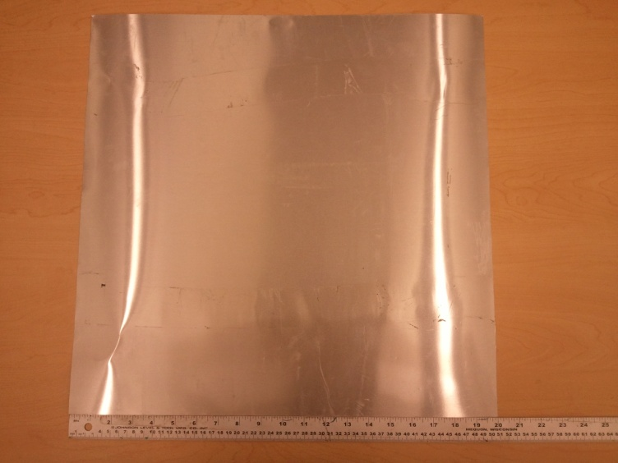
Inner Box Bottom Panel (20 inches square)
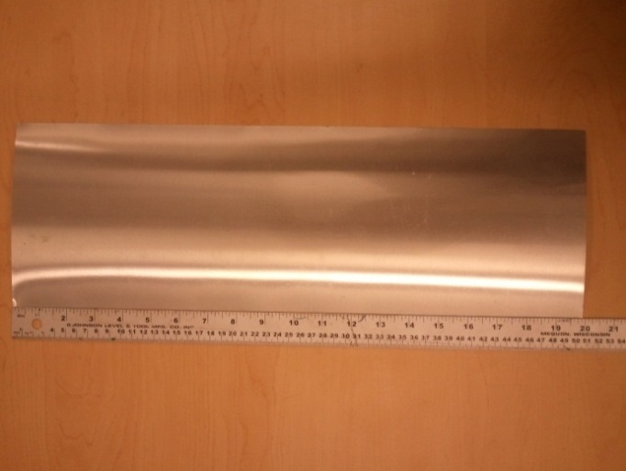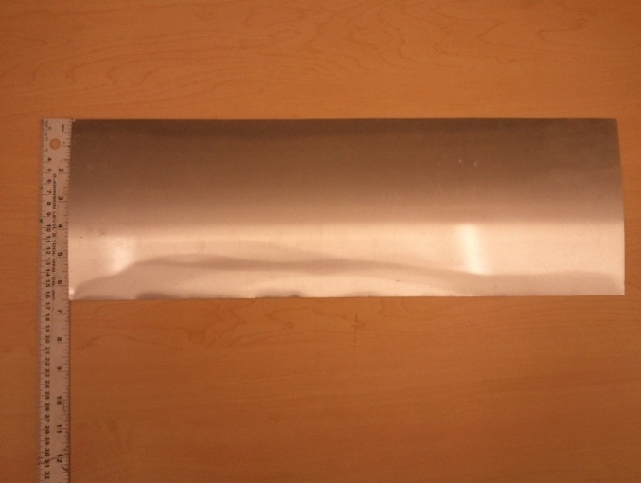
Inner Box Side Panel (6.5 inches by 20 inches)
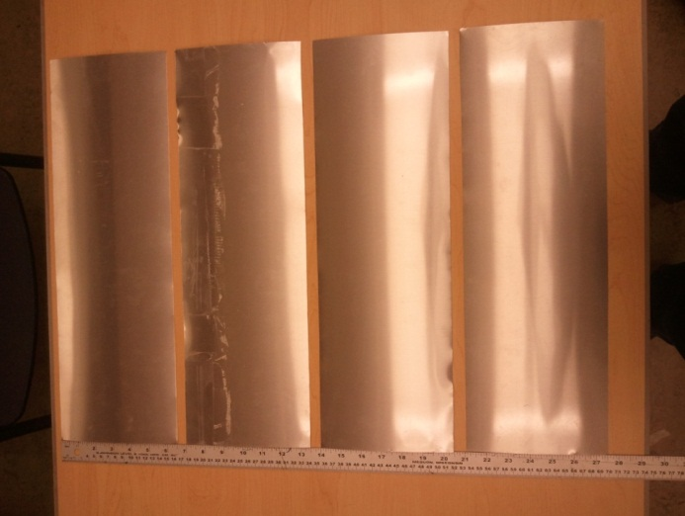

Outer Box Panels
Not Pictured: Outer Box Bottom Panel (24 inches square)
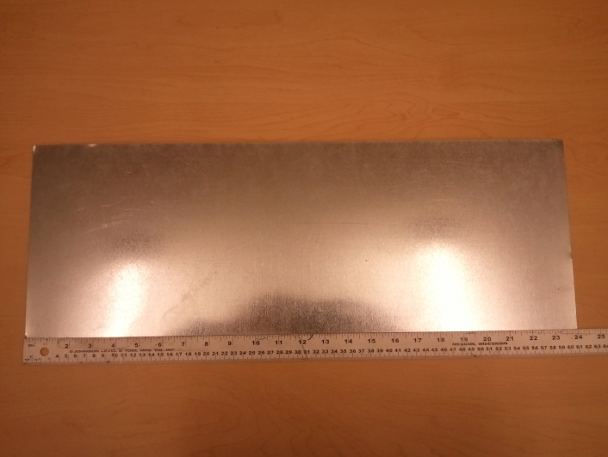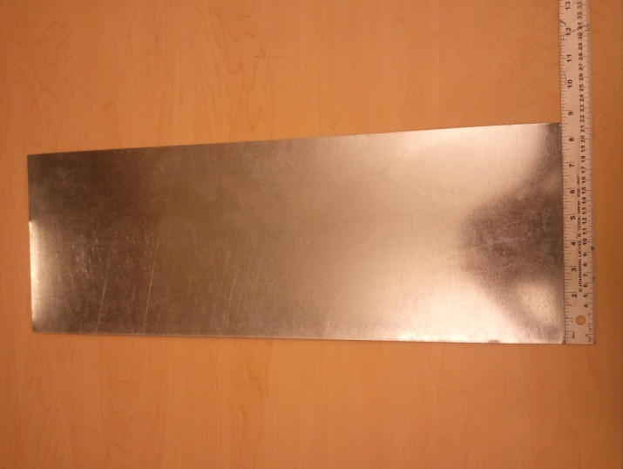
Outer Box Side Panel (8.5 inches by 24 inches)
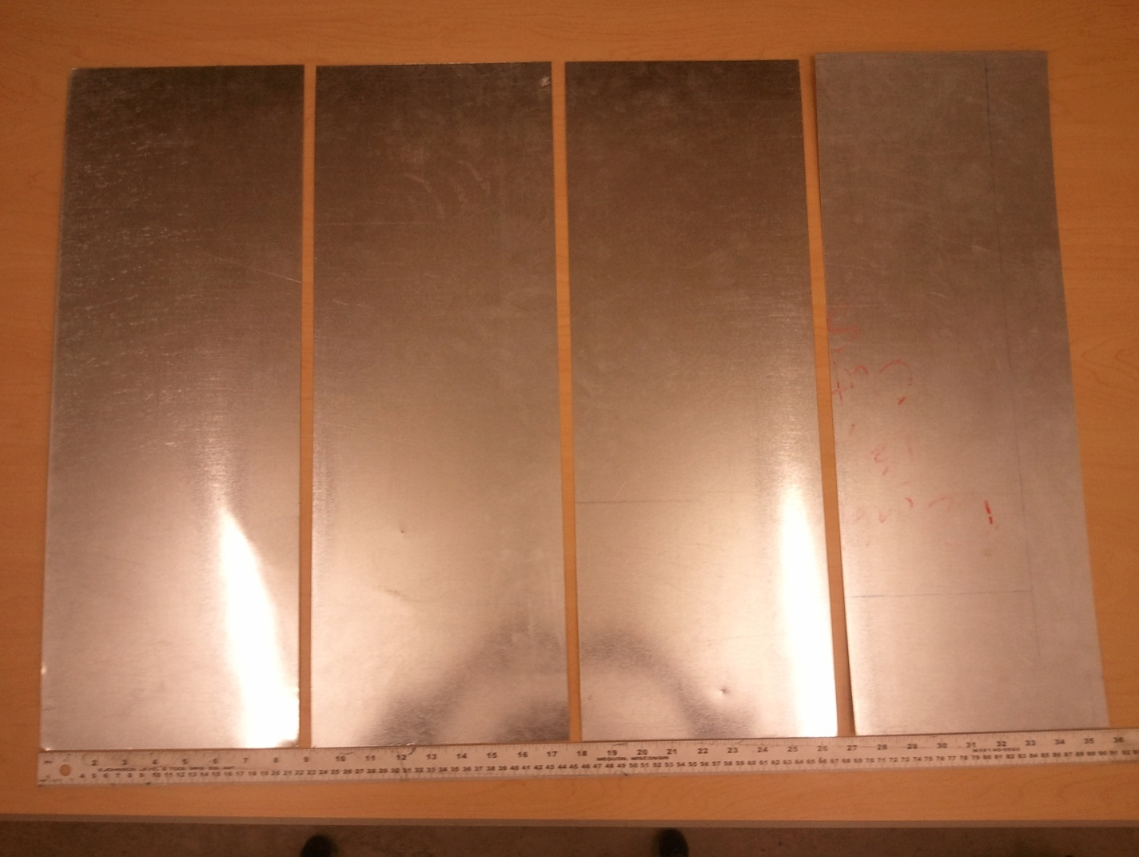

Vertical Aluminum Angles

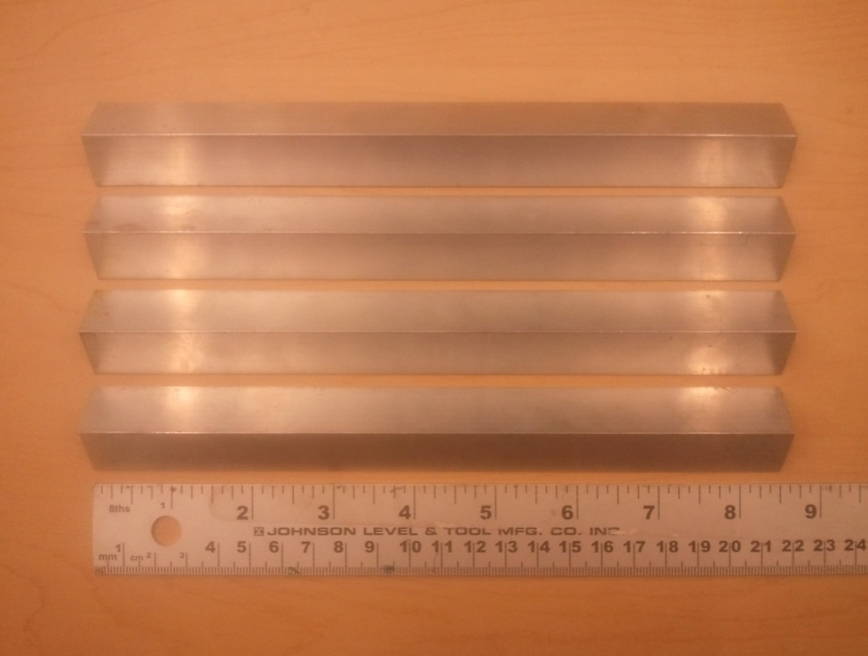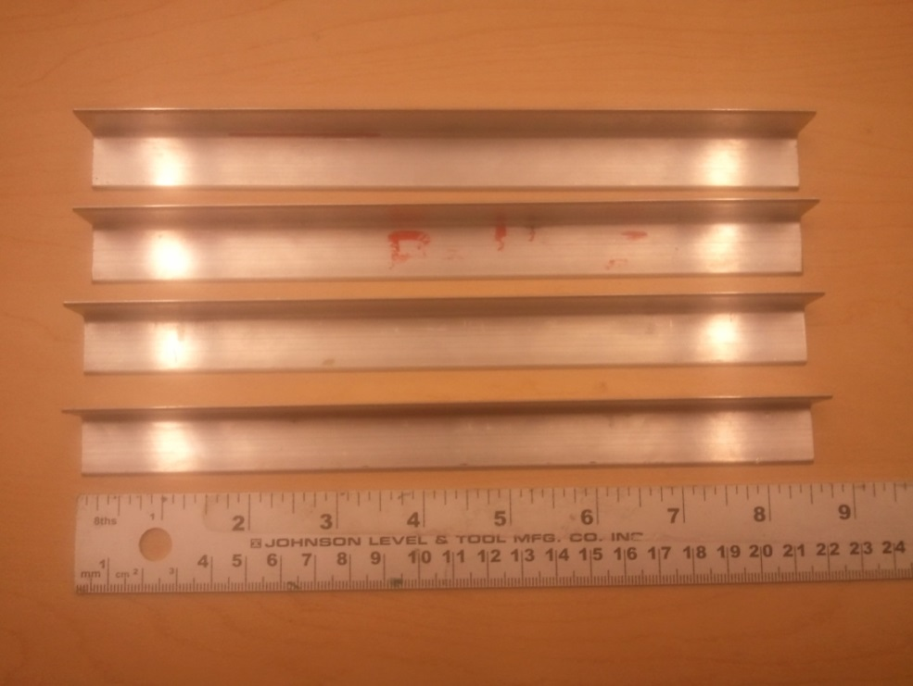

Wooden Base Blocks

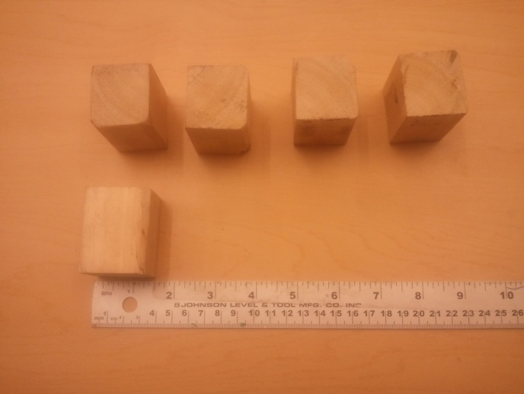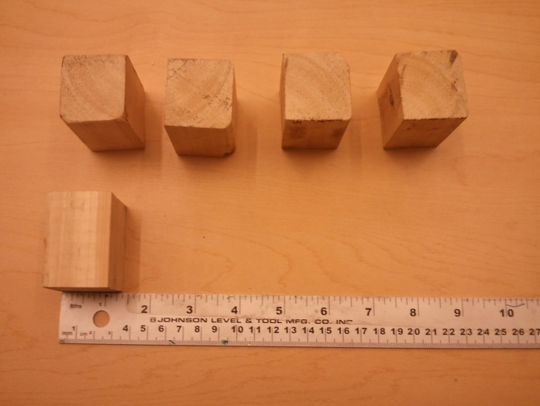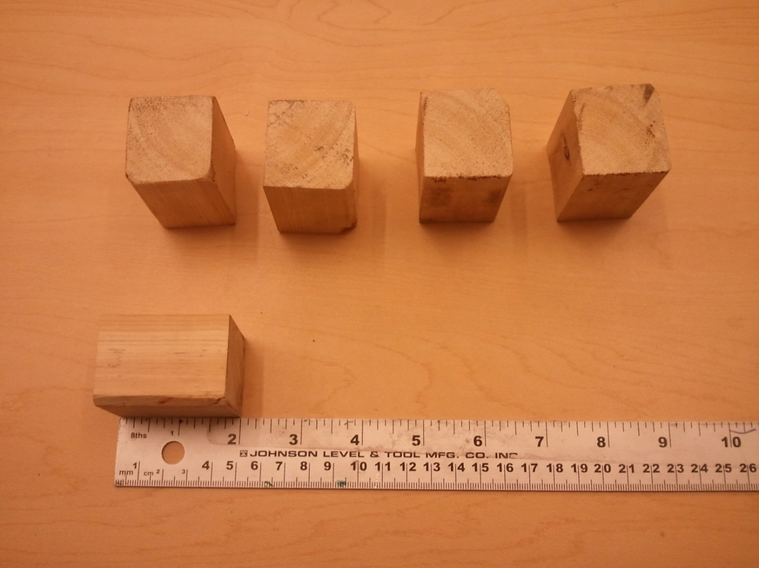

Aluminum Angle Assembly
NOTES: When cutting sheet metal, take into account the thickness of the aluminum angles
- Take the 50 inch length of aluminum angle and mark 2, 24, and 24 inch long portions. Using a machinist’s square, make a 90 degree angle at the 2 and 24 inch markings.
- Using a vertical band saw (or a hack saw) cut on the outside of the line such that the final angle is slightly greater than 90 degrees. There should be 2 of these cuts at the 2 and 24 inch marks. File the cuts down so that they are smooth.
- Repeat steps 1 and 2 for the other 50 inch length of aluminum angle.
- Now take the 42 inch length of aluminum angle and mark the 2, 20, and 20 inch long portions. Using a tri-square, make a 90 degree angle at the 2 and 20 inch markings.
- Using a vertical band saw (or a hack saw) cut on the outside of the line such that the final angle is greater than 90 degrees. There should be 2 of these cuts at the 2 and 20 inch marks. File the cuts down so that they are smooth.
- Repeat steps 4 and 5 for the other 42 inch length of aluminum angle.

Bending Angles
- Take a block of wood and align the corner with the center of the 90 degree cut.
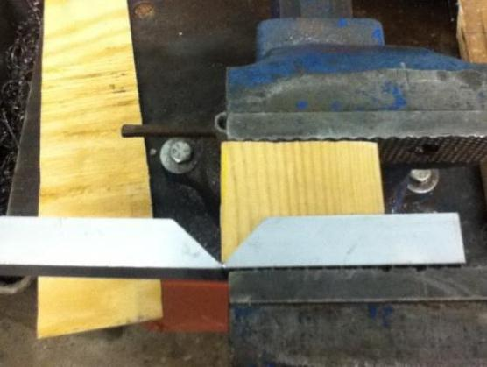
- Using your hands, grasp the angle firmly and bend it around the corner of the wood.
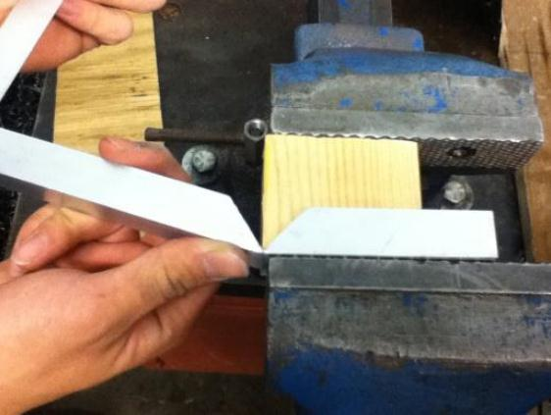
- Using a hammer, lightly tap the angle close to the corner (locations indicated by arrows) of the wooden block, so that the aluminum angle corner conforms to the wooden block. This will make sure the angle is bent exactly 90 degrees. Take care to not bend the corner too tightly, which will fracture the metal at the bend.
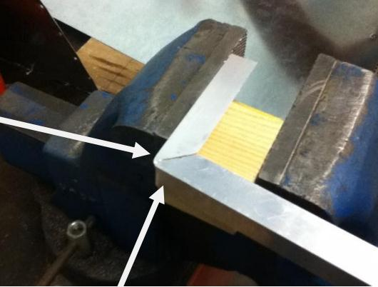

Assembling the Frame
- Take the 50 inch long angles that have been bent and form a rectangle that is 24” x 24”. The outer box bottom plate should be able to fit into this frame. Remember to take into account the thickness of the aluminum angles when cutting sheet metal.
- Clamp the two angle pieces together after they form a rectangle. Drill a hole through the overlapping pieces of angle on each side of the rectangle and bolt the frame together. Make sure the hole is at least an inch from the corner, as we will need to bolt the vertical angles later.
- Place the side wall panel so that it is against the inner side of the bottom frame. Drill a hole through the wall where the wall meets the hole near the corner. Now drill three holes through the wall and angle evenly spaced along the length of the side, then bolt the wall into place.
- Repeat step 3 for the rest of the walls.
- Align the 8.5 inch vertical aluminum angle with the corner of the outer box. Drill a hole at the bottom and bolt into place. Now drill a hole at the middle through the angle and the wall. Bolt all the new holes that have been drilled.
- Repeat step 5 with the rest of the vertical aluminum angles.
- Assemble the inner box frame using steps 1 to 6 using the inner box angle components and inner box walls.

Wood and Insulation
- Cut the base blocks and top cover pieces with dimensions as indicated in table 2.
- Attach 1.5 x 1.5 x 2 inch wooden blocks to the outer bottom panel using wood screws in the following arrangement.
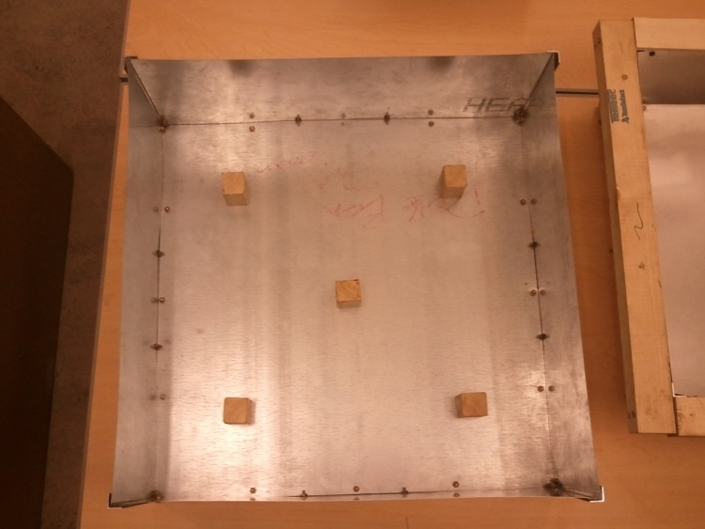
- Attach the top cover pieces of wood to the inner box using wood screws, the final result of this step is shown below
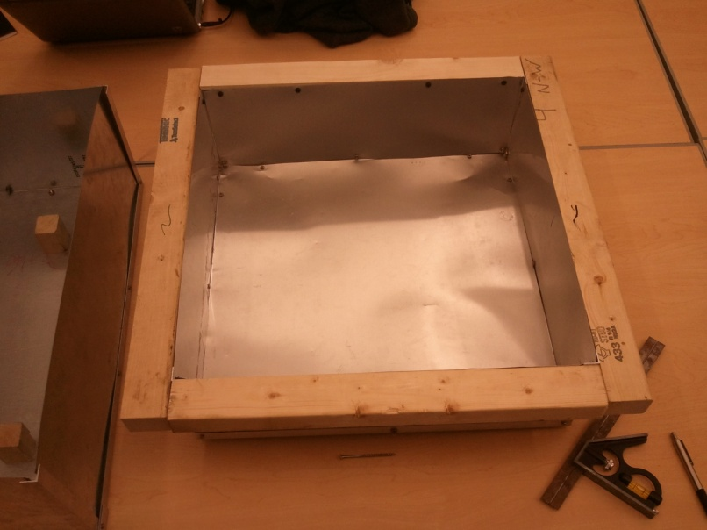
- Fill the outside box with fiberglass batting as insulation as shown in the picture below
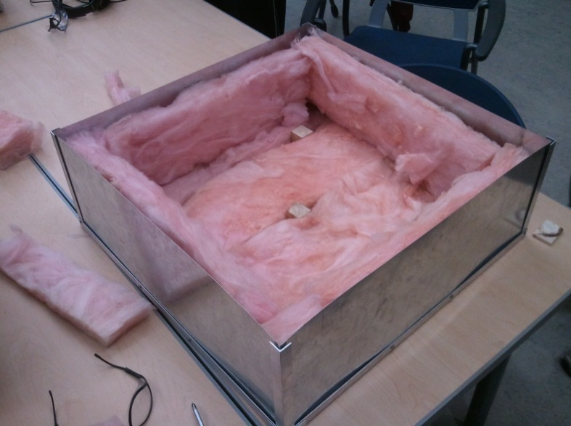
- Slide the inner box into the outer box carefully (making sure that the fiberglass batting stays where it should) and using a drill and wood screws, attach the outer box to the wooden top cover.
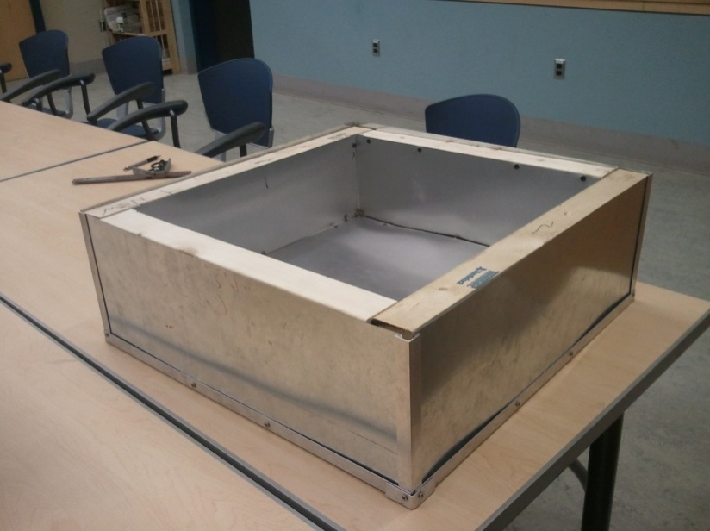
- Attach 2 x 2 x 0.5 inch wooden blocks to bottom of 19 x 19 inch aluminum plate spray painted black. Rest plate within box.
- Line edges and corners with reflective thermal tape.

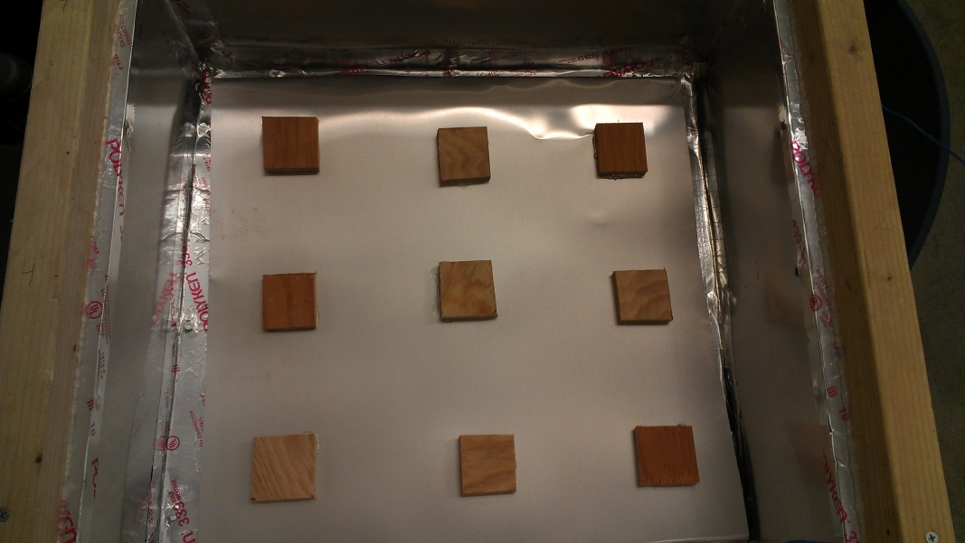

Door
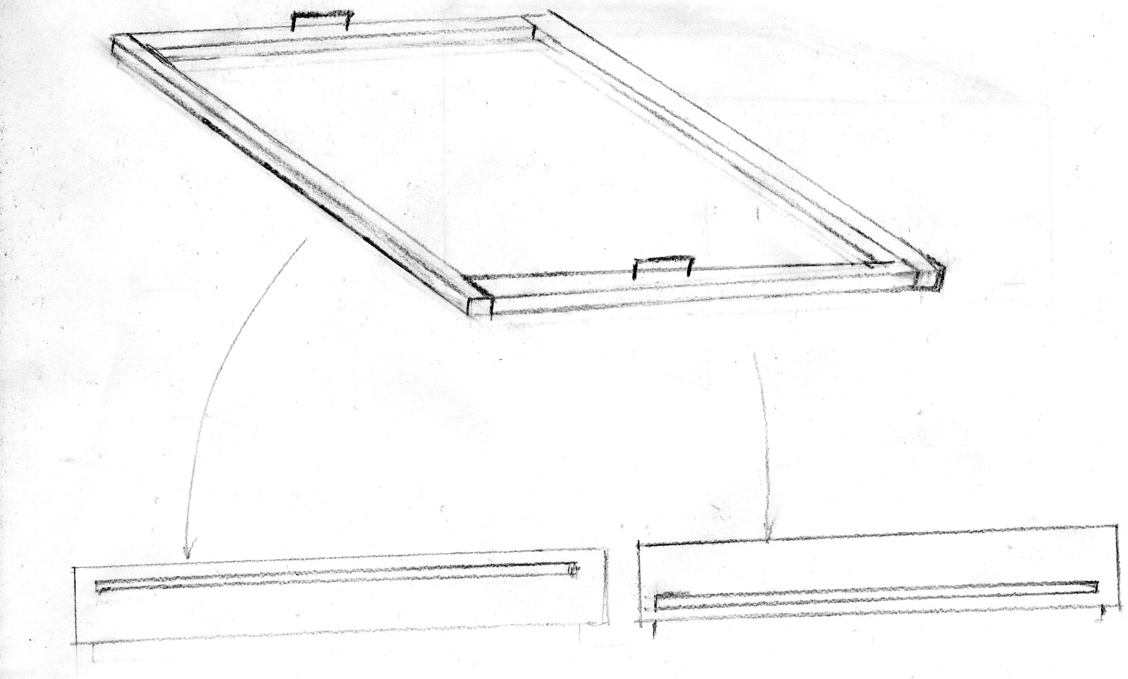
- Set four pieces of wood, 1.5” x 1.5”, upon the outer perimeter of box’s top. This will be considered the outer frame for the door.
- In constructing the inner frame, first cut four pieces of wood, 1.5” in height and 0.5” in width to cover the remaining exposed wood on the oven’s top.
  - There will be 2 longer pieces and 2 shorter pieces.
- Once each piece is cut to the appropriate dimensions, it then needs to be slotted.
  - For slotting the wood, begin by using a drill bit (bit diameter equal to the saw that will be used) and drill a hole 0.5” from one end and 0.25” from the bottom.
  - Next, feed the blade of the scroll saw into the hole and cut a slot to the point 0.5” from the other end.
  - Repeat this process for the piece of equal length. Then implement the same procedure for the two shorter pieces, cutting the slot 0.25” from the top of each piece instead.
- Arrange each piece of the inner frame so that pieces of equal length are opposite each other and attach the wood with wood glue.
- To create the polypropylene glazing, now feed a piece of appropriate width through the two slots of equal height across the oven and another piece through the other two slots.
- Upon placing the inner frame, a tight seal should be created through contact with the outer frame. The door is complete.

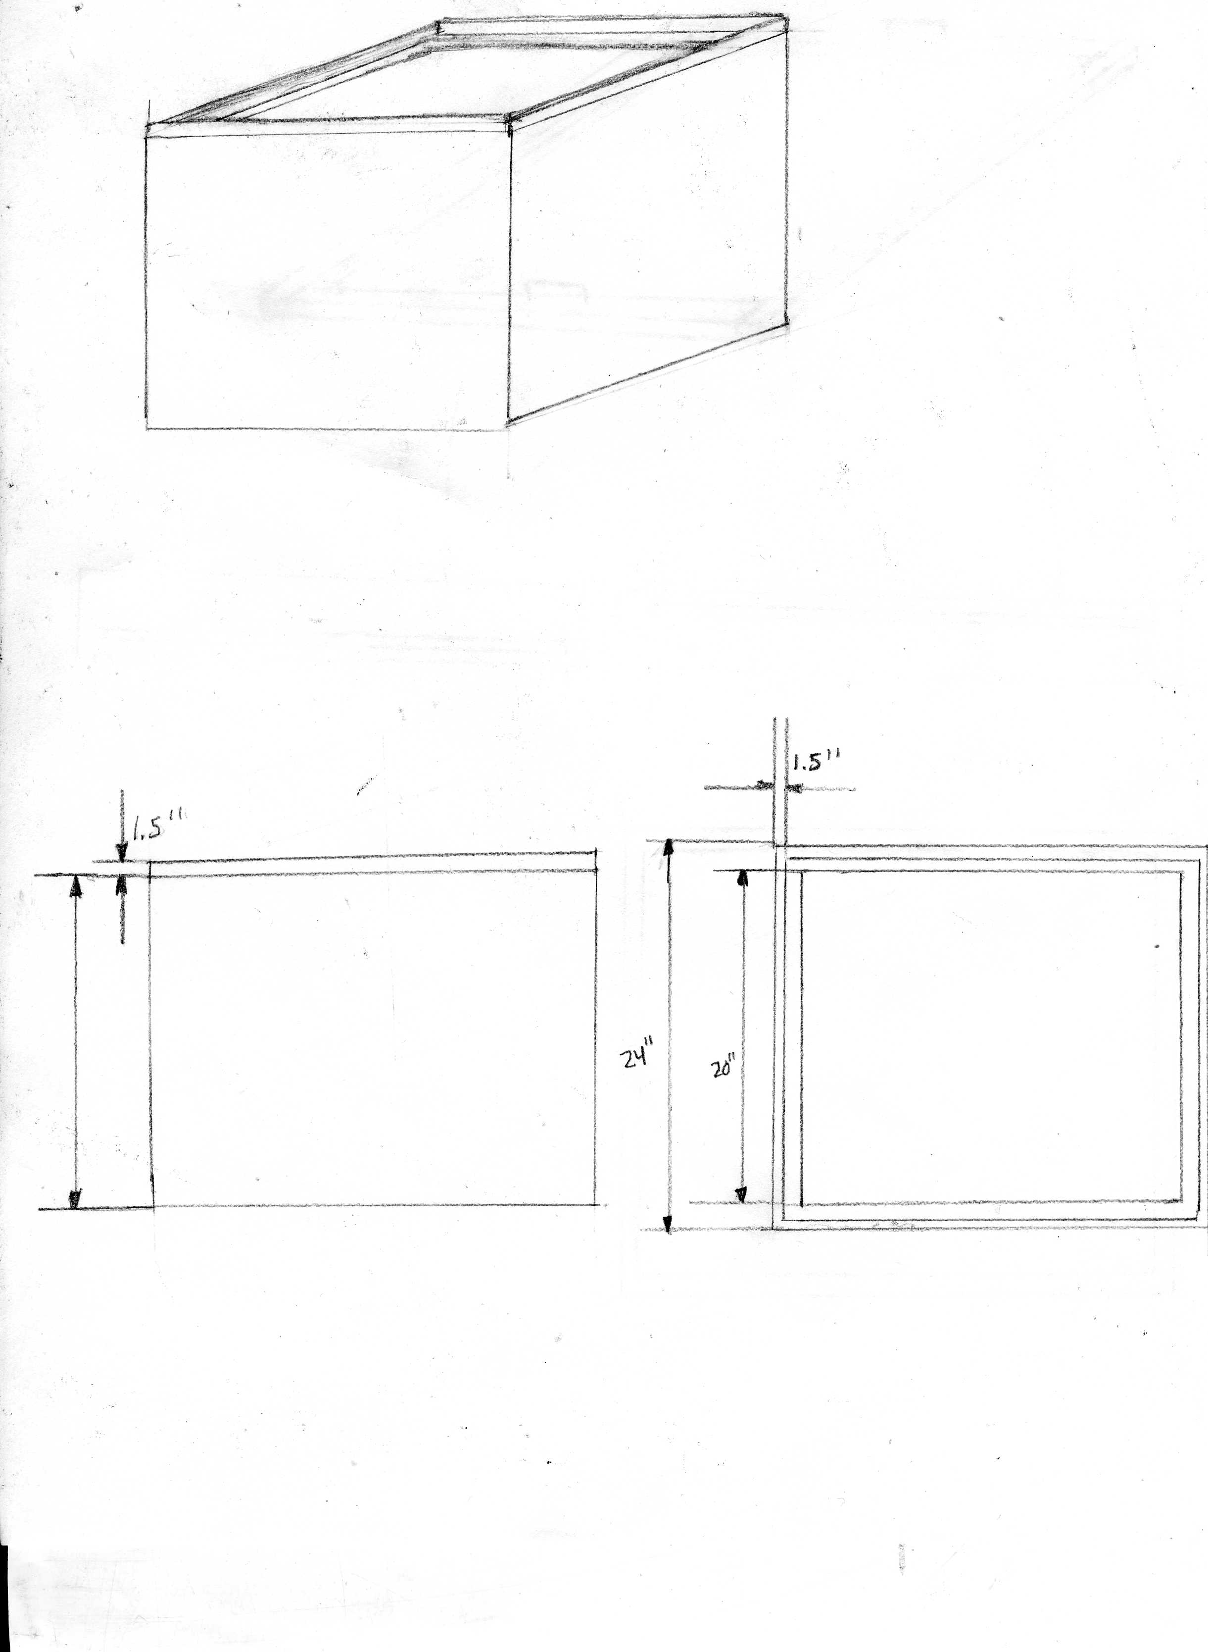
SIDE VIEW
TOP VIEW

Alternate Design
- Alternatively, the door may also be designed without the slot approach. Rather, create the same inner and outer frame, using exactly the same dimensions as explained in the initial design.
- Once the outer frame is set in place and each piece of the inner frame is cut to appropriate size, skip the slotting step. Set the inner frame using wood glue, as described in the primary door design.
- Now, the polypropylene glazing can be created by sliding the inner frame into a polypropylene bag and placing the encased frame in its designated location.
- Upon placing the inner frame, a tight seal should be created through contact with the outer frame. The alternate door is complete.

B. construction Notes

As the construction process for this double box oven bridged two semesters, the following includes notes from fall 2012 and spring 2013:
We had trouble producing angles that were bent at 90 degrees. If the angles are not precise, the frame will be skewed. Therefore, when cutting the aluminum for the angles, use the vertical band saw as opposed to sheers, for the process is considerably easier and more precise.

When measuring the lengths of aluminum angle, we need to take into the account the thickness of the aluminum angles themselves. This caused some difficulties and some bending of the sheet metal since some of it had to be forced in.

Initially, we had the machine screws orientated upward through the base of the inner box. These machine screws would have interfered with pots or pans resting on the surface, so we had to reverse their orientation. So as to save time, avoid orienting screws or other parts in ways that will interfere with the cooking process.

In constructing and setting the walls of the inner box into place, precision in measurements and drilling is key. If the aluminum sides must be forced to accommodate the machine screws, they will bend. When a side bends, it produces gaps through which insolated air can escape. Avoid forcing the sides to fit a hole by securing a properly dimensioned side exactly where you want it and drilling. Tolerances are critical.

Properly fitting the wood top for covering the insulation is tricky. To ensure that measurements are correct, finish both the inner and outer boxes before measuring the necessary lengths and widths of each piece of the wooden top. Do so by placing the inner box where you want it, inside the outer box and measuring. If you do not, the wooden top likely will not fit.

We first tried to drill through the aluminum sheet while it was held in a vice. This bent the aluminum sheet slightly. The easiest way to prevent the bending of the aluminum sheet is to place a scrap wooden block behind the aluminum and drill through the aluminum into the wood. This will evenly support the aluminum as you drill and prevent bending.

We need to implement better wood working techniques, particularly Miter joints, to decrease the presence of leaks. {Miter joints are pretty tricky and considered difficult to make well.}

There needs to be a better overall method of documenting the equipment used in construction, so that there is no trouble relocating equipment needed later in the process.

C. Testing procedure

Adapted from ASAE Standard: ASAE X580 for Cornell ESW Solar Cookers

Purpose: To provide a consistent and relatively accurate method for evaluating solar cooker performance using the light array in Winter lab.

Set up
Loading. Cookers shall have 7,000 grams of water per square meter of intercept area. The water shall be placed in cooking vessels painted black. The mass of water shall be determined with an electric balance to the nearest gram.
Temperature sensing. Water and air temperature should be sensed with thermocouples. One thermocouple junction shall be immersed in the water in the cooking vessel(s) and secured 10 mm above the bottom, at center. Thermocouple leads should pass through the cooking vessel lid inside a thermally nonconductive sleeve to protect the thermocouple wire from bending and temperature extremes. The sleeve should be secured with 100% silicone caulk to reduce water vapor loss. There should be one thermocouple for measuring the temperature of each container of water. One thermocouple is used to measure ambient air temperature.

Testing
Recording. The average water temperature (C) of all cooking vessels in one cooker shall be recorded at one minute intervals. Solar insolation (Wm⁻²) ambient temperature (C) and wind speed (ms⁻¹) shall also be recorded at one minute intervals. A pyranometer is used to measure the incident light intensity.

Calculating cooking power. The change in water temperature for each one minute interval shall be multiplied by the mass and specific heat capacity of the water contained in the cooking vessel(s). This product shall be divided by the 60 seconds contained in a one minute interval, as:

P_{i} = (T₂ – T₁)MC_{v}/60 [1]

where:
P_{i} = cooking power (W)
T₂ = final water temperature
T₁ = initial water temperature
M = water mass (kg)
C_{v} = heat capacity (4186 Jkg⁻¹K⁻¹)

Calculating interval averages. The average insolation, average ambient temperature, and average cooking vessel contents temperature shall be found for each interval.

Standardizing cooking power. Cooking power for each interval shall be corrected to a standard insolation of 700 Wm⁻² by multiplying the interval observed cooking power by 700 Wm⁻² and dividing by the interval average insolation recorded during the corresponding interval.

P_{s} = P_{i}(700/I_{i}) [2]

where:

P_{s} = standardized cooking power (W)
P_{i} = interval cooking power (W)
I_{i} = interval average solar insolation (Wm⁻²)

Temperature difference. Ambient temperature for each interval is to be subtracted from the average cooking vessel contents temperature for each corresponding interval.

T_{d} = T_{w} – T_{a} [3]

where:

T_{d} = temperature difference (C)
T_{w} = water temperature (C)
T_{a} = ambient air temperature (C)

Results

Plotting. The standardized cooking power, P_{s,} (W) is to be plotted against the temperature difference, T_{d,} (C) for each time interval.
Regression. A linear regression of the plotted points shall be used to find the relationship between cooking power and temperature difference in terms of intercept a (W) and slope b (WC⁻¹) or P_{s} = a + b T_{d}. No fewer than 30 total observations from three different days shall be employed. The coefficient of determination (r²) or proportion of variation in cooking power that can be attributed to the relationship found by regression should be higher than 0.75 or specially noted.
Single measure of performance. The value for standardized cooking power, P_{s,} (W) shall be computed for a temperature difference, T_{d,} of 50 C using the regression relationship found according to Regression section
Reporting. A plot of the relationship between standardized cooking power and temperature difference shall be presented with the equation. The report shall also state the standardized cooking power at a temperature difference of 50 C.

