Ventilator Waveforms Chapter 6
pp.116-125

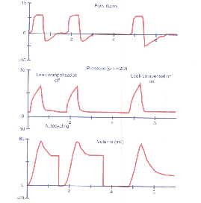
- What are some of the signs on scalar graphics that may demonstrate the presence of a large leak?

- With large air leaks, the ventilator may inaccurately sense a baseline drift in PEEP as a patient effort and respond with a supported breath. What is this phenomenon called?

- The following scalars represent patient-ventilator asynchrony. What is being demonstrated by the notch at point B?
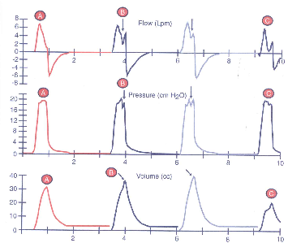

- What can be done to improve patient-ventilator synchrony?

- How would patient-ventilator asynchrony appear on a flow-volume loop? On a pressure-volume loop?

- Define rise time.

- Please list reasons why inadequate rise time or flow can be detrimental.

- Please list reasons why high flow rates can be detrimental.

- What does the spike represent in pressure and flow scalars below?
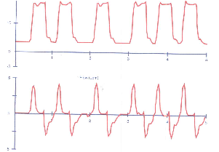

- What does beaking represent?

- Excessive inspiratory time can lead to a number of complications. Please list 4.

- What phenomenon is being represented by the following scalars?
