Toxic Acute Kidney Injury
- The maintenance phase of nephrotoxicant injury in tubular necrosis is characterized by:
  - Activation of inflammatory mediators despite removal of the nephrotoxicant agent
    - This is the extension phase
    - Mediated by microvascular injury
  - Extension of depressed glomerular filtration rate, variable urine output
    - May extend up to six weeks
  - Sudden increase in the urine output
    - Recovery phase
    - Result of regeneration of tubular epithelium
  - Initial exposure to a nephrotoxicant agent
    - Initiation phase
- The phenomenon of tubular backleak as a mechanism of acute tubular necrosis is
  - The sloughing of tubular epithelial cells resulting in the movement of water from the insterstitum to the sodium rich luminal fluid as a result of tubular injury
  - The loss of physiologic tubularglomerular feedback mechanism
  - The sloughing of tubular epithelial cells resulting in increased luminal hydrostatic pressure and movement of solutes and water into the interstitum
  - The sloughing of tubular epithelial cells and resultant movement of luminal contents into the insterstitum as a result of increased permeability
- Acute interstitial nephritis is a syndrome associated with the use of antibiotics and proton pump inhibitors. The underlying cause of this disease is
  - Acute tubular necrosis as a result of direct tubular cell sensitivity to the metabolites of the compounds
  - Rapid onset glomerulonephritis as a result of antibody-antigen deposition
  - Renal interstitial damage from lymphocytic infiltration
  - Tubular luminal obstruction from crystal formation as a result of metabolism disorders
- RIFLE in staging acute kidney injury in humans refers to what?
  - Risk, injury, failure, loss and end stage
- RIFLE and AKIN staging criteria are based on
  - Creatinine or inulin clearance testing, urine output
  - Predisposing patient factors, type of injury, response to therapy
  - Progression of creatinine increase during therapy, urine output
  - Change in creatinine from baseline, urine output

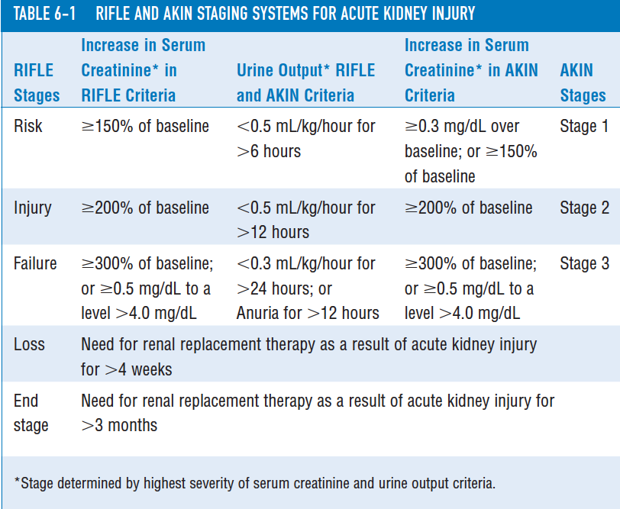
- Toxic injury to the kidney can result in both apoptosis and necrosis. Discuss the physiologic differences between the two.
  - Necrosis is a result of rapid injury and metabolic collapse resulting in cellular swelling, loss of integrity of the membranes within and outside of the cell and release of proteolytic enzymes from intracellular compartmentsinflammation
  - Apoptosis is initiated by cellular signaling (associated with the TNF receptor either by the TNF receptor associated death domain (TRADD) or the Fas-associated death domain protein (FADD)) by recognition of extracellular toxins. Cell signaling will result in capsase activation by either upregulation of pro-apoptotic signal or downregulation of anti-apoptotic signals. Capsases mediate the condensation of the cytoskeleton, chromatin and DNA into apoptotic bodies which are then phagocytosed.
- COX-1 expression is constituent(constituent, induced) and is involved in prostaglandin synthesis. COX-2 expression is induced (constituent, induced) and is involved in modulation of cell growth and inflammation. It is thought that NSAID toxicosis is due to inhibition of COX-2.
- Typical pathologic findings of NSAID toxicosis are
  - Glomerulosclerosis
  - Renal papillary necrosis
  - Renal tubular necrosis
  - Calcium oxalate crystaluria
- Species differences predisposing dogs over humans to renal NSAID injury include
  - Unipapillary kidney in the dog
  - Constituent renal expression of COX-2 in humans
  - Upregulation of COX-2 in states of sodium depletion and hypovolemia in dogs
  - All above
  - A and C
- List three mechanisms by which isosthenuria develops as a result of ethylene glycol toxicity
  - Osmotic diuresis with excretion of unchanged ethylene glycol in stage one
  - Hyperglycemia by aldehyde inhibition of glucose metabolism, stress and decreased insulin release due to hypocalcemia
  - Intrinsic renal failure with renal tubular epithelial necrosis
- Which of the ethylene glycol metabolites accumulates in the body?
  - Glycoaldehyde
  - Glycolate
  - Glyoxylate
  - Oxalate
  - Calcium oxalate
- Explain the mechanism of soft tissue mineralization in vitamin D toxicosis
Cholecalciferol is a required fat-soluble vitamin. Absorbed dietary cholecalciferol is transported to the liver, where hepatocytes convert it to 25-hydroxycholecalciferol. The 25-hydroxycholecalciferol is converted to 1,25-dihydroxycholecalciferol (1,25-diOH) in the kidney. Elevated concentrations of circulating 1,25-diOH induce hypercalcemia as a result of increased absorption of calcium from the gastrointestinal tract, increased resorption of calcium from bone, and reduced excretion of calcium in urine. Increased levels of circulating calcium will then result in ectopic calcification of tissues, typically by complexing with phosphorus and forming hydroxyapatite.

