Chapter 6 pp163-178

MECHANISMS OF HORMONE ACTION

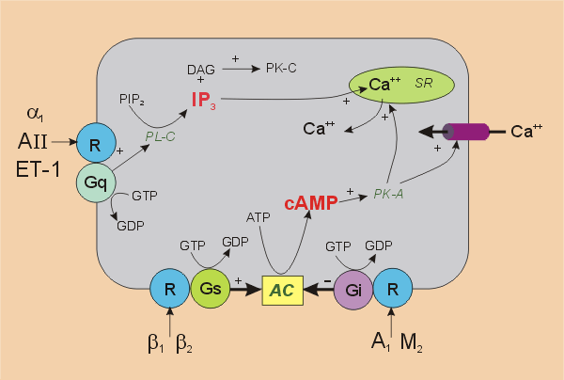
PLC: Stimulate Inhibit
Vasopressin (V1) Vasopressin (V2) Prostaglandins
Angiotensin II Parathyroid Hormone alpha 2
Norepinephrine (alpha 1) Beta-adrenergic Angiotensin II (tubular effect)
Parathyroid hormone Prostaglandins (vascular)

ADH AND WATER BALANCE
- Produced In supraoptic and paraventricular nuclei of hypothalamus
- Secreted by posterior pituitary, but some absorbed into CSF and portal capillary system
- Primarily acts on principle cells of Collecting Tubules
- Receptors
  - V1: vasoconstriction and increased prostaglandins
  - V2: antidiuretic response
  - V3: release of ACTH
- ADH enhances K+ secretion
- Vasopressor role of ADH is relatively minor (AG II more impt)
- ADH increases prostaglandins, which feedback and inhibit its actions
- Activation of V2 receptors can stimulate release of factor VII and VWF from vascular endothelium

CONTROL OF ADH SECRETION
Osmoreceptors:
- Located within the brain
- Perceived as gradient between plasma and receptor cell
- Plasma sodium concentration is the primary osmotic determinant
- In uncontrolled DM glucose can act as an effective osmole and promote ADH release
- Role of thirst-not linked to osmoreceptors
Volume receptors:
- Parasympathetic afferents in carotid sinus baroreceptors
- Low pressure receptors in the left atrium contribute in some spp but not humans
- Not as sensitive as osmoreceptors (stimulated only with hypovolemia)

Other factors:
- Nausea can stimulate ADH release (MOA not understood)
- Stress and pain
- Hypoglycemia
- Drugs (morphine)

QUESTIONS:
- Fill in the blanks.

PLC __________________ and _________________--> PKC

- Note whether the following hormones stimulate or inhibit adenylyl cyclase.
  - Vasopressin ( V2 receptor)
  - Alpha-2 adrenergic receptor
  - Beta-adrenergic receptors
  - Parathyroid hormone receptors

- Which receptor is responsible for the antidiuretic effects of ADH?
  - V1
  - V2
  - V3
  - V4

- What is the primary stimulatory factor for the release of ADH?

