Chapter One:
Introduction to Renal Function:

The kidney performs several essential functions:
Maintenance of the constant extracellular environment that is required for
adequate functioning of cells
Secretes hormones
Catabolism of peptide hormones
Gluconeogenesis in fasting conditions
Renal morphology:
Basic unit: nephron
Glomerulus= Tuft of capillaries interposed between two arterioles
Series of tubules
Glomeruli located in cortex; tubules in medulla
Initial step in the excretory function of the kidney is the formation of an
ultrafiltrate via reabsorption and secretion
Reabsorption= removal of a substance from the filtrate
Secretion= addition of a substance to the filtrate
Fluid filtered across the glomerulus enters Bowman’s space
Then proximal tubule (initial convoluted and later pars recta)
Then loop of Henle (thin descending and thick ascending limb
Then macula densa (specialized distal tubular cells)
Then distal convoluted tubule
Then connecting segment
Then cortical collecting tubule (single drains many connecting
segments)
Then medullary collecting tubule, which subsequently drains sequentially into the calyces, the renal pelvis, the ureters and the bladder
Proximal tubule and loop of Henle reabsorb the bulk of filtered solutes and water; collecting tubules make final small changes
Two cell types in the cortical collecting tubule:
Principal cells: reabsorb sodium and chloride and secrete potassium
(aldosterone)
Intercalated cells: secrete hydrogen/bicarbonate and reabsorb potassium
Reabsorption and secretion:
Tubular reabsorption can occur across the cell or via the paracellular route
between cells
Most reabsorbed solutes are returned to the systemic circulation intact; some are metabolized
Tubular secretion also occurs in the opposite direction
Filtered solutes and water may be transported by one or both of these
mechanisms
Transcellular reabsorption/secretion is facilitated by protein carriers or ion-
specific channels
Sodium enters the cell passively down an electrochemical gradient d/t Na-K-ATPase pump in the basolateral membrane maintaining low intracellular sodium levels
Sodium entry occurs via Na-H exchange and Na-glucose transport in the proximal tubule, Na-K-2Cl carrier protein in the cortical collecting tubule and papillary collecting duct
Potassium is secreted from the cortical collecting tubule cell into the
lumen
Na-K-ATPase pump actively transports K into the cell
Tight Junction:
Composed primarily of the zona occludens
Functions:
- Relative barrier or gate to the passive diffusion of solutes and water between the cells
- Serves a boundary between the luminal and basolateral membranes
Leakiness of the tight junction barrier to passive diffusion varies with the nephron segment (relatively leaky in the proximal tubule; tight in the collecting tubule (ablet o generate very large transepithelial concentration gradients)
Membrane polarity is an essential component of reabsorption/secretion in the renal tubular cells. As each component plays an important role:
Luminal membrane: Contains the channels that allow solutes to enter
cells/be secreted into the lumen
Basolateral membrane:
Part adjacent to the luminal membrane (lateral membrane):
components of the tight junction
More distal part- role in ion-transport and hormone responsiveness
Basal membrane: Basement membrane receptors
Membrane Recycling:
Normal functioning of transporting epithelia requires the delivery of newly
synthesized and recycled membrane components to precise locations in the cell membrane
ex ADH: combines with receptor on the basolateral membrane of collecting tubular cells---preformed water channels (aquaporin-2) in cytoplasmic vesicles are inserted into the luminal membrane allowing reabsorption of water
Hormone-receptor complex internalized by endocytosis and then
enters acidic endosomes where the hormone and receptor are split
Receptor returned to basolateral membrane
Action of adenylyl cyclase?
Composition of Urine:
No absolute normal values for urinary solute or water excretion
Urine contains higher concentrations of uncharged molecules than ECF
Atomic Weight and Molarity:
Atomic weights of elements
Molecular weight of molecules= atomic weights of individual atoms
One mole= molecular/atomic weight of that substance in grams
To convert from milligrams per deciliter to millimoles per liter use the
equation:
Mmol/L=mg/dL x 10/(mol weight)

QUESTIONS:
1. Please label the following diagram.
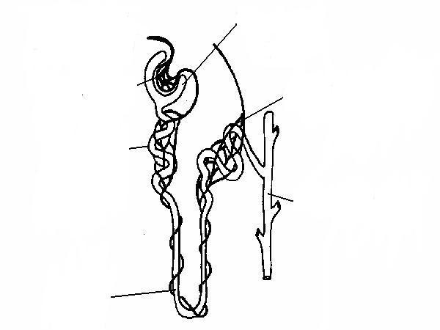

Glomerulus, bowman’s capsule, proximal convoluted tubule, straight portion of proximal tubule, thin descending limb of loop of Henle, thin ascending limb of loop of Henle, thick ascending limb of loop of Henle, macula densa, connecting segment, cortical collecting tubule, medullary collecting tubule

2. Define reabsorption and secretion.
Reabsorption refers to the removal of a substance from the filtrate, secretion refers to the addition of a substance to the filtrate.

3. How is the medullary collecting tubule able to lower the urine pH to 4.5, while the proximal tubule can only reduce the tubular fluid pH to 6.8?
The collecting tubule is a relatively
Tight epithelium with a thicker tight junction than the proximal tubule. Diffusion limited. This relative impermeability to passive paracellular transport allows this segment to created and sustain larg transeptihelial concentration gradients.

4. Disruption of normal cellular polarity, as with opening of the tight junctions due to ischemia will do what to sodium reabsorption?
Decrease d/t disruption of Na-K-ATPASE

