Notes for Rose, Chapters 1 and 2

CHAPTER 1: Introduction to Renal Function

-Juxtaglomerular apparatus: juxtaglomerular cells of the afferent arteriole and the macula densa within the ascending LH, central role in RENIN secretion
-Principle cells: reabsorb Na and Cl, secrete K (ALDOSTERONE)
-Intercalated cells: secrete H and HCO3-, reabsorb K
-The relation b/n intake and output means that there are no absolute “normal” values for urinary solute or water excretion.
-Osmotic pressure generated by a solution is proportional to the NUMBER OF PARTICLES per unit volume of the solvent.

CHAPTER 2: RENAL CIRCULATION AND GLOMERULAR FILTRATION RATE
Affects of renal circulation on urine formation
- Glomerular filtration
- Peritubular capillaries modulate degree of PT reabsorption and secretion
- Vasa recta capillaries, returns salt and water to systemic circulation and counter-current mechanism
-Filtration is limited for ion and drugs bound to albumin, including ionized calcium
-Filtration is both size and charge selective, preference for SMALL and CATIONIC
-Concurrent secretion of AGII and PG: AG II causes systemic vasocxn and raises BP while PG minimizes degree of renal vasocxn, maintains renal BF and GFR
-Filtration equilibrium: Change in filtration as you progress from the afferent arteriole to the efferent arteriole. Initially high filtration due to higher hydrostatic pressure, then zero filtration at the level of the efferent arteriole due to increased oncotic pressure. The presence of this will allow GFR to fall in direct proportion to renal plasma flow.
-
lee herold-Dove Lewis

QUESTIONS:

1) Juxtaglomerular cells responsible for the secretion of renin are located in which part of the nephron?
a) Proximal convoluted tubule
b) Afferent arteriole
c) Distal convoluted tubule
d) Efferent arteriole

2) Angiotensin converting enzyme is primarily located in which organ?
a) Kidney
b) Adrenal gland
c) Liver
d) Lungs

3) Fill in the blanks.
Angiotensinogen
Renin

Angiotensin I

ACE

Angiotensin II

4) Complete the following sentences.
Angiotensin II leads to peripheral ____________________________(vasoconstriction, vasodilation). The second function of Angiotensin is to increase sodium ___________________________(filtration, secretion, absorption) by stimulating the secretion of ________aldosterone_________________.

5) Complete the following sentence.
Angiotensin II constricts the _______efferent_______________arteriole more than the _____afferent___________arteriole of the glomerulus, resulting in a _____________________(increase, decrease) in renal blood flow and a _________________________(increase, decrease) in glomerular filtration rate.

6) Which of the following is released by the glomerulus following Angiotensin II secretion to minimize excessive renal vasoconstriction?
a) Endothelin
b) Prostaglandins
c) Thromboxane
d) Arachadonic acid

7) Which of the following would result in renin secretion?
a) Hypertension
b) Renal hypoxia
c) Decreased sodium intake
d) Increased GFR

8) What are the 3 receptors govern the release of renin?
1) Baroreceptors of carotid and aortic arch
2) Baroreceptors of the afferent arteriole
3) Cl receptor of macula densa

9) Which electrolyte is sensed by the macula densa, indicating changes in GFR?
a) chloride
b) sodium
c) potassium
d) calcium

10) State the changes in GFR and RPR that will result from the depicted alterations of the arterioles.
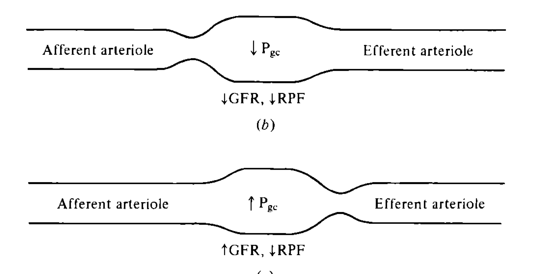

11) Draw a graph plotting GFR to arterial blood pressure that depicts autoregulation at the level of the glomerulus.
