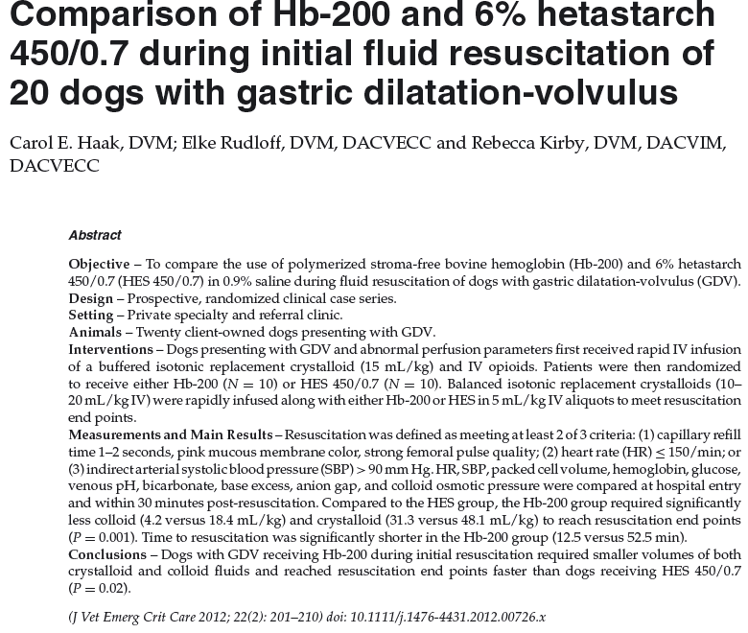
Key Points
- Dogs receiving Hb-200 required less colloid, less crystalloid and less time to reach resuscitation end points than dogs receiving hetastarch

Questions
- The colloid oncotic pressure of 6% hetastarch is 32.7 +/- 0.2 and the COP of Hb-200 is 43.3 +/- 0.1 mmHg.
- The vasoconstrictive and hypertensive effects of hemoglobin based oxygen carriers is thought to be due to
  - Stimulation of catecholamine release due to foreign antigen
  - Atrial natriuretic peptide release as a result of rapid volume expansion
  - Vasopressin release as a result of sudden increase in plasma osmotic pressure as sensed by osmoreceptors in the hypothalamus
  - Scavanging of nitric oxide
- The authors concluded Hb-200 to be superior to hetastarch in what aspects?
  - More rapid achievement of resuscitation end-points
  - Smaller volume fluid (crystalloid and colloid) administration
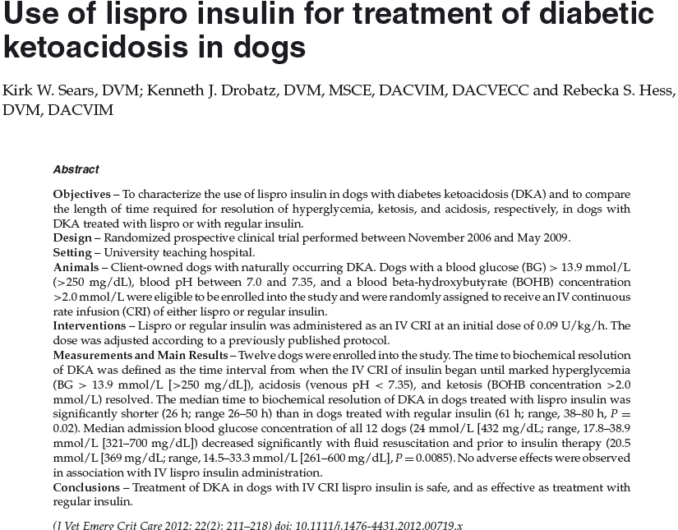
Key points
- Lispro is safe and effective
- Lispro resulted in significantly faster resolution of hyperglycemia + ketosis + acidosis (if all evaluated together) and ketoacidosis (not ketosis and acidosis separately) than the use of regular insulin

Questions
- What percent (in both this study and the previous larger retrospective) had concurrent disorders?
  - 100%
  - 60%
  - 40%
  - 70%
- The authors concluded lispro to be superior to regular insulin in what aspects?
  - The median time of resolution of severe hyperglycemia, ketosis and acidosis (only if all three were evaluated together)
  - The median time of resolution of ketoacidosis (only if the two were evaluated together)

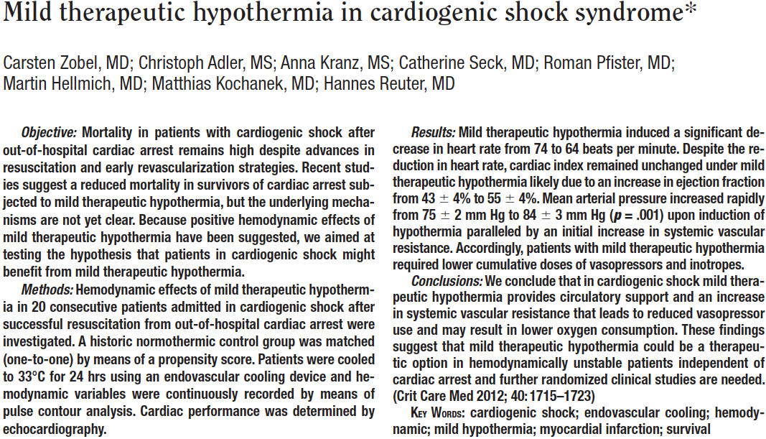
Key Points
- MAP significantly increased with induction of hypothermia
- Rate of norepinephrine could be significantly reduced following induction of hypothermia
- No change in CI was noted with the induction of hypothermia, however there was an increased EF with hypothermia

