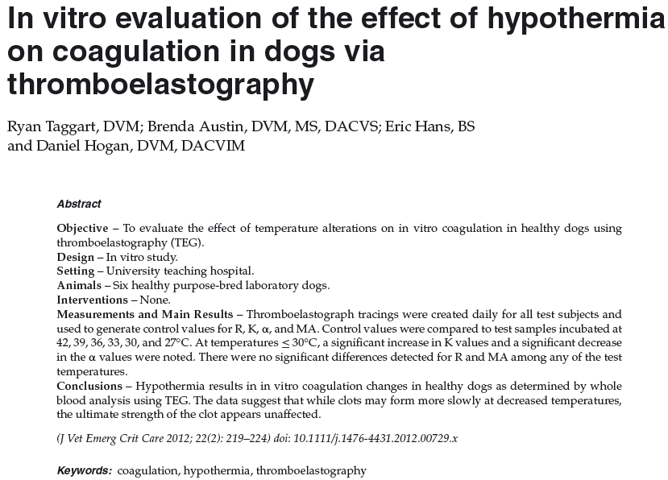
Key Points
- Showed angles which were significantly less steep, and K was significantly longer
- No differences in MA and R
- Concluded that there is a significantly longer time to clot formation but no difference in clot strength
Questions

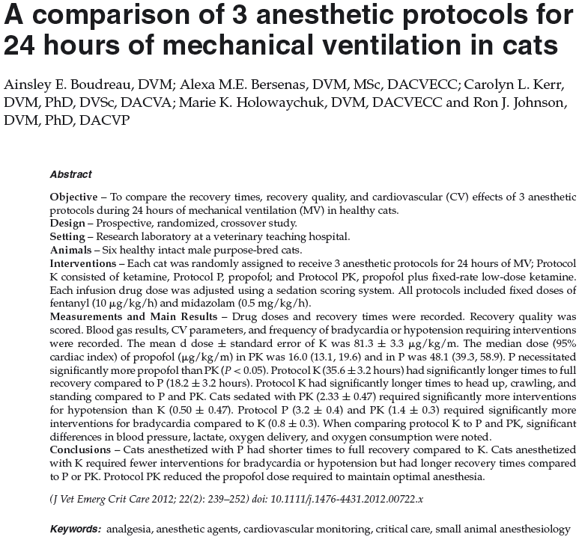
Key Points
- Combination of ketamine and propofol resulted in significantly lower doses of each drug administered individually
- Recovery time was significantly longer w/ ketamine than with either other propofol/ketamine or just propofol
- Ketamine had significantly higher heart rates, blood pressures and airway pressures
- Delivery of oxygen was significantly higher in protocols using ketamine

Questions
- D

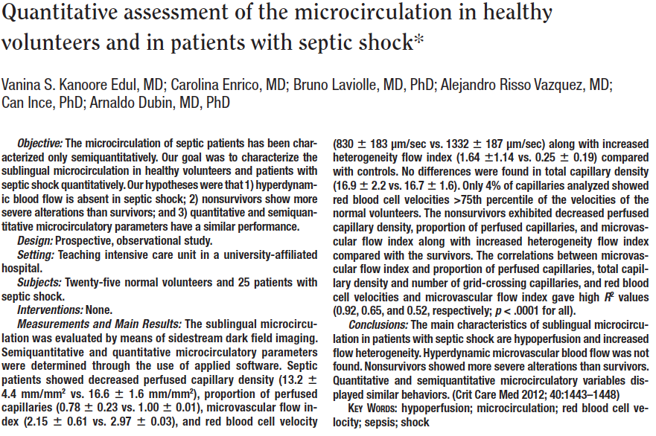
Key Points
- Sepsis showed significantly decreased perfused capillary density, proportion of perfused capillaries, mean flow index, and RBC velocities along with heterogeneity flow index compared w/ normal
- No difference in total capillary density or number of grid crossings capillaries
- No correlation b/t microcirculatory parameters and MAP or cardiac index
- Compared to survivors, nonsurvivors had decreased perfused vessel density and proportion of perfused capillaries and increased heterogeneity of flow index
- Only 4% of septic patients had RBC velocities >75th percentile of normal (so they concluded there is not hyperdynamic microvascular flow in sepsis

