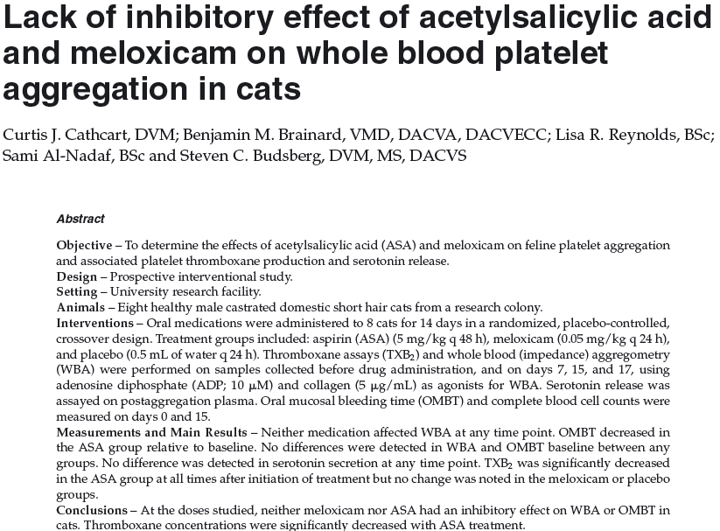Key points
- No significant differences were noted on platelet aggregometery between any of the groups
- Aspirin resulted in a significant decrease in OMBT at day 15 and a significant decrease in TXB2 at all time points compared to baseline

Questions
- True/false: Tromboxane B2 is utilized diagnostically in cats as it is been shown to be the predominant mediator of coagulation
- Platelet aggregation utilized ADP and collagen in this study due to:
  - Conformity with previous veterinary and human studies
  - Inhibit red cell effects on coagulation
  - Create a more physiologic activation
  - Because previous studies used arachadonic acid and they wanted to try something new
- Evidence of decreased platelet activation in the aspirin group in this study was evidenced by:
  - Increased aggregation on aggregometry
  - Increased levels of serotonin
  - Evidence of bleeding in test subjects
  - Decreased levels of thromboxane B2

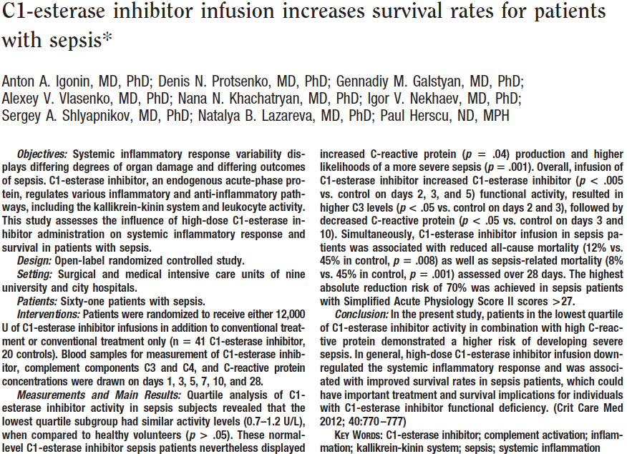Key points
- Treatment group overall mortality rate: 12%, control group: 45%. Mortality at 28 days treatment group: 8%, control group: 45%
- Significant C3 elevations following treatment with c1-esterase inhibitor
- Significant decreased in c-reactive protein following treatment
- Biological effects of C1-esterase inhibitor have been shown to be: prevention of endotoxin induced shock, reduction in vascular permeability, reduction in LPS-mediated macrophage activation, increased bacterial uptake by phagocytes, reduction in viable gram-neg bacteria in blood and peritoneal fluids in peritonitis, improved removal of bacteria via complement receptor 3 mediated pathway, reduction in the level of proinflammatory cytokines, upregulated release of anti-inflammatory cytokine IL-10
Questions
- C1-esterase inhibitor is
  - Proinflammatory
  - A free radical scavenger
  - Anti-inflammatory
  - Not helpful in sepsis
- C1-esterase inhibitor decreased 28 day mortality from _____ to ______.
  - 45 to 12
  - 67 to 23
  - 45 to 8
  - 54 to 12

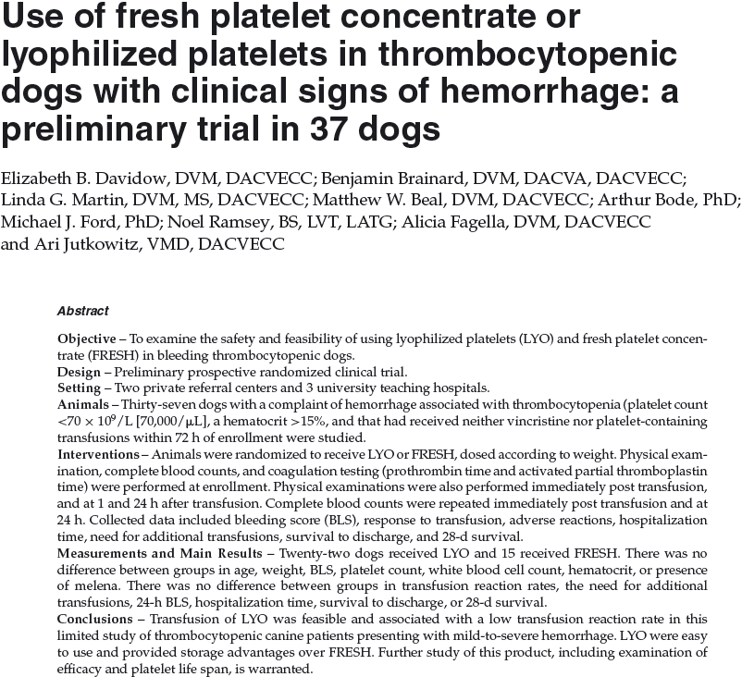Key points
- Fresh platelet concentrate is only good for 5 days, at room temp, with gentle agitation
- Lyophilized platelets are good for about 24 months, in the refrigerator
- Study concluded that both lyophilized and fresh platelets were safe, efficacy could not be evaluated due to low numbers
- Fresh platelets are considered to be efficacious for about 3.5-7days
- Platelets frozen in DMSO considered to be efficacious for about 2 days
- Lyophilized platelets considered to be efficacious for several hours

