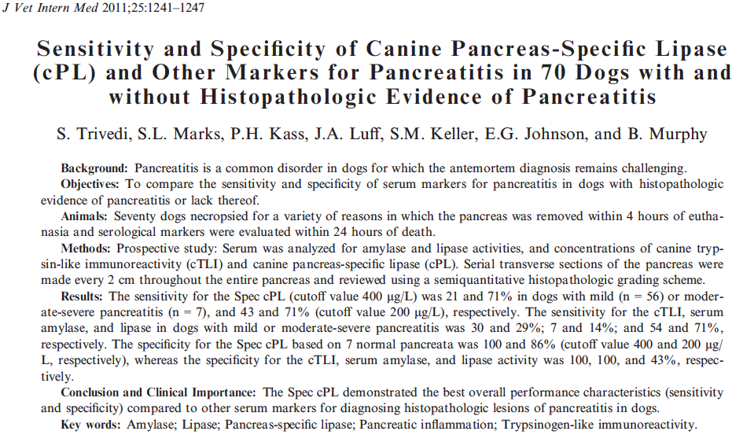

Key Points
- Serum amylase was the least sensitive assay and serum lipase was the least specific assay
- cPL was the most specific assay (100% at 200 ug/L cut off and 86% at 400 mcg/L cut off
- cPL was the most sensitive as well but this was only 71% at 200 mcg/L and only 21% at 400 mcg/L
- The histopathologic scoring system used is very stringent and results in very few clinically normal dogs (7/70)
Questions
- Name four predisposing factors to the development of pancreatitis
  - Obesity
  - DM
  - HAC
  - Hypothyroidism
  - Previous GI disease
  - Epilepsy
  - Breeds-Miniature schnauzer and miniature poodle
- T/F: Using a cut off value of 400 mcg/L for cPL, the sensitivity is quite high at 100% but the specificity is low at 21%
  - False

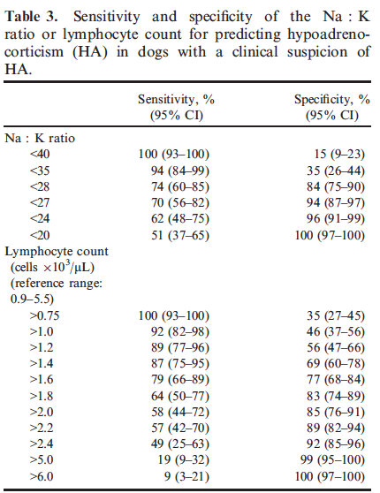
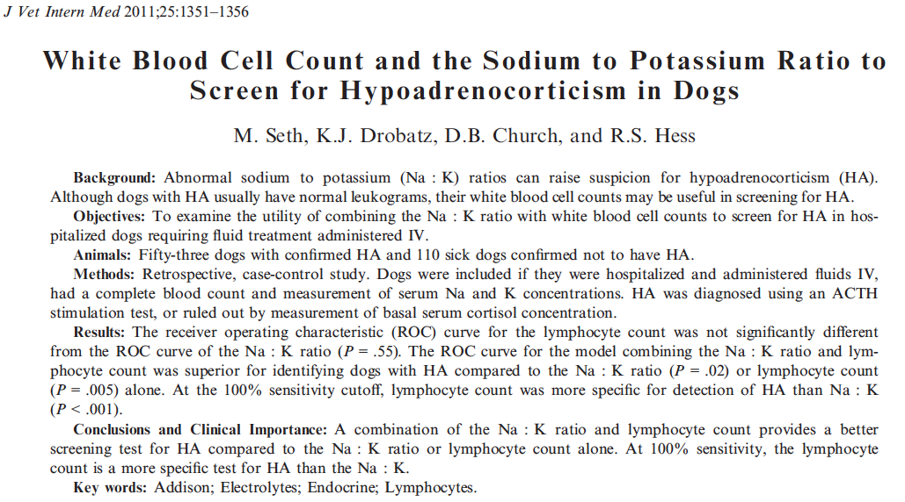
Key Points
- No statistical significance between AUC for Na:K and lymphocyte count but both were significantly better than curves for neutrophil, eosinophil or neutrophil:lymphocyte counts
- With a 100% sensitivity cut off, the calculated specificity was 35% for lymphocyte count and 15% for Na:K
- Combination of Na:K and lymphocyte count better predictor than either value independently

Questions
- What is the previously published Na:K ratio cut off value?
  - 27
- True/False: The neutrophil:lymphocyte ratio was more predictive of hypoadrenocoritism than a normal absolute lymphocyte count
  - False
- Based on the information presented in this report, the combination of what two values best predicts the presence of hypoadrenocoritism?
  - Lymphocyte count and the sodium:potassium

