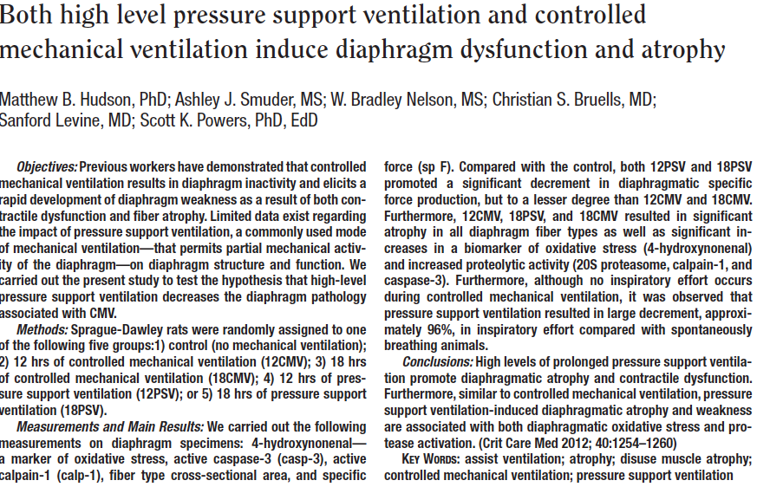
Key Points
- Controlled ventilation for 12 and 18 hours and pressure support ventilation for 18 hours all increased markers of diaphragmatic atrophy
- Markers included 4-hydroxynonenal (oxidative stress), 20s proteasome activity (proteolysis), calpain-1 activity/caspase 3 levels (diaphragmatic damage), histologic myofibril atrophy, diaphragmatic contractile performance

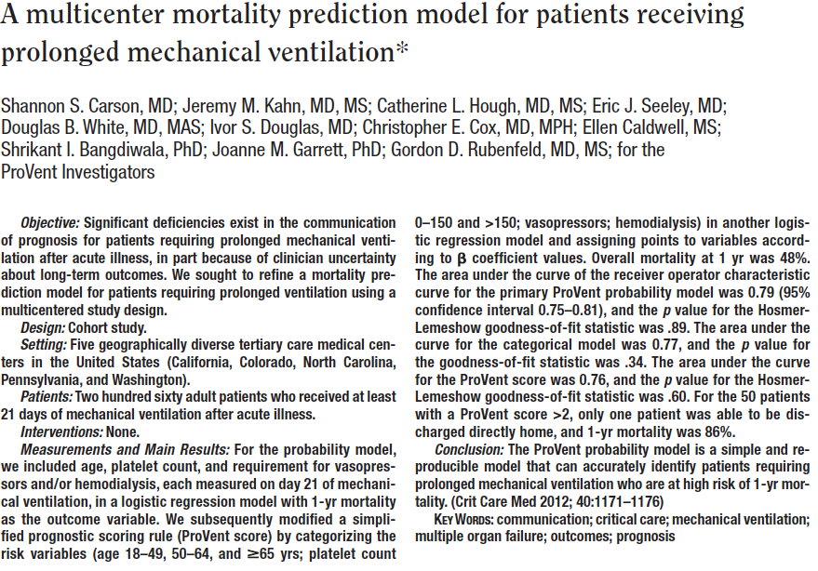

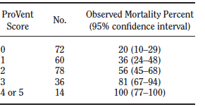
Key Points
- The ProVent probability model utilizes age, platelet count, vasopressor dependence, and use of hemodialysis to predict 1 year mortality in patients on prolonged mechanical ventilation
- This study was clinically applying the model to variety of clinical cases, accurately predicted death
- High score means very low chance of long term survival

Questions
- At one year after prolonged mechanical ventilation what percent of patients are at home?
  - 50%
  - 40%
  - 10%
  - 20%
- Less than what percent of patients are alive at 1 year if their ProVent score is >2?
  - 90%
  - 30%
  - 40%
  - 15%

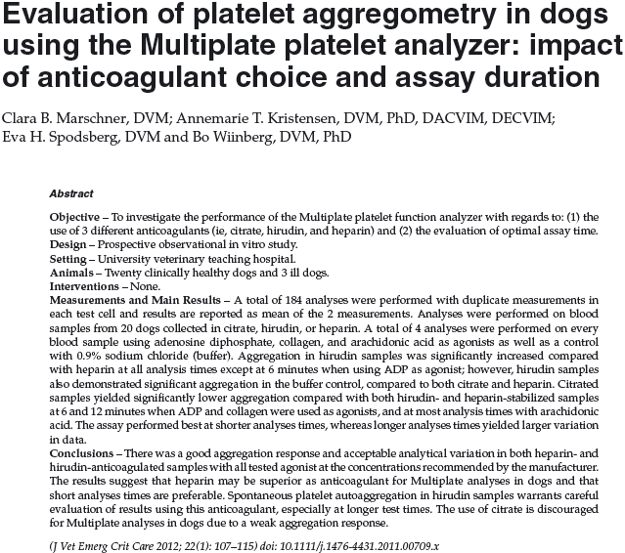
Key Points
- Citrate decreased significantly the coagulation parameters
- Heparin and hirudin are both acceptable anticoagulation with no significant differences
- Analysis beyond 6 minutes did not give any further analytical variation, and may decrease the variation

Questions
- True/false, Citrate does not effect coagulation parameters as measured by the MultiPlate platelet aggregometry test
- What is the mechanism of action of each citrate (calcium chelation), heparin (antithrombin potentiation), and hirudin (thrombin inhibition)

