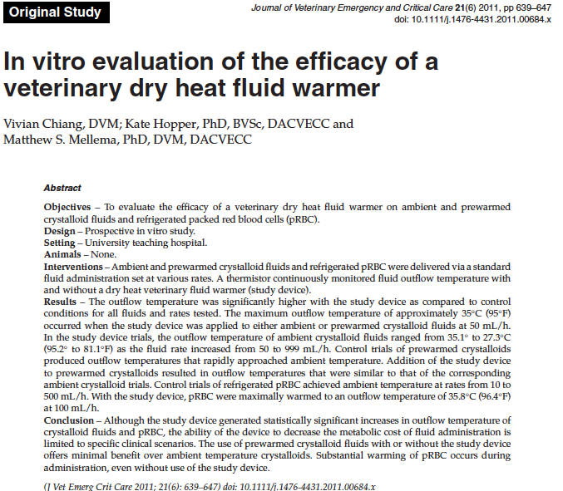
Key points
- Change in temperature for room temp crystalloids running through the warmer is significantly higher than without at 50, 250, 500, and 999 mL/hr and progressively increased with fluid rate
- Change in temperature of prewarmed crystalloids is significantly slower if using a fluid warmer at 50, 250, 500 and 999 mL/hr
- Temperature of prewarmed crystalloid is significantly lower at 50, 250, 500, 999 mL/hr regardless of fluid warmer or non-fluid warmer fluids
- Temperature of refrigerated blood was significantly higher in control and study groups at all fluid rates, reached ambient temperature in 5 minutes and fluid warmer had a significant increase in temperature compared to controls
Questions
- Estimation of change in body temperature for every liter of fluids administered is
  - 0.25 degrees Fahrenheit
  - 0.45 degrees Fahrenheit
  - 0.1 degrees Fahrenheit
  - 0.65 degrees Fahrenheit
- True/false, the fluid warmer has significantly higher temperatures at both low and high fluid rates of room temperature crystalloid compared to control

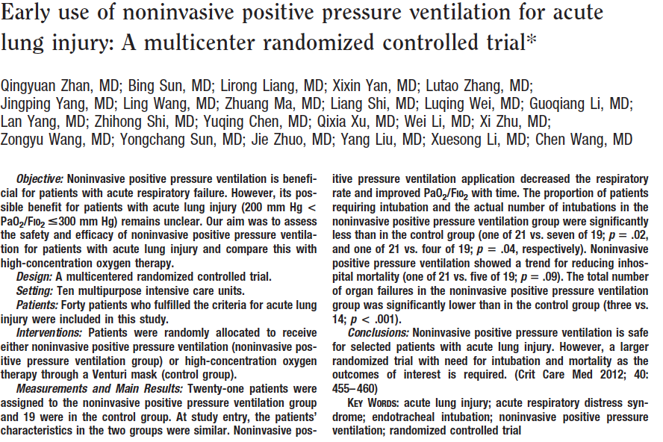
Key points
- Complications of NPPV included abdominal distention, cough suppression, facial abrasion, and inefficient cough
- Respiratory rate and PaO2:FiO2 significantly improved in the study group
- Significantly fewer patients intubated and organ failures in the study group
- No difference in overall hospital mortality, length of stay in icu/hospital, VALI, pneumonia, or abdominal sepsis
Questions
- Which of the following is not a contraindication for NPPV
  - Low Glasgow coma score
  - Hypercapnea
  - Unable to spontaneously clear secretions from airways
  - Severe abdominal distenion
Also:
  - Facial injury
  - Non-cooperative patient
  - Severe organ dysfunction
- Conclusions of this study include:
  - NPPV prevents the progression of ALI to ARDS
  - NPPV is safe for ALI
  - NPPV has increased incidence of organ failure compared to no NPPV
  - NPPV has decreased mortality compared to no NPPV

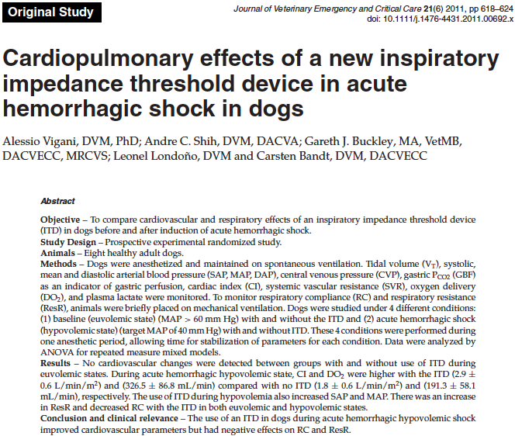
Key Points
- ITDs create increased airway resistance and augment negative intrathoracic pressure and improve venous return, high cracking pressure for CPR and low cracking pressure for spontaneous breathing
- Significant increase in airway resistance, respiratory compliance, cardiac index, delivery of oxygen, systolic pressure and mean arterial pressure was noted with the ITD
- Significant increase in cardiac index and delivery of oxygen with ITD
Questions
- The presumed mechanism of action of the ITD in hemorrhagic shock is
  - Increased resistance improves oxygen delivery to the alveolus
  - Decreased resistance decreases the the intrathoracic pressure resulting in improved preload
  - Increased resistance results in a reciprocal increase in compliance allowing for decreased dead space ventilation
  - Increased resistance results in an decreased intrathoracic pressure and improved venous return

