Leptospirosis Diagnosis
Microscopic agglutination test (MAT)
- Mix serial dilutions of canine sera w/ cultured leptospira organisms of different serovars
  - Highest serum dilution resulting in 50% agglutination of leptospires in reaction
- A 4-fold change in titer supports recent infection
  - Increase in titer may be blunted by antimicrobial therapy
- Sensitivity for single MAT titer >800 for diagnosis was 22-67% and specificity was 69-100%
- Recommend acute and convalescent testing
- Negative aspects:
- Hazardous b/c need to maintain live cultures of pathogenic serovars
- Subjective interpretation, requires expertise
- Cross-contamination of serovars is likely over time
- Lack of consensus of what titer should be used as a cut-off for negative result
- Frequently negative in the first week of illness
- Falsely negative if the infecting serovar is not included in panel used to perform test
- Persistence of antibodies in subclinical infections results in positive test w/out current infections
- Does not differentiate between vaccination and infection
- serovars w/in the same serogroup will cross-react extensively
Culture
- Useful early in course of disease
- In the first 10 days of infection, blood samples are preferred as the organisms are highest there, after that organisms are highest in urine
  - If time of infection is unknown, recommendation is to test both urine and blood
- Negative aspects
  - Requires special media
  - Growth is slow (3-6 months)
  - Risks exposure to the lab technicians
  - Falsely negative if antibiotics are already instituted
Polymerase Chain Reaction (PCR)
- Useful early in the course of disease
- Considered most sensitive
- Recommended to perform on urine and blood early in course of disease to increase sensitivity
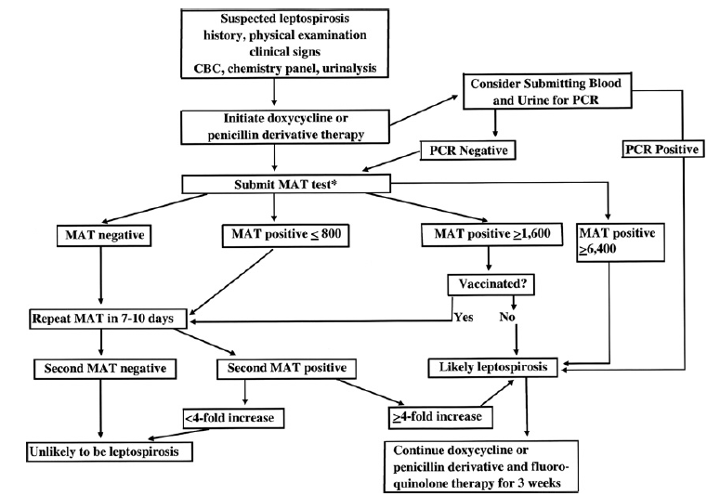
- Negative aspects:
  - No differentiation between serovars/groups
  - Falsely negative:
  - low organismal burden
  - antibiotic therapy
  - Presence of PCR inhibitors
Direct visualiation
- Darkfield microscopy
  - Lacks sensitivity and specificity
  - Not recommended anymore
- Histopathology
  - Giemsa/modified Steiner stain
  - Immunofluorescence
  - Immunohistochemistry

Leptospirosis Treatment
Supportive care

Antibiotic therapy
- Penicillins
  - If vomiting ensues
  - Ampicillin 20 mg/kg IV q 6 hr
  - PenG 25k-40k u/kg IV q12 hr
  - Dose reduced for azotemia
- Doxycycline
  - Consensus panel recommends treatment with doxy 5 mg/kg PO or IV q 12hr for 2 weeks
- Azithromycin
- Recommend for other dogs in the household to be treated with antibiotics as well
Dialysis
- Indications:
  - Inadequate urine output and volume overload
  - Hyperkalemia
  - BUN > 80 mg/dL
  - Uremia non-responsive to medical care
- More than 80% of patients that would otherwise die from uremia survive with RRT
Leptospirosis Pulmonary Hemorrhage
- Cyclophosphamide
- Plasma exchange
- No improvement with dexamethasone and desmopressin therapy
  - Kohn paper suggested attempting steroids due to possibility of immune mediated disease and humans do better with them

Diltiazem
- Suggested MOA:
  - Reversal of renal vasoconstriction with pre-glomerular dilation
  - Improved naturesis independent of
  - Reduction of creatinine 1.76 times faster with diltiazem
- No clinically relevant effect on systemic blood pressure

