- In an air leak situation, the ventilator may not adequately maintain the baseline PEEP on the pressure scalar the presence of supported breaths without an obvious trigger such as pressure or flow change, and the tidal volume scalar not returning to baseline, as demonstrated in the scalars below.
- This phenomenon is called autocycling.
- The notch at point B represents an inspiratory effort by the patient.
- To improve synchrony, either shorten inspiratory time or increase inspiratory pressure.
- Patient-ventilator asynchrony would appear:
Flow-volume loop

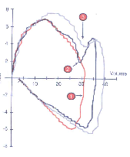

Pressure-volume loop
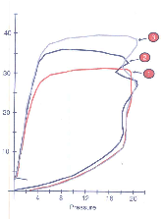

- Rise time is defined as the time required to reach the set pressure level.
- Inadequate rise time or flow can be detrimental because flow rates that are too slow may cause flow starvation and dyssynchrony, increased work-of breathing, inadequate mean airway pressure and lead to the increase of peak airway pressure to attain tidal volumes.
- High flow rates may be detrimental because they may prematurely terminate the inspiratory phase of a breath, since some breath termination criteria utilize a calculation based on a percentage of the peak flow. High flow rates may also potentially activate an inspiratory termination reflex, resulting in brief, shallow respirations.
- The spike represents a pressure spike due to excessive flow delivery that does not translate into increased tidal volume delivery.
- Beaking represents excessive inspiratory pressure without a change in volume.
- Excessive inspiratory time can lead to a number of complications including patient agitation, increased carbon dioxide production, increased oxygen and calorie consumption, delayed ventilator weaning, increased ICP, increased risk of cerebral bleed, and a compromised cardiovascular status. It also can lead to active exhalation.
- Breath-stacking (auto-PEEP).

