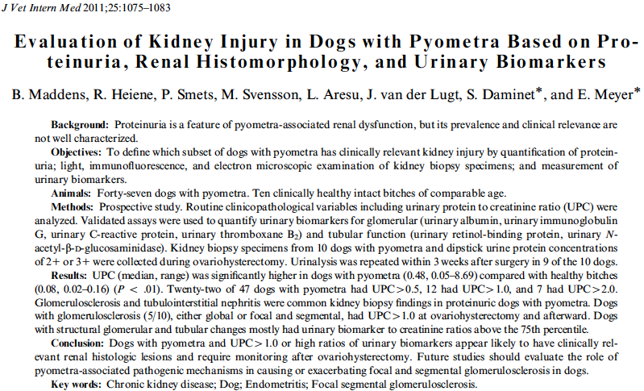

Key points
- Uterine culture results negative in 13/47 dogs, remainder mostly e coli
- 4/47 had free fluid, which wasn’t associated w/ proteinuria
- Pyometra dogs had significantly higher UPC than non-pyometra dogs
  - About half of the pyos had proteinuria, most was transient
- UPC decreased significantly after OVH in proteinuric, pyometras
- Most common glomerular change was glomerular sclerosis
- Only one dog had staining consistent with immune complex deposition
- Significantly higher in pyometras: urine albumin:creat, uring IgG:creat, urine c-reactive protein:creat, urine retinol-binding protein:creat, urine n-acetyl-B-D, glcosaminidase:creat, and urine thromboxane A2: creat
  - All except urine crp:creat, urine NAG:creat and uThromboxane:creat were also significantly higher in high UPC pyos
Questions
- The most common isolate of the pyos was
  - Nothing
  - E coli
  - Staph
  - Strep
- Proteinuria was associated with which kidney change
  - Immune complex deposition
  - Glomerularsclerosis
  - Tubular epithelial necrosis
  - No change

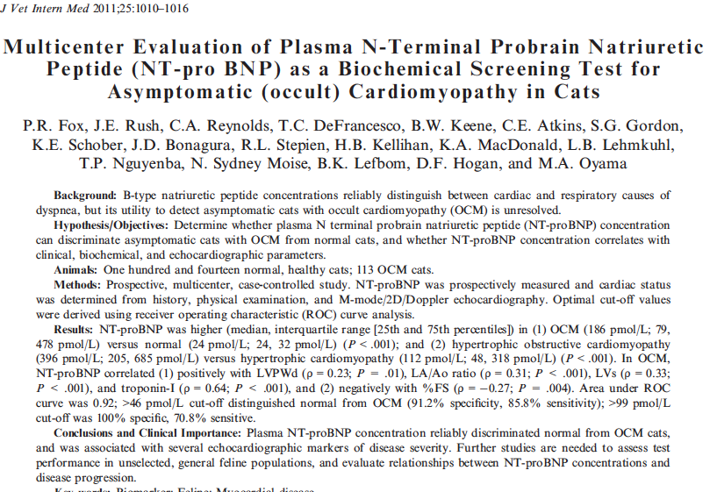

Key points
- BNP secretion from stretch of myocytes, concentration increases in CHF, asymptomatic/minimally symptomatic systolic or diastolic dysfunction
- NT-proBNP significantly increased in cats w/ occult cardiomyopathy compared to normal
- Suggest a cut off value of > 46 pmol/L, sens=86%, spec=91%
Questions:
- NT-proBNP above what level was recommended for evaluation in cats with occult cardiomyopathy?
  - 46

