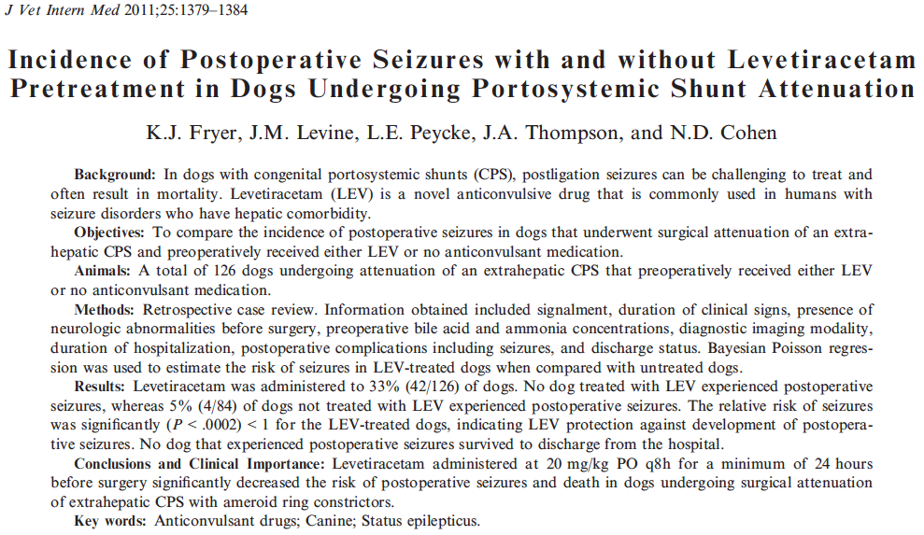

Key Points
- Average dose of Keppra was 60 mg/kg/d, median duration of treatment was 33 days (0-99d)
- 3% incidence of postoperative seizure, 0 of which were pretreated w/ keppra
- on Bayesian Poisson regression, the risk of seizure was significantly < 1, indicated protective effect

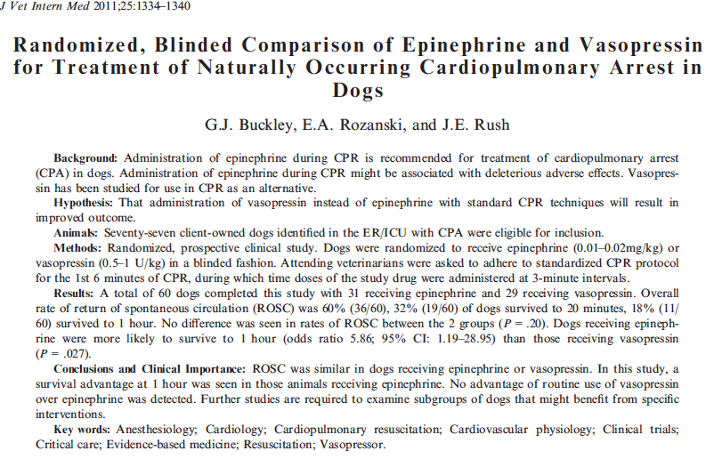
Key Points
- ROSC in 53% of patients
- No significant difference b/t epinephrine and vasopressin at 6 min post-arrest
- Significantly increased survival to 1 hour post-resuscitation with epinephrine
- Low numbers of survival at 24 hours and discharge limited statistical evaluation

