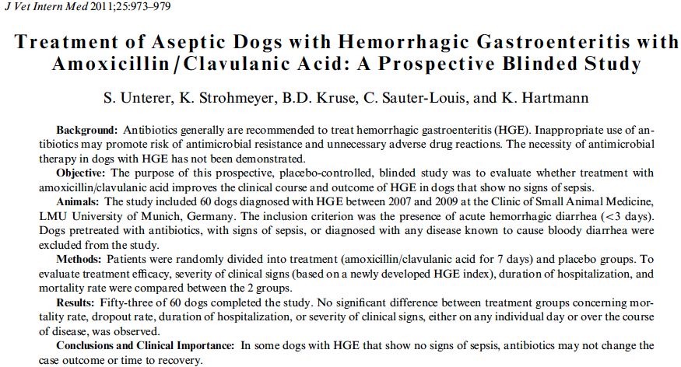
Key Points
- No difference between treatment and placebo regarding activity index, fecal consistency, duration of hospitalization, or mortality in general
- Specifically to the clostridium group, only one day had a significant difference between activity indices
- No difference between drop out rates, though the power was too low
- Conclude that endotoxemia isn’t a major player in HGE b/c the antibiotic group did not do more poorly
Questions
- According to this paper, previous justification of antibiosis in HGE has been to treat
  - Living clostridium populations
  - Intestinal epithelial penetration
  - Anti-inflammatory properties of the antibiotics
  - Secondary bacterial pneumonia
- True or false: The use of amoxicillin/clavulanate is justified in the treatment of HGE according to this study

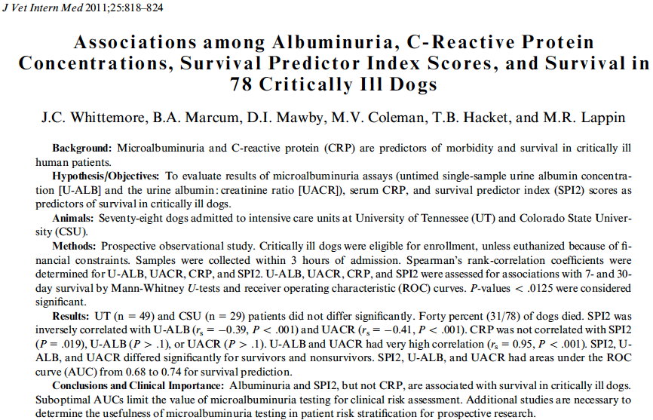
Key points
- Data points in SPI2 are: aterial pressure, respiratory rate, creatinine, PCV, albumin, age and medical vs surgical status
- SPI2 was significantly but low correlated to urine albumin and urine albumin:creatinine ratio
- Urine albumin and urine albumin:creatinine ratio were perfectly correlated
- No correlation b/t CRP and any other measured variable or survival
- Urine albumin and SPI2 were significantly correlated to seven day survival and urine albumin, urine albumin:creatinine ratio and SPI2 score were significantly correlated to 30 day survival
Questions
- C-reactive protein is thought to be a measure of disease severity due to
  - Its role in stimulation of coagulation by tissue factor enhancement
  - It is derectly produced by bacterial endotoxin
  - Concentrations are direct indication of degree of tissue inflammation
  - It is an easily measured benchside biomarker
- Which is true regarding urine albumin?
  - It has pretty low concentrations in healthy canine subjects
  - In dogs correlates well with the ratio of albumin to creatinine
  - Young age is associated with higher concentrations
  - Variable assay methodology minimally influences results
- True/false: the SPI2 score, creatinine levels and urine albumin levels were significant predictors of survival in this study

