Chapter 5: Common Clinical Findings
Ventilator Waveform Analysis

1. You have just placed a patient on the ventilator and obtain the following loops:

Interpret the loops. How do you fix the problem?

These flow-volume and pressure-volume loops are consistent with active exhalation. This happens when the patient is actively exhaling more than his/her expiratory volume. Clinically, active exhalation can occur when the patient changes position, feels pain or tries to cough. To fix the problem, I would assess my patient’s anesthetic depth and increase or give additional drugs for analgesia and/or anesthesia.

2. You fix the problem and obtain the following pressure-volume loop.

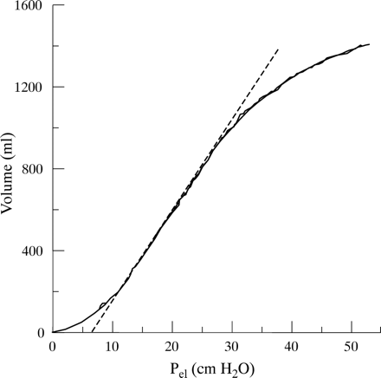

What is the estimated compliance?

Compliance = Δ volume/Δ pressure
= 33 ml/cm H2O

3. Your patient becomes more difficult to ventilate and the PaO2:FiO2 ratio declines rapidly. You obtain the following loop.

A. What does the change in waveform indicate? Decreased respiratory compliance

B. What are the differentials for this change?
1. Atelectasis
2. ARDS
3. ALI
4. Pulmonary fibrosis
5. Large airway obstruction
6. ET tube advancement into the right mainstem bronchus
7. Pleural space disease (pneumothorax)

4. Following a negative thoracocentesis, you decide to increase your PEEP. How would you initially perform a lung recruitment maneuver?
1. Sustained inflation (CPAP, 40 cm H2O for 40 seconds)
2. Sigh (increase tidal volume, PEEP, PIP, RR or inspiratory time for 1-2 breaths)

5. You increase your tidal volume (or PIP in pressure-targeted ventilation) and then get distracted. When you look at the monitor again you have the following loop:
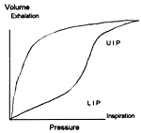

What happened? What do you do to fix the problem?
Overdistention. Decreased your set tidal volume (or PIP)

6. After 2 days on the ventilator, your pressure-volume curve is beginning to look like image A:
What would you do to trouble shoot the problem?
This pressure-volume curve is indicative of an upper airway obstruction or kinked ET tube. I would first suction the ETT and reposition the ETT and patient’s head. If this did not fix the problem I would replace the ETT.

7. You end up replacing the ETT and get the following waveforms

Interpret the loops. How do you fix the problem?
These flow-volume and pressure-volume loops are consistent with volume loss (leak) during a patient breath because the expiratory volume is smaller than the inspiratory volume. I would check the ventilator circuit to make sure the tubing was properly attached to the machine and to my patient, check the ETT cuff for a leak, make sure my ETT was correctly placed in the trachea and auscult my patient’s chest for a pneumothorax.

8. What medication would administer if you obtained the following flow-volume curve?

A bronchodilator

