West Respiratory Physiology
Chapter 2: Ventilation
Summary

Lung volumes
- Static lung volumes are measured with a spirometer
- Normal breathing involves inspiration and expiration of a tidal volume
- On maximal inspiration, the additional volume inspired above tidal volume is called the inspiratory reserve volume
- On maximal expiration, the additional volume expired below tidal volume is called the expiratory reserve volume
- The volume of gas remaining in the lungs after a maximal forced expiration is the residual volume

Lung capacities
- Inspiratory capacity: tidal volume + inspiratory reserve volume
- Functional residual capacity: expiratory reserve volume + residual volume
- Vital capacity: inspiratory capacity + expiratory reserve volume
- Total lung capacity: vital capacity + residual volume

• Lung volumes that cannot be measured with a simple spirometer include the total lung capacity, the functional residual capacity and the residual volume
• These can be determined by helium dilution or the body plethysmograph

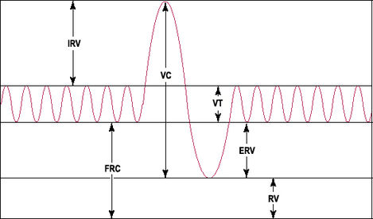
IC
TLC

Dead space
- The volume of the airways and lungs that does not participate in gas exchange
- Anatomic dead space is the volume of the conducting airways (nose, mouth, trachea, bronchi, bronchioles) and is approximately 150 ml in people
- Physiologic dead space is the total volume of the lung that does not participate in gas exchange, including the anatomic dead space and functional dead space in the alveoli
- The most common reason alveoli do not participate in gas exchange is high V/Q mismatch
- Volume of physiologic dead space can be estimated by measuring PaCO₂ and P_{E}CO₂
  - V_{D} = V_{T} x (PaCO₂ – P_{E}CO₂)/PaCO₂ (Bohr equation)

• There are regional differences in ventilation throughout the lung
- Lower regions of the lung ventilate better than upper zones
- In dorsal or lateral recumbency, ventilation of the dependent lung exceeds that of the non-dependent lung
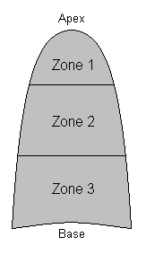
Ventilation
Higher
Lower

