West Respiratory Physiology
Chapter 2: Ventilation

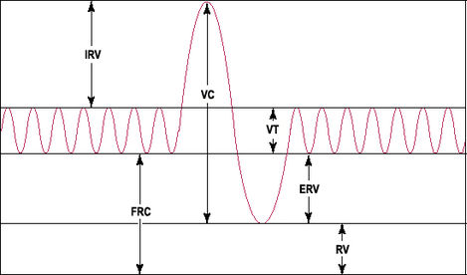
8
7
4
6
5
2
3
1

Label each of the following:
_1__ Inspiratory reserve volume
_4__ Tidal volume
_5__ Expiratory reserve volume
_6__ Residual volume
_8__ Inspiratory capacity
_2__ Functional residual capacity
_3__ Vital capacity
_7__ Total lung capacity

2. Which of the following cannot be measured by spirometry?
a. Tidal volume
b. Inspiratory reserve volume
c. Residual volume
d. Expiratory reserve volume

3. Functional residual capacity is the volume remaining in the lungs after a normal tidal volume is expired.

4. Anatomic/Physiologic dead space is the volume of the conducting airways where no gas exchange occurs. Anatomic/Physiologic dead space is the total volume of the lungs that does not participate in gas exchange and includes the functional dead space in the alveoli.

5. A dog who has a tidal volume of 300 ml is breathing at a rate of 12 breaths/minute. The PCO2 in his arterial blood is 40 mmHg and the PCO2 in his expired air is 30 mmHg.

a. What is his minute ventilation?
Minute ventilation = Tidal volume x RR
= 300 ml x 12 bpm = 3600 mL/min

b. What percentage of each tidal volume is dead space?
V_{D} = V_{T} x (PaCO₂ – P_{E}CO₂)/ PaCO₂
= 300 ml x (40 mmHg – 30 mmHg)/40 mmHg
= 75 mL

c. What is his alveolar ventilation?
V_{A} = (V_{T}-V_{D})
= 300 mL – 75 mL
= 225 mL

d. What percentage of each tidal volume reaches functional alveoli?
225/300 x 100 = 75%

6. True or false. When a patient is in lateral or dorsal recumbancy (supine), the dependent lung is less ventilated.

False. The lower regions of the lung are better ventilated than the upper regions because of the effects of gravity on the lungs.

7. In a measurement of physiologic dead space using Bohr’s method, the alveolar and expired PCO2 were 40 mmHg and 30 mmHg respectively. What was the ratio of dead space to tidal volume?
V_{D}/V_{T} = (P_{A}CO₂ – P_{E}CO₂)/P_{A}CO₂
= (40 – 30)/40
= 0.25

